

Part 1: TITLE, AUTHORS, APPROVALS, etc

Code assigned: | 2022.076B
Short title: Create a new genus Shantouvirus in the family Chaseviridae including a new species Shantouvirus ZPAH14 (Caudoviricetes)
Author(s) and email address(es)
Li J-Q | lijinquan2017@163.com
Author(s) institutional address(es) (optional)
Huazhong Agricultural University [LJQ]
Corresponding author
Li J-Q (lijinquan2017@163.com)
List the ICTV Study Group(s) that have seen this proposal
Bacterial & Archaeal Virus Subcommittee
ICTV Study Group comments and response of proposer
ICTV Study Group votes on proposal
Study Group | Number of members
Study Group | Votes support | Votes against | No vote
Authority to use the name of a living person
Is any taxon name used here derived from that of a living person (Y/N) | N

Taxon name | Person from whom the name is derived | Permission attached (Y/N)
Submission dates
Date first submitted to SC Chair | April 2022
Date of this revision (if different to above)
ICTV-EC comments and response of the proposer

Part 2: NON-TAXONOMIC PROPOSAL
Text of proposal

Part 3: TAXONOMIC PROPOSAL
Name of accompanying Excel module
2022.076B.N.v1.Shantouvirus_ng.xlsx
Abstract
We isolated a new Aeromonas phage named ZPAH14, and ViPTree analysis classified as a member of the family Chaseviridae. Based on the VIRIDIC and phylogenetic analysis, we found that ZPAH14 fell within a clade that separated from the other genera of the family.
Therefore, we propose a new genus Shantouvirus, and a new species Shantouvirus ZPAH14. The genome of ZPAH14 had been submitted to the NCBI GenBank database and is available under the accession number OM810291.
Text of proposal
Species demarcation criteria: Two phages are assigned to the same species if their genomes are more than 95% identical over their genome length for isolates.
These values can be calculated by a number of tools, such as BLASTn – usually calculated using intergenomic distance calculator VIRIDIC [1].

Genus demarcation criteria: In search for criteria that create cohesive and distinct genera that are reproducible and monophyletic, the Bacterial Viruses Subcommittee has established 70% nucleotide identity of the genome length as the cut-off for genera. Genus-level groupings should always be monophyletic in the signature genes, as tested with a phylogenetic tree [2].

Supporting evidence
ViPTree analysis: ViPTree analysis (https://www.genome.jp/viptree/; [3]) is based upon Rohwer and Edwards (2002) famous Phage Proteomic Tree [4]. The phages of interest are indicated with red arrow and box.
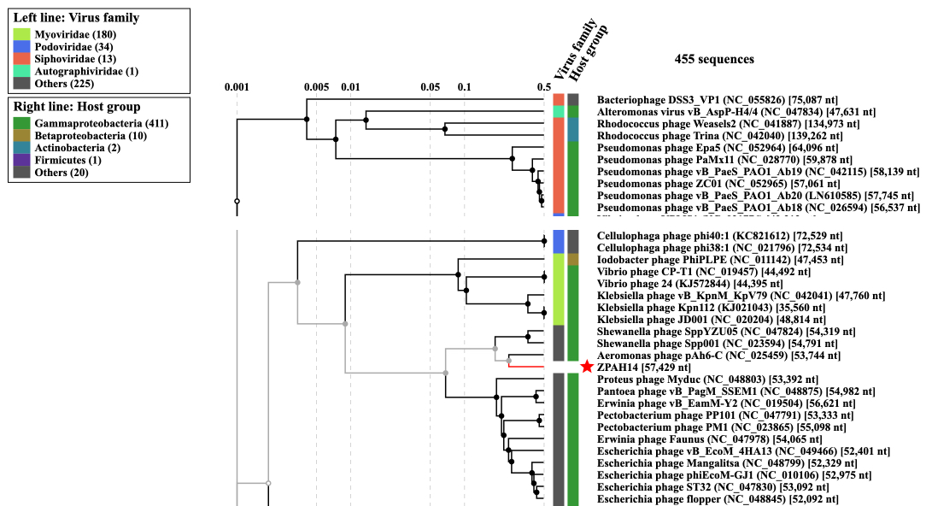
VIRIDIC heat map: VIRIDIC (Virus Intergenomic Distance Calculator; [1]; http://rhea.icbm.uni-oldenburg.de/VIRIDIC/) computes pairwise intergenomic distances/similarities amongst phage genomes.
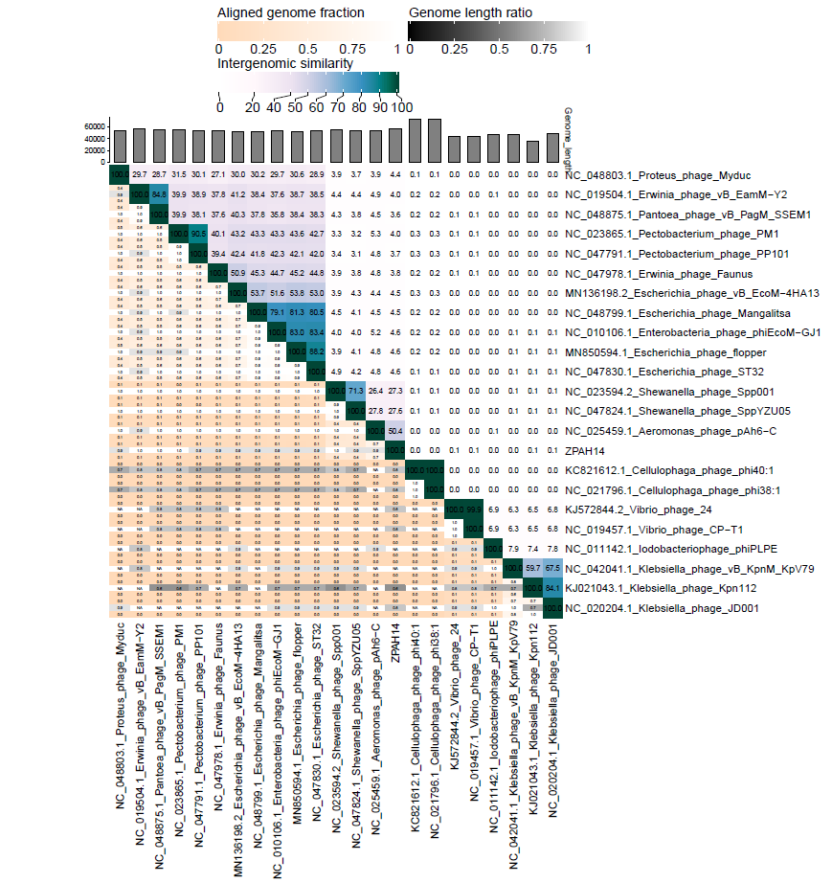
Phylogeny: The phylogenetic tree was constructed using the major capsid proteins of phages [5]. MUSCLE was used for multiple alignment and MEGA(v11.0.10) was used for building phylogenetic tree using maximum-likelihood method with 500 bootstrap replicates [6]. The new genus is indicated with red box and new species is indicated with red arrow.

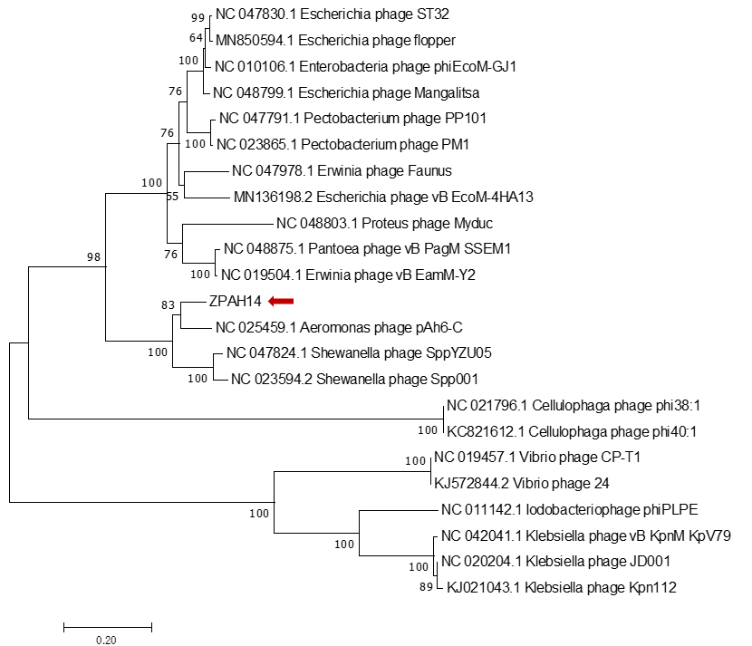

Origin of the name of this taxon: This genus is named based on Shantou, a city located in southern China.

Historical aspects: The phage ZPAH14 was isolated in 2018 by our team from lake water, using Aeromonas hydrophila as the host bacterium.

Specific References: None

Genome summary:

Phage name | RefSeq No. | INSDC | Size (Kb) | GC% | Protein | tRNA | Overall % DNA sequence identity (*) | Overall % homologous proteins (**)
Aeromonas phage ZPAH14 |  | OM80291 | 57.4 | 56.8 | 71 | 1 | 100 | 100
(*) Determined using VIRIDIC [1]
(**) Determined using CoreGenes 3.5 at http://binf.gmu.edu:8080/CoreGenes3.5/[7]

References
1: Moraru C, Varsani A, Kropinski AM. VIRIDIC-A Novel Tool to Calculate the Intergenomic Similarities of Prokaryote-Infecting Viruses. Viruses. 2020 Nov 6;12(11):1268. doi: 10.3390/v12111268. PMID: 33172115.
2: Turner D, Kropinski AM, Adriaenssens EM. A Roadmap for Genome-Based Phage Taxonomy. Viruses. 2021 Mar 18;13(3):506. doi: 10.3390/v13030506. PMID: 33803862.
3: Nishimura Y, Yoshida T, Kuronishi M, Uehara H, Ogata H, Goto S. ViPTree: the viral proteomic tree server. Bioinformatics. 2017 Aug 1;33(15):2379-2380. doi: 10.1093/bioinformatics/btx157. PMID: 28379287.
4: Rohwer F, Edwards R. The Phage Proteomic Tree: a genome-based taxonomy for phage. J Bacteriol. 2002 Aug;184(16):4529-35. doi: 10.1128/jb.184.16.4529-4535.2002. PMID: 12142423.
5: Dereeper A, Guignon V, Blanc G, Audic S, Buffet S, Chevenet F, Dufayard JF, Guindon S, Lefort V, Lescot M, Claverie JM, Gascuel O. Phylogeny.fr: robust phylogenetic analysis for the non-specialist. Nucleic Acids Res. 2008;36(Web Server issue):W465-9. doi: 10.1093/nar/gkn180. Epub 2008 Apr 19. PMID: 18424797.
6: Anisimova M, Gascuel O. Approximate likelihood-ratio test for branches: A fast, accurate, and powerful alternative. Syst Biol. 2006;55(4):539-52. doi: 10.1080/10635150600755453. PMID: 16785212.
7: Turner D, Reynolds D, Seto D, Mahadevan P. CoreGenes3.5: a webserver for the determination of core genes from sets of viral and small bacterial genomes. BMC Res Notes. 2013;6:140. doi: 10.1186/1756-0500-6-140. PMID: 23566564.

