

Part 1: TITLE, AUTHORS, APPROVALS, etc

Code assigned: | 2022.074B
Short title: Create a new species (Segzyvirus LPSTLL), and assign it to the genus Segzyvirus (Caudoviricetes)
Author(s) and email address(es)
Li J-Q | lijinquan2017@163.com
Author(s) institutional address(es) (optional)
Huazhong Agriculture University, China [LJQ]
Corresponding author
Li JQ (lijinquan2017@163.com)
List the ICTV Study Group(s) that have seen this proposal

Bacterial Viruses Subcommittee
ICTV study group comments and response of proposer

ICTV Study Group votes on proposal

Study Group | Number of members
Study Group | Votes support | Votes against | No vote
Authority to use the name of a living person

Is any taxon name used here derived from that of a living person (Y/N) | N

Taxon name | Person from whom the name is derived | Permission attached (Y/N)

Submission dates
Date first submitted to SC Chair | April 2022
Date of this revision (if different to above)
ICTV-EC comments and response of the proposer

Part 2: NON-TAXONOMIC PROPOSAL
Text of proposal

Part 3: TAXONOMIC PROPOSAL
Name of accompanying Excel module
2022.074B.N.v1.Segzyvirus_1nsp.xlsx
Abstract
We isolated a novel Salmonella phage LPSTLL [1]. VIRIDIC and ViPTree analysis showed that LPSTLL has 72.7% identity with Salmonella phage Segz_1 of Segzyvirus genus. LPSTLL share many properties with Segz_1 but differ significantly enough (less than 95% identity with Segzyvirus species) to classify it as separate species of this genus. Thus, this proposal will place LPSTLL in this genus Segzyvirus as a new species.

Text of proposal
Species demarcation criteria: Two phages are assigned to the same species if their genomes are more than 95% identical over their genome length for isolates.
These values can be calculated by a number of tools, such as BLASTn – usually calculated using intergenomic distance calculator VIRIDIC [2].

Genus demarcation criteria: In search for criteria that create cohesive and distinct genera that are reproducible and monophyletic, the Bacterial Viruses Subcommittee has established 70% nucleotide identity of the genome length as the cut-off for genera. Genus-level groupings should always be monophyletic in the signature genes, as tested with a phylogenetic tree [3].

Supporting evidence
ViPTree analysis: ViPTree analysis (https://www.genome.jp/viptree/; [4]) is based upon Rohwer and Edwards (2002) famous Phage Proteomic Tree [5]. The phages of interest are indicated with red box.
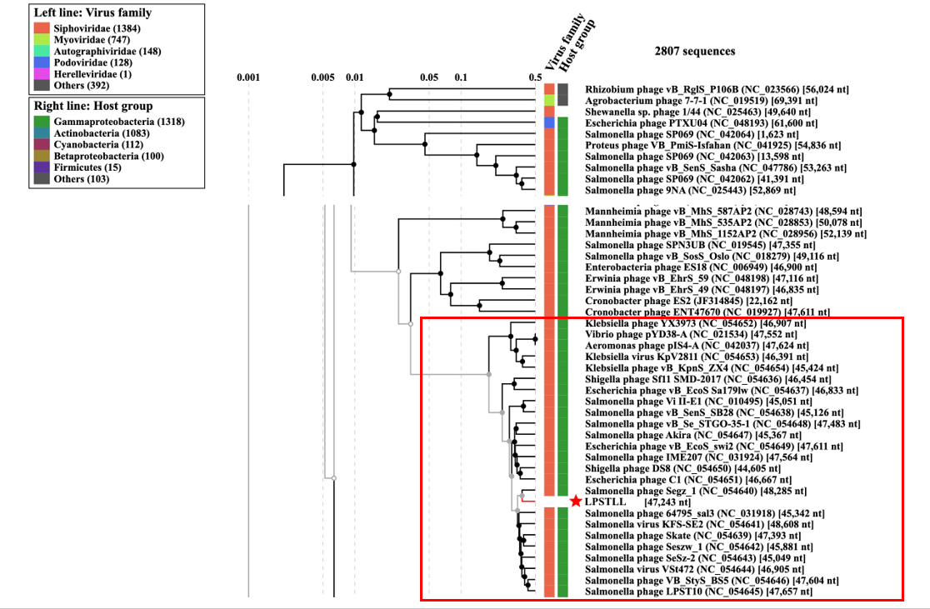

VIRIDIC heat map: VIRIDIC (Virus Intergenomic Distance Calculator; [2]; http://rhea.icbm.uni-oldenburg.de/VIRIDIC/)computes pairwise intergenomic distances/similarities amongst phage genomes.
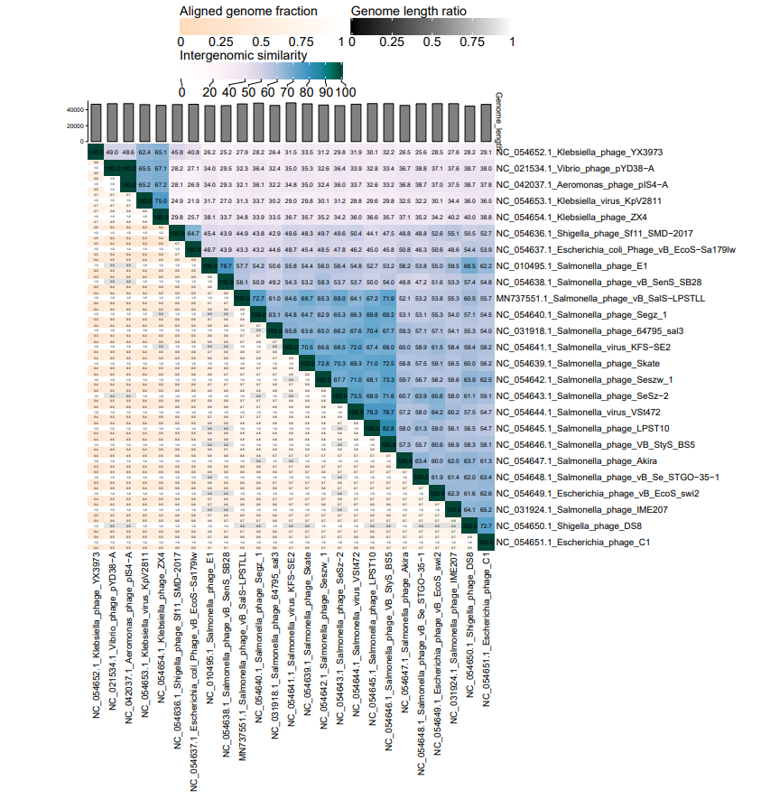
Phylogeny: The phylogenetic tree was constructed using the major capsid proteins of these phages with phylogeny. MUSCLE was used for multiple alignment and MEGA (v11.0.10) was used for building phylogenetic tree using maximum-likelihood method with 500 bootstrap [6]. The red box represents the phage of the new proposed genus and red star represents new species.
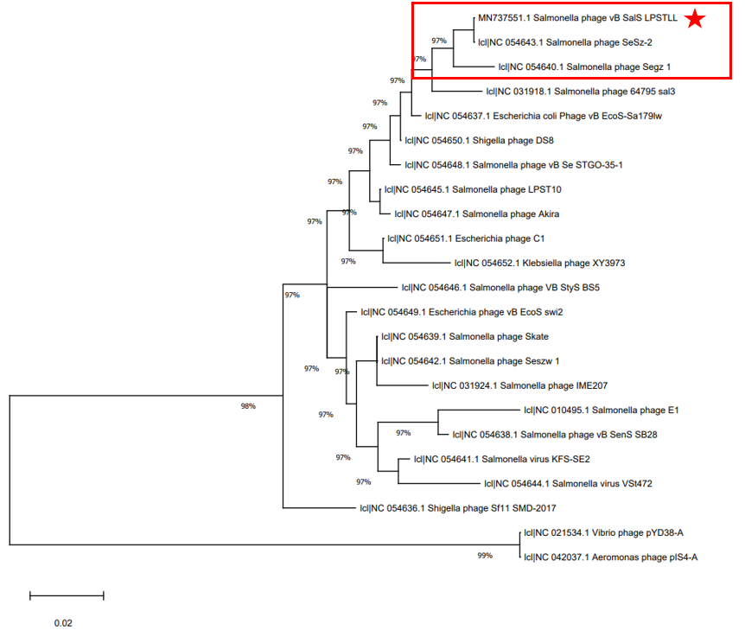

Origin of the name of this taxon: None.

Historical aspects: Salmonella phage LPSTLL collected from the lake by Huazhong Agricultural University in 2018, using Salmonella Typhimurium as the host bacterium.

Specific References: None

Genome summary:
Phage name | RefSeq No. | INSDC | Size (Kb) | GC% | Protein | tRNA | Overall % DNA sequence identity (*) | Overall % homologous proteins (**)
Salmonella phage LPSTLL |  | MN737551.1 | 47.2 | 54.6 | 80 | 2 | 100 | 100
(*) Determined using VIRIDIC [2]
(**) Determined using CoreGenes 3.5 at http://binf.gmu.edu:8080/CoreGenes3.5/ [7]

References

1: Guo Y, Li J, Islam MS, Yan T, Zhou Y, Liang L, Connerton IF, Deng K, & Li J. (2021). Application of a novel phage vB_SalS-LPSTLL for the biological control of Salmonella in foods. Food research international (Ottawa, Ont.), 147, 110492. https://doi.org/10.1016/j.foodres.2021.110492.
2: Moraru C, Varsani A, Kropinski AM. VIRIDIC-A Novel Tool to Calculate the Intergenomic Similarities of Prokaryote-Infecting Viruses. Viruses. 2020 Nov 6;12(11):1268. doi: 10.3390/v12111268. PMID: 33172115
3: Turner D, Kropinski AM, Adriaenssens EM. A Roadmap for Genome-Based Phage Taxonomy. Viruses. 2021 Mar 18;13(3):506. doi: 10.3390/v13030506. PMID: 33803862.
4: Nishimura Y, Yoshida T, Kuronishi M, Uehara H, Ogata H, Goto S. ViPTree: the viral proteomic tree server. Bioinformatics. 2017 Aug 1;33(15):2379-2380. doi: 10.1093/bioinformatics/btx157. PMID: 28379287.
5: Rohwer F, Edwards R. The Phage Proteomic Tree: a genome-based taxonomy for phage. J Bacteriol. 2002 Aug;184(16):4529-35. doi: 10.1128/jb.184.16.4529-4535.2002. PMID: 12142423.
6:Tamura K, Stecher G, Kumar S. MEGA11: Molecular Evolutionary Genetics Analysis Version 11. Molecular biology and evolution. 2021; 38(7), 3022-3027. doi: 10.1093/molbev/msab120. PMID: 33892491.
7:Turner D, Reynolds D, Seto D, Mahadevan P. CoreGenes3.5: a webserver for the determination of core genes from sets of viral and small bacterial genomes. BMC Res Notes. 2013;6:140. doi: 10.1186/1756-0500-6-140. PMID: 23566564.

