

Part 1: TITLE, AUTHORS, APPROVALS, etc

Code assigned: | 2022.043B
Short title: Creation of seven new genera within the family Kyanoviridae (Caudoviricetes)
Author(s) and email address(es)
Millard A, Puxty R, Nicholas M. | Adm39@le.ac.uk;r.puxty@warwick.ac.uk; mtn9@student.le.ac.uk
Author(s) institutional address(es) (optional)
University of Leicester,UK [AM, MN]
University of Warwick, UK [RP]

Corresponding author
Andrew Millard
List the ICTV Study Group(s) that have seen this proposal

Bacterial Viruses Subcommittee, Tevenvirinae Study Group

ICTV Study Group comments and response of proposer

ICTV Study Group votes on proposal

Study Group | Number of members
Study Group | Votes support | Votes against | No vote
Teven phages | 2 | 0 | 0

Authority to use the name of a living person

Is any taxon name used here derived from that of a living person (Y/N) | N

Taxon name | Person from whom the name is derived | Permission attached (Y/N)

Submission dates
Date first submitted to SC Chair | May 2022
Date of this revision (if different to above) | November 2022
ICTV-EC comments and response of the proposer
ICTV-EC: Two genus names already exist in the taxonomy. Please provide new names.

Proposer: Done

Part 2: NON-TAXONOMIC PROPOSAL
Text of proposal

Part 3: TAXONOMIC PROPOSAL
Name of accompanying Excel module
2022.043B.A.v2.Kyanoviridae_7ng.xlsx
Abstract

Building on the recent description of the Kyanoviridae family, this proposal adds further cyanophages into the family Kyanoviridae by the creation of seven new genera.

Text of proposal
Species demarcation criteria: Two phages are assigned to the same species if their genomes are more than 95% identical over their genome length for isolates using VIRIDIC [3].

Genus demarcation criteria: In search for criteria that create cohesive and distinct genera that are reproducible and monophyletic, the Bacterial Viruses Subcommittee has established 70% nucleotide identity of the genome length as the cut-off for genera. Genus-level groupings should always be monophyletic in the signature genes, as tested with a phylogenetic tree [5].

Phylogenetic analysis was carried out using signature genes as detailed below. Gene sequences were aligned with MAFFT [2] using default settings and trees constructed with Fasttree [4]. For calculation of genomic similarity genomes were compared with VIRIDIC [3].

Building on the recent description of the Kyanoviridae family, this adds further cyanophages family Kyanoviriade by the creation of seven new genera. With the genus Tamkungvirus that is currently unclassified at the family level, moved into the family Kyanoviriade.

Supporting evidence

Origin of the name of this taxon: Proposed name Huanghaivirus, after the Huanghai sea which was the source of isolation.

Huanghaivirus snothree

Genome summary:

Phage name | INSDC | Size (Kb) | GC% | Protein | tRNA
Synechococcus phage S-N03 | MT162466 | 167069 | 50.053 | 243 | 1

VIRIDIC heat map: VIRIDIC (Virus Intergenomic Distance Calculator) heatmap was computed using top hits as identified using mash distance.

Phylogenetic analysis
Phylogeny was constructed from the nucleotide sequence of the terL gene. The top 100 hits were extracted as identified by blastn and T4 terL used as an outgroup. Genes were aligned using MAFFT and trees constructed with Fasttree. Bootstrap values are represented by black circles with the size proportional to percentage from 70-100%.

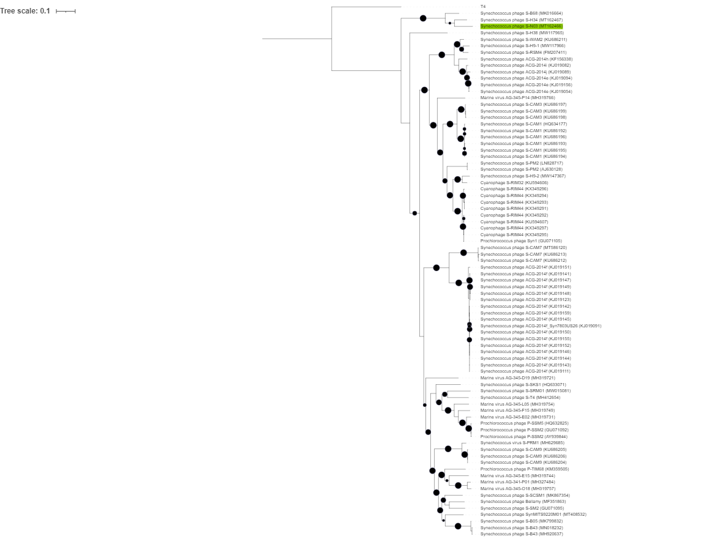

Origin of the name of this taxon:

Named after the road the institute is located on that was the source of isolation. Yushanluvirus satich

Genome summary:

Phage name | INSDC | Size (Kb) | GC% | Protein | tRNA
Synechococcus phage S-H9-2 | MW147367 | 187320 | 40.32 | 204 | 15

VIRIDIC heat map: VIRIDIC (Virus Intergenomic Distance Calculator) heatmap was computed using top hits as identified using mash distance.

Phylogenetic analysis
Phylogeny was constructed from the nucleotide sequence of the terL gene. The top 100 hits were extracted as identified by blastn and T4 terL used as an outgroup. Genes were aligned using MAFFT and trees constructed with Fasttree. Bootstrap values are represented by black circles with the size proportional to percentage from 70-100%. Synechococcus phage S-H9-2 forms a single clade and is sufficiently different based on VIRIDIC analysis to forma a new genus within the family Kyanoviridae

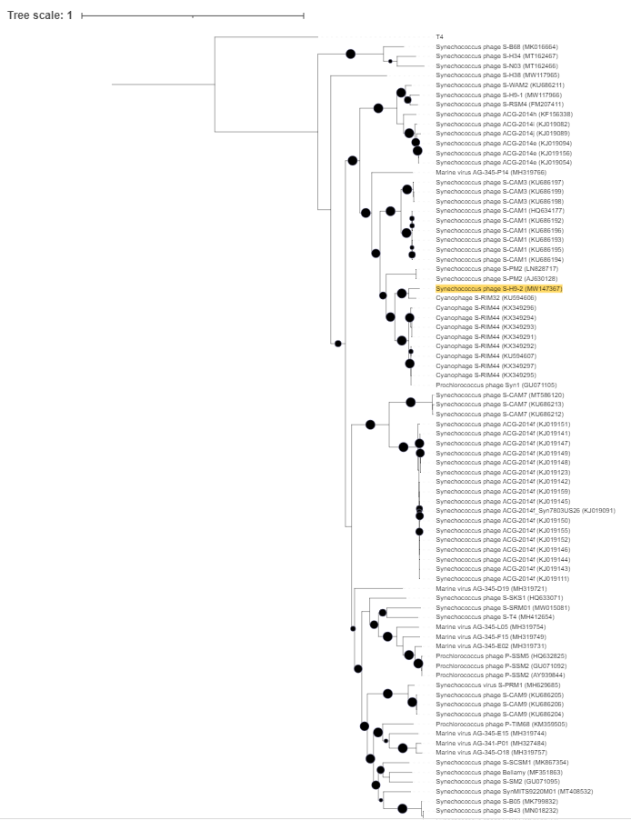
Origin of the name of this taxon:

Named after the mythical sea creature Scylla

Scyllavirus aitchnine

Genome summary:

Phage name | INSDC | Size (Kb) | GC% | Protein | tRNA | Overall % DNA sequence identity (*) | Overall % homologous proteins (**)
Synechococcus phage S-H9-1 | MW117966 | 192454 | 40.994 | 226 | 13

VIRIDIC heat map: VIRIDIC (Virus Intergenomic Distance Calculator) heatmap was computed using top hits as identified using mash distance.

Phylogenetic analysis
Phylogeny was constructed from the nucleotide sequence of the terL gene. The top 100 hits were extracted as identified by blastn and T4 terL used as an outgroup. Genes were aligned using MAFFT and trees constructed with Fasttree. Bootstrap values are represented by black circles with the size proportional to percentage from 70-100%.

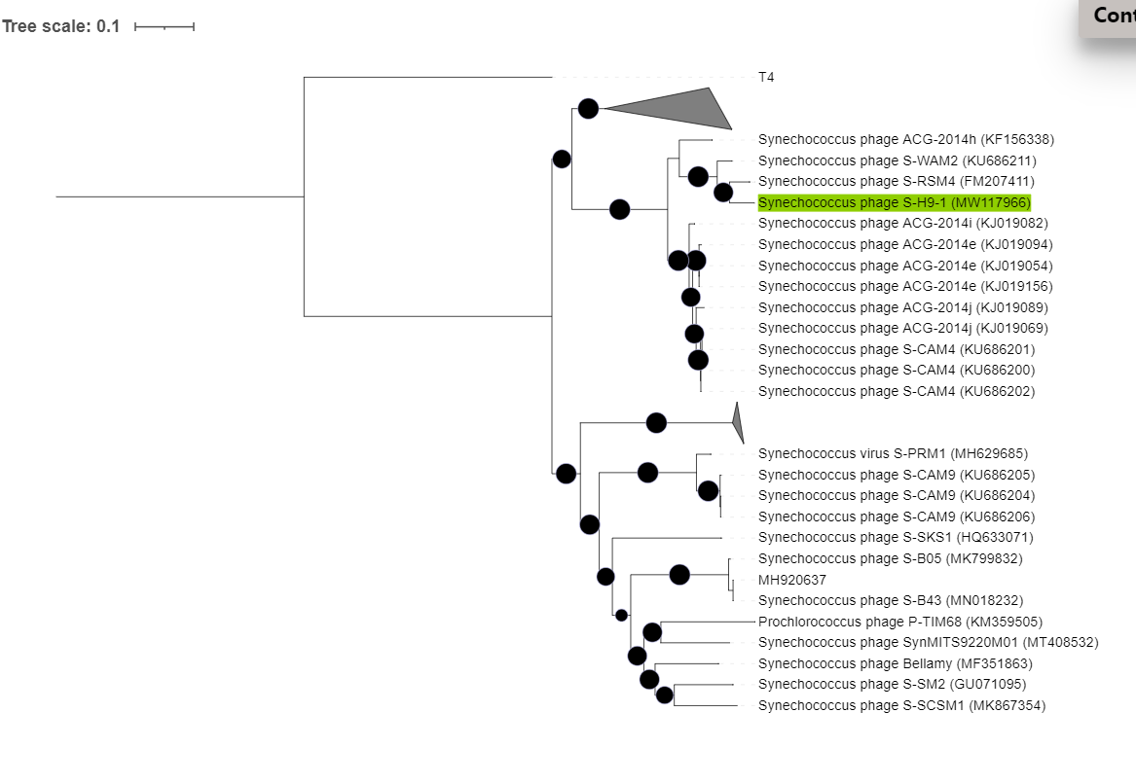

Synechococcus phage S-H9-1 forms a single clade, that is sister to S-RSM4. Based on VIRIDIC analysis the genomes share < 70% nucleotide identity and thus represents a new genus.

Origin of the name of this taxon:

Named after the Institute building where the first isolate was obtained (Zhoulongquan)

Zhoulongquanvirus

Zhoulongquanvirus esscess

Genome summary:

Phage name | INSDC | Size (Kb) | GC% | Protein | tRNA
Synechococcus phage S-SCSM1 | MK867354 | 228827 | 36.842 | 281 | 9

VIRIDIC heat map: VIRIDIC (Virus Intergenomic Distance Calculator) heatmap was computed using top hits as identified using mash distance from INPHARED database(Cook et al. 2021).

A phylogeny was constructed from the nucleotide sequence of the terL gene. The top 100 hits were extracted as identified by blastn and T4 terL used as an outgroup. Genes were aligned using MAFFT and trees constructed with Fasttree. Bootstrap values are represented by black circles with the size proportional to percentage from 70-100%.

Synechococcus phage S-SCSM1 forms a single clade within the Kyanoviridae , based on VIRIDIC analysis none of the genomes in sister clades share >70% ANI, thus supporting the creation of a new genus with S-SCMS1 the sole member.

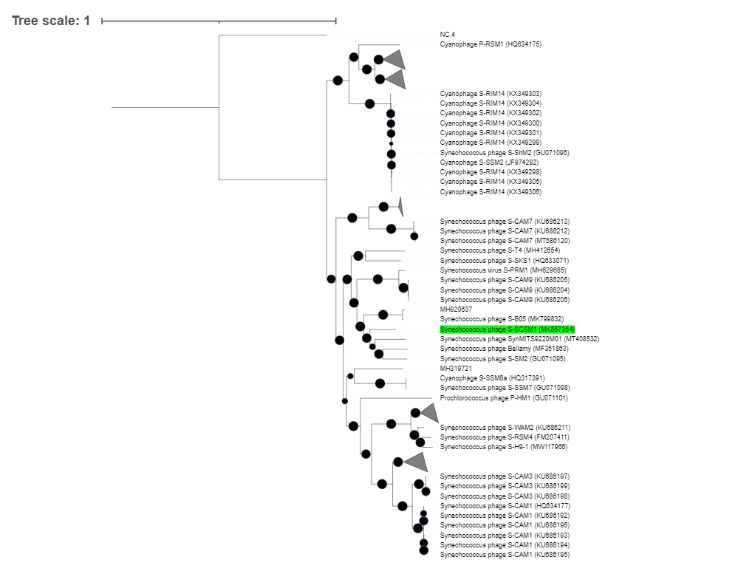
Origin of the name of this taxon:

Named after the location of the reservoir the sample was taken from for phage isolation (Serangoonvirus).

Serangoonvirus essarone

Genome summary:

Phage name | INSDC | Size (Kb) | GC% | Protein | tRNA
Synechococcus phage S-SRM01 | MW015081 | 240842 | 35.642 | 367 | 12

VIRIDIC heat map: VIRIDIC (Virus Intergenomic Distance Calculator) heatmap was computed using genomes that are currently within the genus

A phylogeny was constructed from the nucleotide sequence of the terL gene. The top hits were extracted as identified by blastn and T4 terL used as an outgroup. Genes were aligned using MAFFT and trees constructed with Fasttree. Bootstrap values are represented by black circles with the size proportional to percentage from 70-100%.

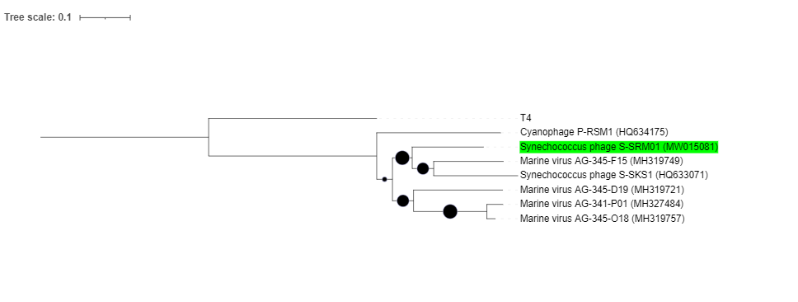

Origin of the name of this taxon:

The Kyanoviridae was recently created and includes all “T4like” cyanophages. The genus Tamkungvirus, remains unclassified at the family level. The similarity of the phage ST4 to other cyanophages places this within the family Kyanoviridae. Phage ST4 is still the only isolate to date within this genus.

Phylogenetic analysis of the terL gene clearly places ST4 with other cyanophages in Kyanoviridae family.

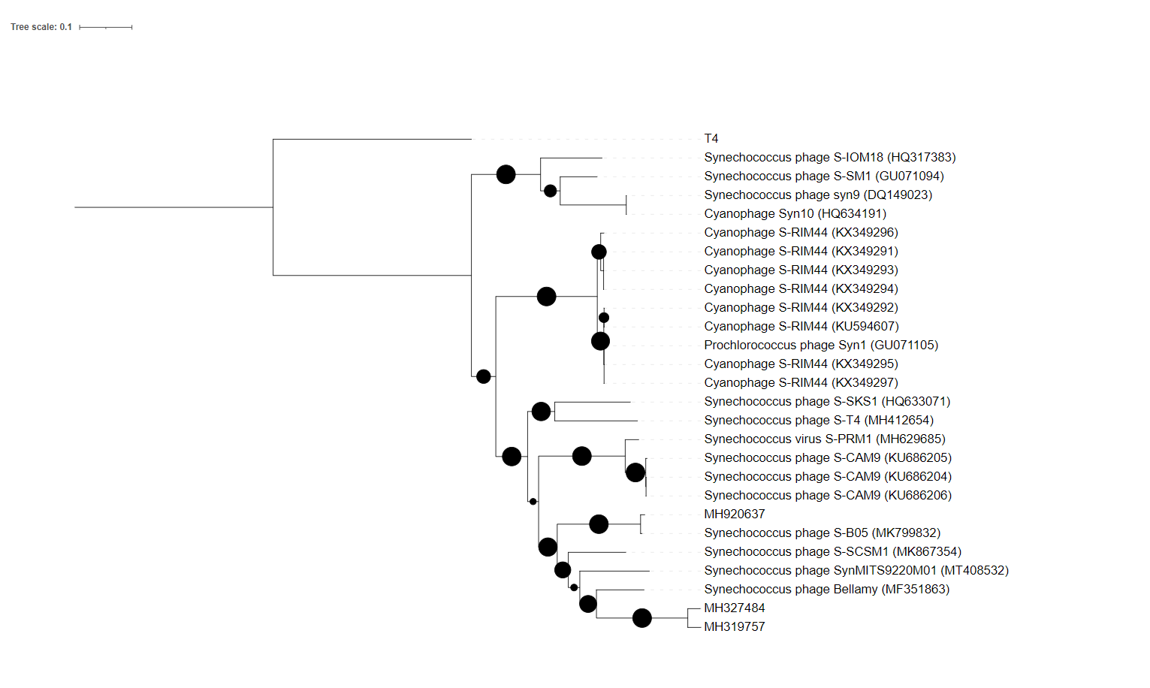

A phylogeny was constructed from the nucleotide sequence of the terL gene. The top hits were extracted as identified by blastn and T4 terL used as an outgroup. Genes were aligned using MAFFT and trees constructed with Fasttree. Bootstrap values are represented by black circles with the size proportional to percentage from 70-100%.

Origin of the name of this taxon:

Named after the location of the site of the sample was taken from for phage isolation (Yellow Sea) .

Yellowseavirus thirtyeight

Genome summary:

Phage name | INSDC | Size (Kb) | GC% | Protein | tRNA
Synechococcus phage S-H38 | MW117965 | 180224 | 42.42 | 214 | 8

VIRIDIC heat map: VIRIDIC (Virus Intergenomic Distance Calculator) heatmap was computed using the most closely related genomes as identified by mash.

A phylogeny was constructed from the nucleotide sequence of the terL gene. The top hits were extracted as identified by blastn and T4 terL used as an outgroup. Genes were aligned using MAFFT and trees constructed with Fasttree. Bootstrap values are represented by black circles with the size proportional to percentage from 70-100%. S-H38 falls with other cyanophages within the family Kyanoviriade, as a single clade. Combined with the lack of genomic similarity as determined by VIRIDIC analysis, represents a new genus.

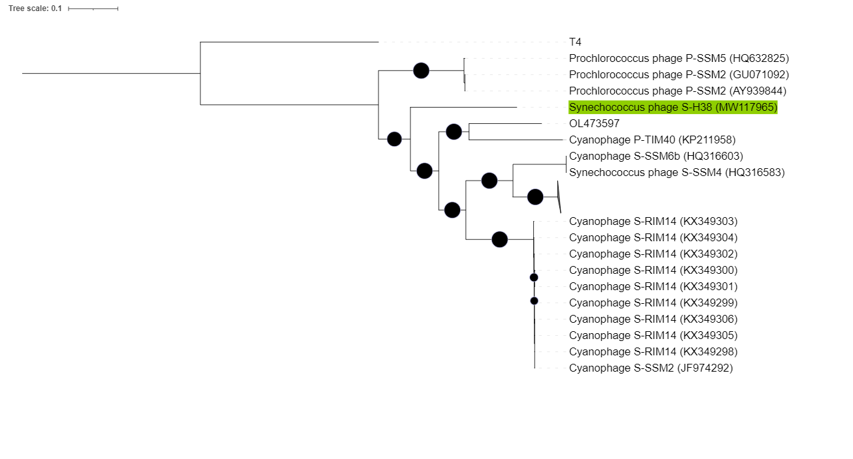

Origin of the name of this taxon:

Named after sandskrit for “sea dragon”, a mythical sea creature that looks different. Makaravirus

Makaravirus thirtyfour

Genome summary:

Phage name | INSDC | Size (Kb) | GC% | CDS | tRNA
Synechococcus phage S-H34 | MT162467 | 167040 | 42.42 | 248 | 5

VIRIDIC heat map: VIRIDIC (Virus Intergenomic Distance Calculator) heatmap was computed using the most closely related genomes as identified by mash comparison

A phylogeny was constructed from the nucleotide sequence of the terL gene. The top hits were extracted as identified by blastn and T4 terL used as an outgroup. Genes were aligned using MAFFT and trees constructed with Fasttree. Bootstrap values are represented by black circles with the size proportional to percentage from 70-100%. S-H34 falls with other cyanophages within the family Kyanoviriade, as a single clade. Combined with the lack of genomic similarity as determined by VIRIDIC analysis, represents a new genus.

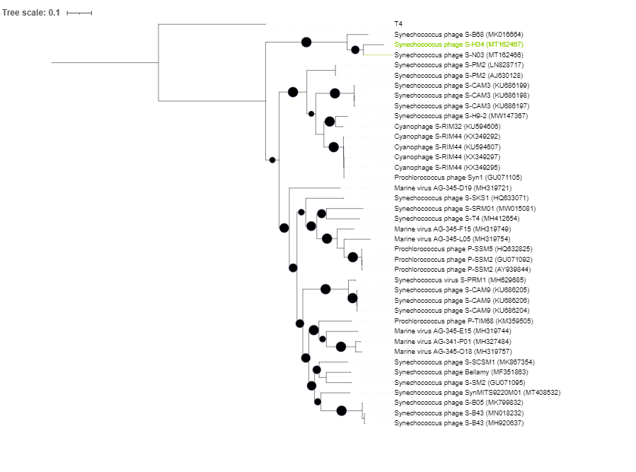

References
- Cook, Ryan, Nathan Brown, Tamsin Redgwell, Branko Rihtman, Megan Barnes, Martha Clokie, Dov J. Stekel, Jon Hobman, Michael A. Jones, and Andrew Millard. 2021. “INfrastructure for a PHAge REference Database: Identification of Large-Scale Biases in the Current Collection of Cultured Phage Genomes.” PHAGE, October. https://doi.org/10.1089/phage.2021.0007.
- Katoh, Kazutaka, and Daron M. Standley. 2013. “MAFFT Multiple Sequence Alignment Software Version 7: Improvements in Performance and Usability.” Molecular Biology and Evolution 30 (4): 772–80.
- Moraru, Cristina, Arvind Varsani, and Andrew M. Kropinski. 2020. “VIRIDIC — A Novel Tool to Calculate the Intergenomic Similarities Of.” Viruses 12: 1268.
- Price, Morgan N., Paramvir S. Dehal, and Adam P. Arkin. 2010. “FastTree 2 – Approximately Maximum-Likelihood Trees for Large Alignments.” PloS One 5 (3): e9490.
- Turner, Dann, Andrew M. Kropinski, and Evelien M. Adriaenssens. 2021. “A Roadmap for Genome-Based Phage Taxonomy.” Viruses 13 (3). https://doi.org/10.3390/v13030506.

