

Part 1: TITLE, AUTHORS, APPROVALS, etc

Code assigned: | 2022.041B
Short title: Create one new species in the genus Janusvirus (Caudoviricetes: Arquatrovirinae)

Author(s) and email address(es)
Ongenae V, Rozen DE, Briegel A, Claessen D, Kropinski AM. | v.m.a.ongenae@biology.leidenuniv.nl;  d.e.rozen@biology.leidenuniv.nl;  a.briegel@biology.leidenuniv.nl;  d.claessen@biology.leidenuniv.nl;  Phage.Canada@gmail.com
Author(s) institutional address(es) (optional)
Leiden University, The Netherlands [VO], [DER], [AB], [DC]
University of Guelph, Canada [AMK]
Corresponding author
Véronique Ongenae
List the ICTV Study Group(s) that have seen this proposal

Bacterial Viruses Subcommittee, Actinophages Study Group

ICTV Study Group comments and response of proposer

ICTV Study Group votes on proposal

Study Group | Number of members
Study Group | Votes support | Votes against | No vote

Authority to use the name of a living person

Is any taxon name used here derived from that of a living person (Y/N) | N

Taxon name | Person from whom the name is derived | Permission attached (Y/N)

Submission dates
Date first submitted to SC Chair | February 2022
Date of this revision (if different to above)
ICTV-EC comments and response of the proposer

Part 2: NON-TAXONOMIC PROPOSAL

Text of proposal

Part 3: TAXONOMIC PROPOSAL
Name of accompanying Excel module
2022.041B.N.v1.Janusvirus_1nsp.xlsx
Abstract

We have proposed a new species, Janusvirus pablito, for a phage (Streptomyces phage Pablito) isolated from host Streptomyces lividans from soil samples in the Netherlands at longitude N52°23’31” and latitude E4°34’49”. This janusvirus contains linear ds DNA genomes of, on average, 48.49 kb (66.4 mol%G+C) and encode for 76 proteins. This new species can be included in the genus Janusvirus together with Streptomyces phage Hank144.
Text of proposal
Species demarcation criteria: Two phages are assigned to the same species if their genomes are more than 95% identical over their genome length for isolates.
These values can be calculated by a number of tools, such as BLASTn [1] – usually calculated using intergenomic distance calculator VIRIDIC [2].

Genus demarcation criteria: In search for criteria that create cohesive and distinct genera that are reproducible and monophyletic, the Bacterial Viruses Subcommittee has established 70% nucleotide identity of the genome length as the cut-off for genera. Genus-level groupings should always be monophyletic in the signature genes, as tested with a phylogenetic tree. [6]

Family demarcation criteria: The family is represented by a cohesive and monophyletic group in the main predicted proteome-based clustering tools (ViPTree, GRAViTy dendrogram, vConTACT2 network). Members of the family share a significant number of orthologous genes (the number will depend on the genome sizes and number of coding sequences of members of the family; usually ca. 10%). [6]

Supporting evidence
Proposals:

- To add one new species (Janusvirus pablito) to Janusvirus

Origin of the name of this taxon: The name of the new species has originated from my dearest British short hair cat, called Pablo.

Historical aspects: This lytic phages was isolated in the Netherlands against Streptomyces lividans. It was originally called phage LA7 [3].

Electron micrograph: N/A

Genome summary:

Phage name | RefSeq No. | INSDC | Size (Kb) | GC% | Protein | Overall % DNA sequence identity (*) | Overall % homologous proteins (**)
Streptomyces phage Janus | NC_054660.1 | MK392366.1 | 50.63 | 67.0 | 78 | 100 | 100
Streptomyces phage Pablito |  | OK412919.1 | 49.49 | 66.4 | 76 | 70.0 | 88.5
Streptomyces phage Hank144 | NC_054661.1 | MH669004.1 | 50.55 | 66.3 | 78 | 72.8 | 85.9

(*) determined using VIRIDIC [2]
(**) determined using CoreGenes 3.5 [5]

VIRIDIC heat map: VIRIDIC (Virus Intergenomic Distance Calculator; VIRIDIC (Virus Intergenomic Distance Calculator; [2]; http://rhea.icbm.uni-oldenburg.de/VIRIDIC/) computes pairwise intergenomic distances/similarities amongst phage genomes.
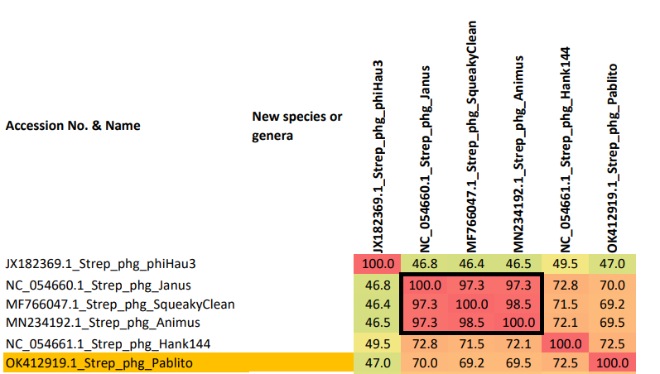

Phylogenetic tree analysis: MEGAX analysis [4] was used to create a phylogenetic tree of the closely related species. The phage of interest is indicated with a red star.

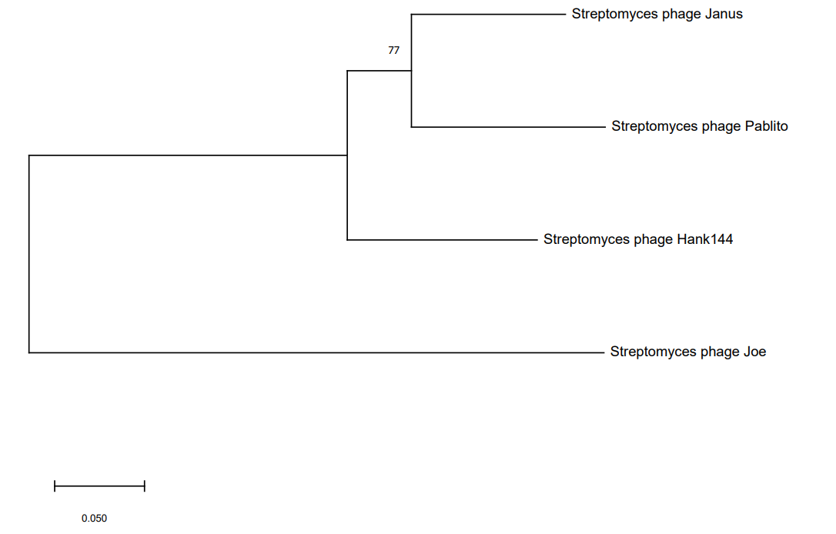
*
Phylogeny: The phylogenetic tree was constructed using the major capsid head proteins from phages belonging to the genus Janusvirus. Streptomyces phage joe was chosen as an outlier. MUSCLE was used for multiple alignment and MEGAX to construct the maximum likelihood phylogenetic tree with 100 bootstraps

References
- Sayers EW, Beck J, Bolton EE, Bourexis D, Brister JR, Canese K, Comeau DC, Funk K, Kim S, Klimke W, Marchler-Bauer A, Landrum M, Lathrop S, Lu Z, Madden TL, O'Leary N, Phan L, Rangwala SH, Schneider VA, Skripchenko Y, Wang J, Ye J, Trawick BW, Pruitt KD, Sherry ST. Database resources of the National Center for Biotechnology Information. Nucleic Acids Res. 2021 Jan 8;49(D1):D10-D17. doi: 10.1093/nar/gkaa892. PMID: 33095870
- Moraru C, Varsani A, Kropinski AM. VIRIDIC-A Novel Tool to Calculate the Intergenomic Similarities of Prokaryote-Infecting Viruses. Viruses. 2020 Nov 6;12(11):1268. doi: 10.3390/v12111268. PMID: 33172115; PMCID: PMC7694805. http://kronos.icbm.uni-oldenburg.de/viridic/
- Ongenae, V., Mabrouk, A. S., Crooijmans, M., Rozen, D., Briegel, A., & Claessen, D. (2021). Reversible bacteriophage resistance by shedding the bacterial cell wall. bioRxiv. doi: https://doi.org/10.1101/2021.11.17.468999
- Sudhir Kumar, Glen Stecher, Michael Li, Christina Knyaz, and Koichiro Tamura (2018) MEGA X: Molecular Evolutionary Genetics Analysis across computing platforms. Molecular Biology and Evolution 35:1547-1549
- Turner D, Reynolds D, Seto D, Mahadevan P. CoreGenes3.5: a webserver for the determination of core genes from sets of viral and small bacterial genomes. BMC Res Notes. 2013;6:140. doi: 10.1186/1756-0500-6-140. PMID: 23566564.
- Turner D, Kropinski AM, Adriaenssens EM. A Roadmap for Genome-Based Phage Taxonomy. Viruses. 2021 Mar 18;13(3):506. doi: 10.3390/v13030506. PMID: 33803862; PMCID: PMC8003253.

