

Part 1: TITLE, AUTHORS, APPROVALS, etc

Code assigned: | 2022.026B
Short title: Create one new species in the genus Copernicusvirus, subfamily Sarlesvirinae (Caudoviricetes: Rountreeviridae)

Author(s) and email address(es)
Łobocka M, Stefańczyk E, Adriaenssens EM, Kropinski AM, Turner D | lobocka@ibb.waw.pl;  e.stefanczyk@ibb.waw.pl;  evelien.adriaenssens@quadram.ac.uk;  Phage.Canada@gmail.com; dann2.turner@uwe.ac.uk
Author(s) institutional address(es) (optional)
Institute of Biochemistry and Biophysics of the Polish Academy of Sciences Poland [MŁ]
Institute of Biochemistry and Biophysics of the Polish Academy of Sciences Poland [ES]
Quadram Institute Bioscience, UK [EMA]
University of Guelph, Canada [AMK]
University of the West of England [DT]
Corresponding author
Malgorzata Łobocka
List the ICTV Study Group(s) that have seen this proposal

Salasmaviridae, Rountreeviridae, Guelinviridae Study Group, Bacterial Viruses Subcommittee
ICTV Study Group comments and response of proposer
ICTV Study Group votes on proposal
Study Group | Number of members
Study Group | Votes support | Votes against | No vote
 | 2 | 0 | 0

Authority to use the name of a living person

Is any taxon name used here derived from that of a living person (Y/N) | N

Taxon name | Person from whom the name is derived | Permission attached (Y/N)

Submission dates
Date first submitted to SC Chair | May 2022
Date of this revision (if different to above)
ICTV-EC comments and response of the proposer

Part 2: NON-TAXONOMIC PROPOSAL

Text of proposal

Part 3: TAXONOMIC PROPOSAL

Name of accompanying Excel module
2022.026B.N.v1.Copernicusvirus_1nsp.xlsx
Abstract

In a complete review of the enterococcal phages belonging to the Sarlesvirinae subfamily of Rountreeviridae using VIRIDIC and ViPTree we have discovered one more species in the genus Copernicusvirus. These phages share almost all properties with other phages of this genus, but differ significantly enough (less than 95% identity with phages of other Copernicusvirus species) to classify them as separate species of this genus.

Text of proposal
Species demarcation criteria: We have chosen 95% DNA sequence identity as the criterion for demarcation of species in this new genus. Each of the proposed species differs from the others with more than 5% at the DNA level as confirmed with the BLASTN and Viridic algorithm

Supporting evidence

History: This genus was established via Taxonomy Proposal 2020.140B.R.Rountreeviridae.zip

Specific References: None. References concerning general description of Copernicusvirus genus were included in Taxonomy Proposal 2020.140B.R.Rountreeviridae.zip.

GenBank Summary:

Phage name | RefSeq No. | INSDC | Size (Kb) | GC% | Protein | tRNAs* | Overall % DNA sequence identity (**) | Overall % homologous proteins (***)
MDA1 |  | MW623430 | 18.06 | 33.0 | 25 | 0 | 85.6 | 88.0

N.B. Exemplar representative of Copernicusvirus genus is Enterococcus phage vB_Efae230P-4 (JQ309827.1).
(*) determined using RNAscan-SE [1]
(**) determined using Viridic [2] and compared to Enterococcus phage vB_Efae230P-4
(***) determined using CoreGenes 5.0 [3,4] and compared to Enterococcus phage vB_Efae230P-4

BLASTN homologs: VIRIDIC analysis reveals that the closest relative besides other phages of Copernicusvirus genus is Enterococcus virus v_EfaP_IME199 [KT945995.1] of Minhovirus genus of Sarlesvirinae subfamily, Rountreeviridae family. It shares 21% DNA sequence with Enterococcus phage MDA1.

VIRIDIC heat map: VIRIDIC (Virus Intergenomic Distance Calculator; [2]) computes pairwise intergenomic distances/similarities amongst phage genomes. The comparison below provides the results of DNA sequence comparison of strains of known and proposed new species of enterococcal Copernicusvirus genus phages. The phage names correspond to phages of existing species or, when indicated by an arrow, to newly proposed species that will be added through this TaxoProp.

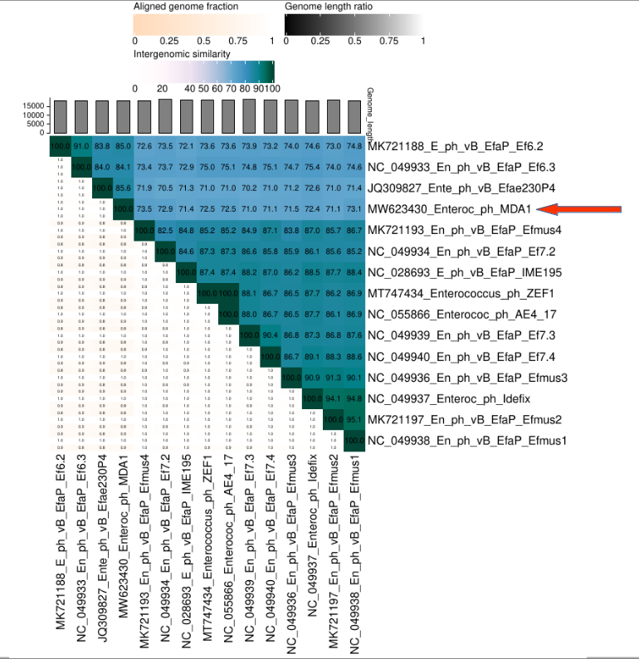

ViPTree analysis: ViPTree analysis (https://www.genome.jp/viptree/; [5]) is based upon Rohwer and Edwards (2002) famous Phage Proteomic Tree [6]. The red asterisk points to the new species of Copernicusvirus genus. The red and blue arrowhead point to Copernicusvirus genus and to Sarlesvirinae subfamily, respectively.

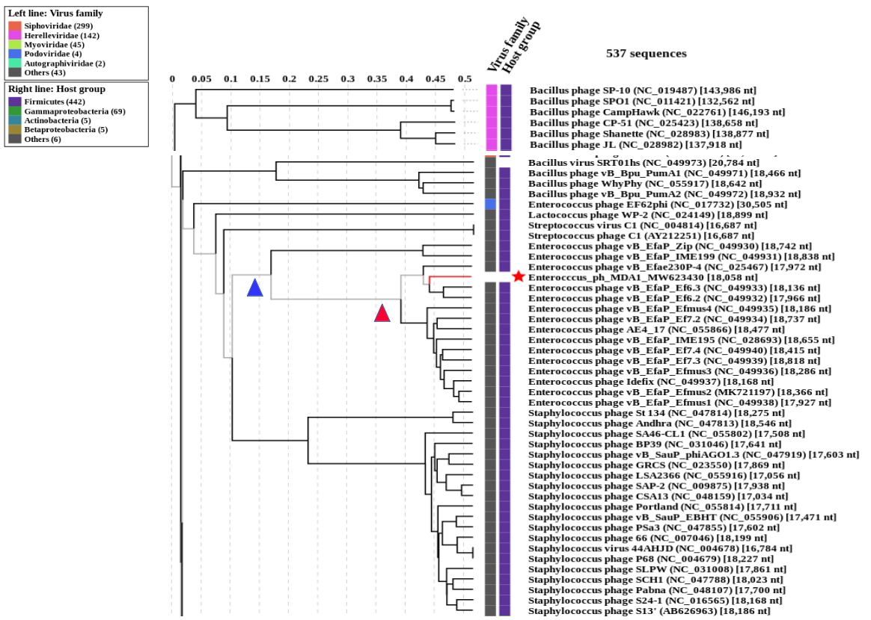

Phylogeny: The phylogenetic trees weres constructed using the major capsid protein and DNA polymerase homologs of Enterococcus phage MDA1 and related phages by employing the Tamura–Nei genetic distance model and a neighbour-joining tree-build method using the Geneious Tree Builder included in the Geneious Prime 2022 software. As an outgroup, a sequence of corresponding gene (DNA polymerase or major head/capsid protein) of closely related species was used, that was selected based on prior VipTree results. Proteins of phages of proposed new species are pointed with arrows.

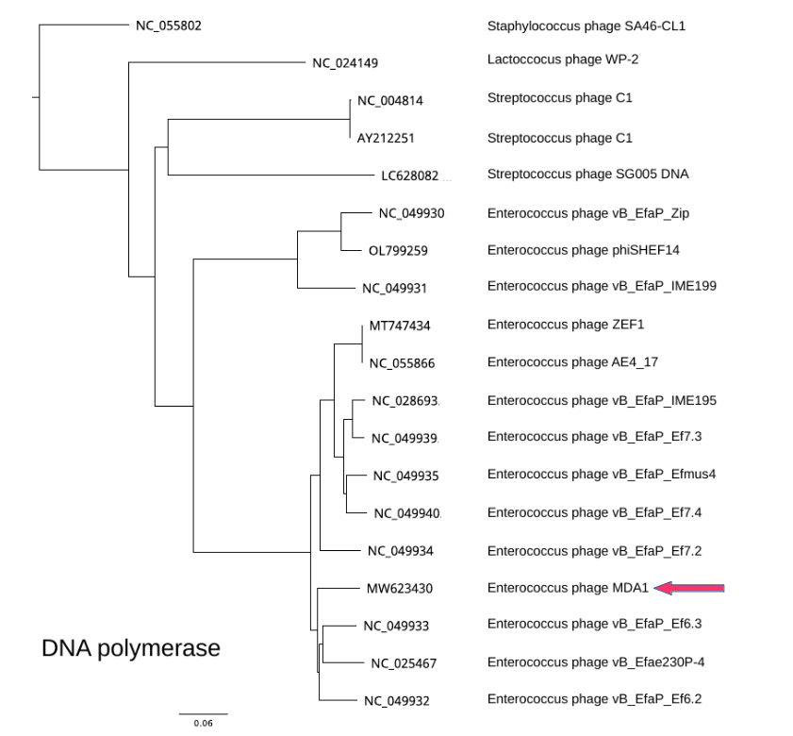

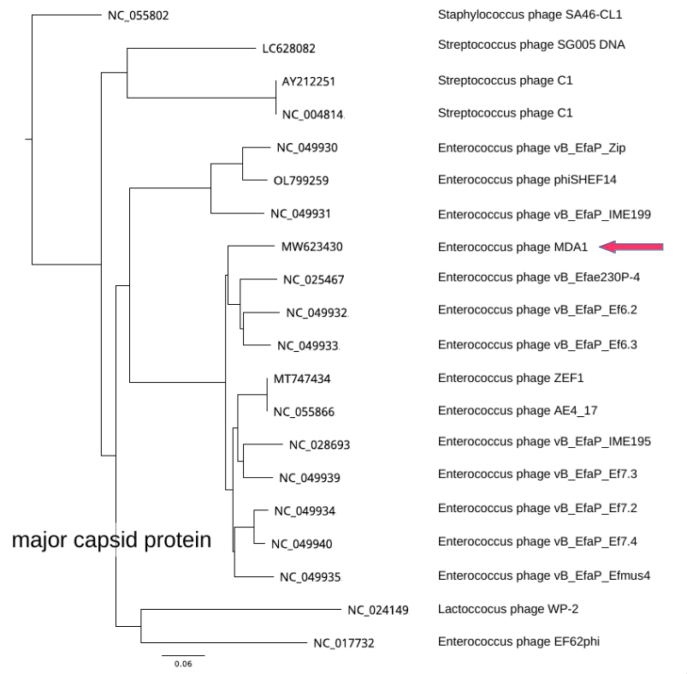

References
1: Chan PP, Lowe TM (2019) tRNAscan-SE: Searching for tRNA Genes in Genomic Sequences. Methods Mol Biol 1962:1-14. https://doi.org/10.1007/978-1-4939-9173-0_1. PMID: 31020551.

2: Moraru C (2020) VIRIDIC (Virus Intergenomic Distance Calculator) computes pairwise intergenomic distances/similarities amongst phage genomes. http://kronos.icbm.uni-oldenburg.de/viridic/
3: Turner D, Reynolds D, Seto D, Mahadevan P. (2013) CoreGenes3.5: a webserver for the determination of core genes from sets of viral and small bacterial genomes. BMC Res Notes 6:140. https://doi.org/10.1186/1756-0500-6-140. PMID: 23566564.

4: Contreras-Moreira, B., & Vinuesa, P. (2013). GET_HOMOLOGUES, a versatile software package for scalable and robust microbial pangenome analysis. Appl Environ Microbiol 79:7696-7701.

5: Nishimura Y, Yoshida T, Kuronishi M, Uehara H, Ogata H, Goto S. ViPTree: the viral proteomic tree server. (2017) Bioinformatics 33:2379-2380. https://doi.org/10.1093/bioinformatics/btx157. PubMed PMID: 28379287.

6: Rohwer F, Edwards R (2002) The Phage Proteomic Tree: a genome-based taxonomy for phage. J Bacteriol 184:4529-35. PubMed PMID: 12142423

