

Part 1: TITLE, AUTHORS, APPROVALS, etc

Code assigned: | 2022.021B
Short title: Create one new genus (Certevirus) including one new species (Caudoviricetes)

Author(s) and email address(es)

Grami E, Saidi N | emna.grami@gmail.com;  neila_saidi@yahoo.fr
Author(s) institutional address(es) (optional)
Center of Research and Water Technologies (CERTE)
University of Carthage
Science faculty of Bizerta
Corresponding author
Emna Grami
List the ICTV Study Group(s) that have seen this proposal
ICTV Caudovirales Study Group, Bacterial and Archaeal Viruses Subcommittee

ICTV Study Group comments and response of proposer
Direct submission to the SC Chair.
Comments: Format proposal according to guidelines. Choose names for species and genus that are compliant with the Code. Genus should be placed directly in class Caudoviricetes because family Myoviridae is being abolished.
ICTV Study Group votes on proposal
Study Group | Number of members
Study Group | Votes support | Votes against | No vote
Authority to use the name of a living person
Is any taxon name used here derived from that of a living person (Y/N)

Taxon name | Person from whom the name is derived | Permission attached (Y/N)
Submission dates
Date first submitted to SC Chair | January 2022
Date of this revision (if different to above) | October 2022
ICTV-EC comments and response of the proposer
Typo in Excel file fixed.

Part 2: NON-TAXONOMIC PROPOSAL
Text of proposal

Part 3: TAXONOMIC PROPOSAL
Name of accompanying Excel module
2022.021B.A.v2.Certevirus_ng.xlsx
Abstract
Create a genus for the isolated phage Pd_C23 infecting Pantoea dispesa (OL396571.1).
(No phages infecting P. dispersa have been reported yet, it will be the first p. dispersa phage classified within the new Genus proposal).
Text of proposal
Genus demarcation criteria
- Based on Bacterial Virus Subcommittee standards as a cohesive group of viruses sharing a high degree (>70%) of nucleotide identity of the whole genome length [1], Pd_C23 nt % similarity with any other phage genome ranges below 70%.
-Monophyletic groupings tested with generated phylogenetic tree.

Species demarcation
There is only one phage in this proposed genus, which will be the exemplar for the new species. New species in the genus will differ in their genome with at least 5% over the entire genome length.

Supporting evidence
Pantoea phage Pd_C23 characteristics:
Size:44714 pb / GC content: 49.66 % / tRNAs:1 / coding sequences: 49%

- A total genome BLASTn [1] showed similarities with mostly unclassified partial genome phages, and one complete genome classified Klebsiella phage VB chronis (MN013086.1) Multiple Sequence Alignment showed no significant similarity hits apart from the beginning part (6500pb) of the genome for all best hits (Fig. 1).
Pairwise alignment between Pd_C23 (OL396571.1) and Best Hits of the Query Sequence is generated [2], Neighbor joining tree generated by NCBI was reconstructed using Mega11 [3] Molecular Evolutionary Genetic analysis program (MEGA11), Max Seq Difference (0.5), scale: 0.02, it shows that the phage shares no branches with any existing sequence. (Fig. 2),

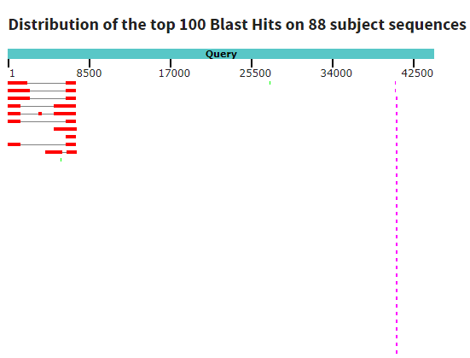
Fig 1. Graphic summary of the whole phage genome Pd_C23 with best hits according (NCBI new MSA Viewer)

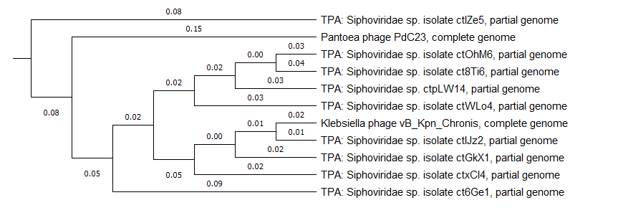

Fig 2. Whole genome Neighbor joining tree representation of BLAST pairwise alignment of Pd_C23 OL396571.1 and blasted best hits by Mega11 of Pd_C23 (OL396571.1).
(Numbers on the Branches indicates the lengths Max Seq Difference (0.5), scale: 0.02)

- Thus, based on BLASTn sequence homologies PD_C23 shares several regions of nucleotide similarity with Klebsiella phage vB_Kpn_Chronis, in total the first 23 ORFs among 75 ORFs share similarities with the totally sequenced genome of Klebsiella phage vB_Kpn_Chronis (MN013086.1) that infects the bacteria Klebsiella pneumoniae.
P. dispersa phage Pd_C23 consensus genome is 50.6% similar to that of Kpn-Chronis. Pantoea phage Pd_C23 complete genome is 44,715 pb (GC content % 49.66), Klebsiella phage vB_Kpn_Chronis is 45,702 pb (GC content % 52.2).
Genetic distances between Pd_C23 and Kpn vB chronis phage between the two phages is verified, pairwise sequence identities and similarities are calculated using the Webserver SIAS: (http://imed.med.ucm.es/Tools ) [4]. Along with four other blasted best hits phages. (Fig.3)
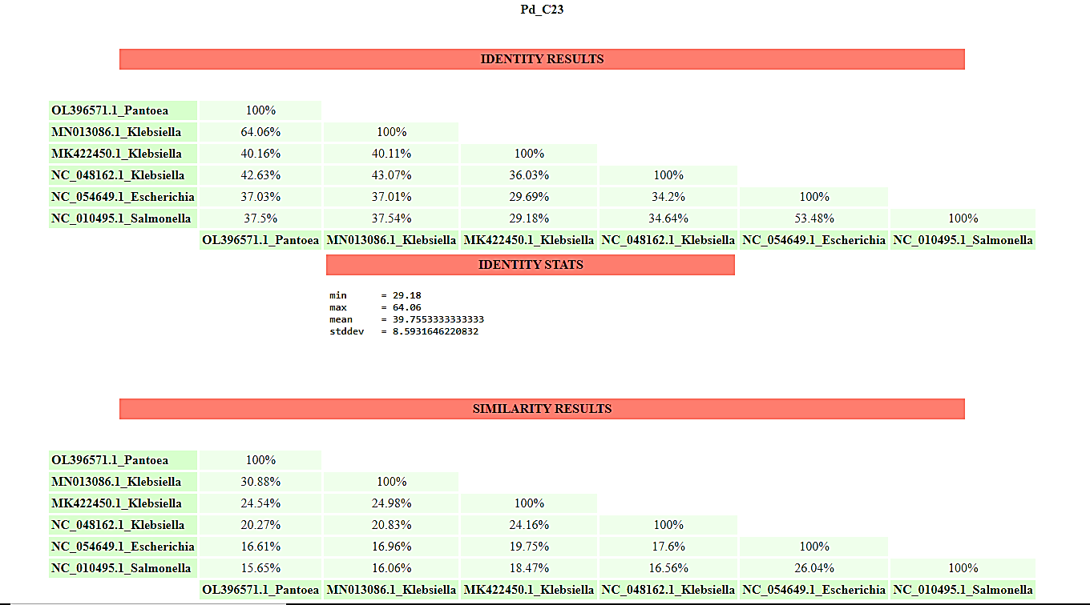

Fig 3. Photo representing the Pairwise sequence identities and similarities values of whole genome of Pd_C23 calculated along with five complete genomes phages blasted best hits phages using the Webserver SIAS: (http://imed.med.ucm.es/Tools)

- Nucleotide and amino acid identity heat map between Pd_C23 whole genome, best hits and with gene markers is calculated (Fig. 4) using a Software package (Clustal Omega (RRID:SCR_001591) as multiple sequence alignment tool between multiple sequences.
URL: http://www.ebi.ac.uk/Tools/msa/clustalo/

Although, a connection is found between eleven caudovirales phages, they remain far relatives since the Nucleotide Identity between genus is described as a cohesive group of viruses sharing a high degree (>70%) of nucleotide identity of the whole genome length [5]. Along with Pd_C23 embody a distant branch on the neighbor joining tree (Fig. 2).

Fig 4. Nucleotide and amino acid identity heat map between Pd_C23 whole genome and eleven best hits (NA: not available)

- Viral proteomic tree using VipTree based on maximum likelihood method of whole genomic nucleotide sequences of 11 selected dsDNA viruses, among Myoviridae, siphoviridae, podoviridae, autographiviridae [6], has been generated (ViPTree - The Viral Proteomic Tree Server), it revealed further information about the phylogenetic positions of Pd_C23 (Fig. 5).

We consider that Pd_C23 cannot be classified to any genus currently recognized by ICTV considering that the phylogenetic relationship analysis showed no significant closeness with any existing genus and that it represents a new genus.

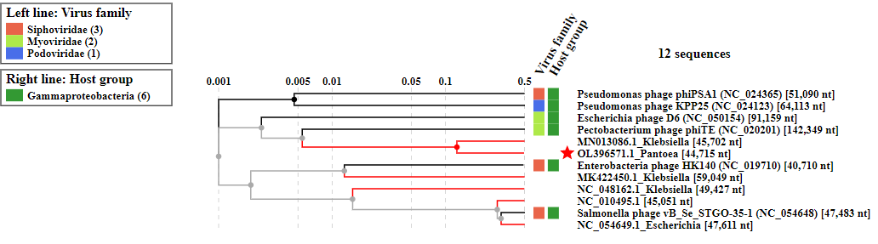

Fig 5. Viral proteomic tree of Pd_C23 based on maximum likelihood method of whole genomic nucleotide sequences of elven selected blasted best hits (dsDNA viruses). ViPTree analysis was obtained MLM analysis heuristic search with 12 bootstrap replicates. Branch lengths are logarithmically scaled, the log scaled is represented by the numbers on top representing the SG values ((normalized scores by blastx).

Origin of the new genus name: Certevirus (After the institute name: CERTE)

References

- NCBI 2021 Resource Coordinators. Database resources of the National Center for Biotechnology Information. Nucleic Acids Res. PMID: 29140470. DOI: 10.1093/nar/gkx1095

- Katoh K, Rozewicki J, Yamada KD (2019) (Briefings in Bioinformatics 20:1160-1166). MAFFT online service: multiple sequence alignment, interactive sequence choice and visualization. PMID: 28968734. DOI: 10.1093/bib/bbx108

- Tamura K, Stecher G, and Kumar S (2021) MEGA11: Molecular Evolutionary Genetics Analysis version 11. Molecular Biology and Evolution 38:3022-3027.
https://doi.org/10.1093/molbev/msab120

- Cai L, Ma H, (2016) Using nuclear genes to reconstruct angiosperm phylogeny at the species level: A case study with Brassicaceae species. journal of Systematics and Evolution 54(4). https://doi.org/10.1111/jse.12204.

- Turner D, Kropinski A M, Adriaenssens E M (2021) A roadmap for genome-based phage taxonomy. Viruses 2021, 13, 506. PMID: 33803862. doi: 10.3390/v13030506

- Nishimura Y et al (2017) ViPTree: the viral proteomic tree server.Bioinformatics, 33, 2379–2380, doi:10.1093/bioinformatics/btx157.

