

Part 1: TITLE, AUTHORS, APPROVALS, etc

Code assigned: | 2022.020B
Short title: Create one new species in the genus Teetrevirus (Autographiviridae) and one new species in the genus Felixounavirus (Caudoviricetes)
Author(s) and email address(es)
Imklin N, Sriprasong P, Nasanit R | faiimklin@gmail.com; sriprasong_p@su.ac.th; nasanit_r@su.ac.th
Author(s) institutional address(es) (optional)
Department of Biotechnology, Silpakorn University, Thailand [NI, PS, RN]

Corresponding author
Rujikan Nasanit

List the ICTV Study Group(s) that have seen this proposal
ICTV Study Group comments and response of proposer
ICTV Study Group votes on proposal
Study Group | Number of members
Study Group | Votes support | Votes against | No vote

Authority to use the name of a living person

Is any taxon name used here derived from that of a living person (Y/N) | N

Taxon name | Person from whom the name is derived | Permission attached (Y/N)

Submission dates
Date first submitted to SC Chair | Feb 16, 2022
Date of this revision (if different to above)
ICTV-EC comments and response of the proposer
Part 2: NON-TAXONOMIC PROPOSAL
Text of proposal

Part 3: TAXONOMIC PROPOSAL
Name of accompanying Excel module
2022.020B.N.v1.Caudoviricetes_2nsp.xlsx
Abstract

Genomes of Salmonella phage vB_SAg-RPN15 and Salmonella phage vB_SAg-RPN213 were fully sequenced and identified as two novel species to be included in the genus Teetrevirus and Felixounavirus, respectively.

Text of proposal
Species demarcation criteria:
We have chosen 95% DNA sequence identity as the criterion for demarcation of species in a genus. Each of the proposed species differs from the others with more than 5% at the DNA level as confirmed with the BLASTN algorithm.

Supporting evidence

Proposal 1: To create new species Salmonella virus RPN15 in the genus Teetrevirus (Autographiviridae)

History: Salmonella phage vB_SAg-RPN15 was isolated from a drain water sample collected from an open market in Nakhon Pathom province, Thailand. Phage isolation and propagation used Salmonella Agona CBn15 that was isolated from a chicken intestine.

vB_SAg-RPN15 virions have icosahedral heads (head length = 58.0±3.8 nm; head width = 55.9±2.1 nm) and short non-contractile tails (tail length = 11.7±1.8 nm; tail diameter = 12.0±1.9 nm)

GenBank Summary: Salmonella phage vB_SAg-RPN15 and its closely related sequences in Teetrevirus [1]

Phage name | RefSeq | INSDC | Size (kb) | GC% | No. of CDSs | No. tRNA | % nt seq. ident. with RPN15  **
Citrobacter phage SH2 | NC_031092.1 | KU687348.1 | 39.16 | 50.7 | 53 | 0 | 90.20
Klebsiella phage 31 | - | MN149904.1 | 39.6 | 50.4 | 46 | 0 | 86.99
Citrobacter phage phiCFP-1 | NC_028880.1 | KP313531.1 | 38.63 | 50.3 | 43 | 0 | 86.51
Klebsiella phage Kpn-11mx | - | MW296877.1 | 38.77 | 50.8 | 49 | 0 | 86.22
Klebsiella phage KPP-5 | - | MW600722.1 | 38.25 | 50.8 | 40 | 0 | 85.98
Klebsiella phage vB_KpnP_Emp27 | - | MN013074.1 | 38.6 | 50.7 | 45 | 0 | 85.81
Enterobacter phage E-4 | - | KP791807.1 | 39.14 | 50.5 | 52 | 0 | 85.29
Yersinia phage phiYe-F10 | NC_047755.1 | KT008108.1 | 39.21 | 50.7 | 46 | 0 | 85.05
Escherichia phage ECA2 | NC_047766.1 | KX130726.1 | 38.89 | 50.5 | 47 | 0 | 84.25
Enterobacter phage E-2 | NC_029102.1 | KP791805.1 | 36.05 | 50.6 | 41 | 0 | 83.63
Salmonella phage vB_SAg-RPN15 | - | OL800605.1 | 38.5 | 50.4 | 47 | 0*
* Aragorn (v1∙2∙41) was employed to find tRNAs on the genome (http://www.ansikte.se/ARAGORN/) [2]
** The overall nucleotide identity was obtained by PAirwise Sequence Comparison (PASC) [3]

BLASTN homologs: A neighbour joining tree between complete genome sequence of Salmonella phage vB_SAg-RPN15 and its closely related sequences in Teetrevirus was constructed on the basis of BLASTN analysis at NCBI.

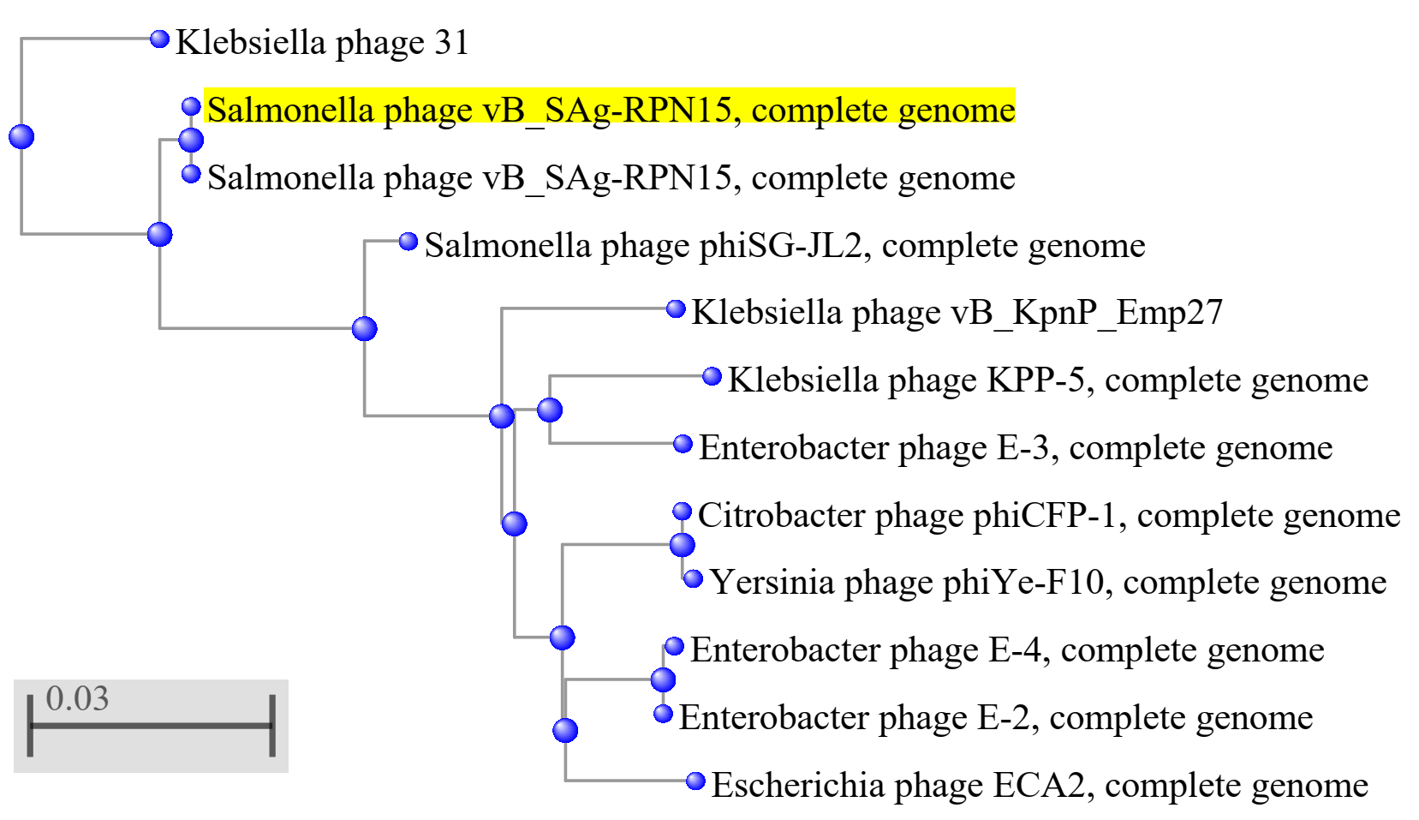

Phylogeny: Phylogenetic analyses of the major capsid proteins (A) and terminase large subunit (B) of Salmonella phage vB_SAg-RPN15, other closely related phages in Teetrevirus and other genera All sequences were aligned using MUSCLE [4]. The trees were constructed by MEGA7 [5] running on neighbor-joining method with 1,000 bootstrap replication [6]. Numbers on branches represent the bootstrap percentage greater than 50%.

A) MCP

B) TerL

Proposal 2: To create new species Salmonella virus RPN213 in the genus Felixounavirus

History: Salmonella phage vB_SAg-RPN213 was isolated from a drain water sample collected from an open market in Nakhon Pathom province, Thailand. Phage isolation and propagation used Salmonella Agona Pco213 that was isolated from a pig intestine.

vB_SAg-RPN213 virions have icosahedral heads (head length = 67.0±2.3 nm; head width = 63.5±2.3 nm) and long contractile tails (tail length = 107.8±4.9 nm; tail diameter = 17.0±2.5 nm)

GenBank Summary: Salmonella phage vB_SAg-RPN213 and its closely related sequences in Felixounavirus [1]

Phage name | RefSeq | INSDC | Size (kb) | GC% | No. of CDSs | No. tRNA | % nt seq. ident. with RPN213  **
Salmonella phage ph2-2 | - | OL474141.1 | 85.94 | 38.8 | 128 | 0 | 92.27
Salmonella phage D1-2 | - | MN481367.1 | 86.88 | 38.7 | 128 | 23 | 91.60
Salmonella phage BPSELC-1 | - | MN227145.1 | 87 | 38.8 | 125 | 19 | 91.45
Salmonella phage BPS17W1 | NC_042097.1 | MG646669.1 | 87.61 | 38.8 | 129 | 0 | 91.42
Salmonella phage BPS17S6 | - | MG646671.1 | 87.63 | 38.8 | 129 | 0 | 91.41
Salmonella phage vB Seyj1-1 | - | MW423797.1 | 88.8 | 38.7 | 129 | 0 | 90.38
Escherichia phage JN01 | - | MN882542.1 | 88.36 | 38.8 | 97 | 0 | 90.05
Salmonella phage BPS17L1 | NC_042096.1 | MG646672.1 | 84.92 | 38.9 | 126 | 0 | 89.85
Escherichia phage finno | - | MN850619.1 | 87.54 | 38.9 | 123 | 24 | 89.05
Salmonella phage vB_SPuM_SP116 | NC_027329.1 | KP010413.1 | 87.51 | 38.8 | 126 | 22 | 88.71
Salmonella phage vB_SAg-RPN213 | - | OL800606.1 | 86.12 | 38.7 | 131 | 22*
* Aragorn (v1∙2∙41) was employed to find tRNAs on the genome (http://www.ansikte.se/ARAGORN/) [2]
** The overall nucleotide identity was obtained by PAirwise Sequence Comparison (PASC) [3]

BLASTN homologs: A neighbour joining tree between complete genome sequence of Salmonella phage vB_SAg-RPN213 and its closely related sequences in Felixounavirus was constructed on the basis of BLASTN analysis at NCBI.

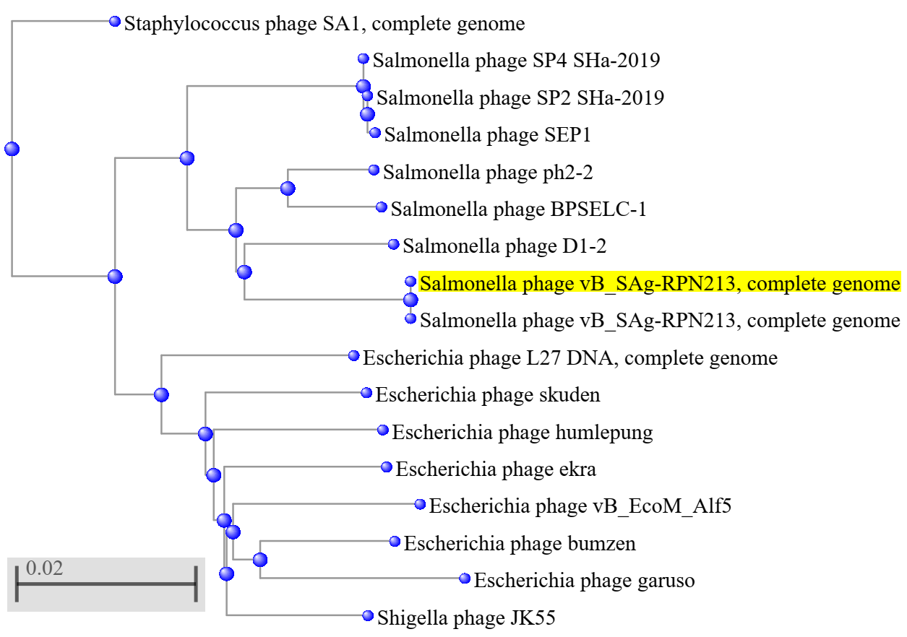

Phylogeny: Phylogenetic analyses of the major capsid proteins (A) and terminase large subunit (B) of Salmonella phage vB_SAg-RPN213, other closely related in Felixounavirus and other genera. All sequences were aligned using MUSCLE [4]. The trees were constructed by MEGA7 [5] running on neighbor-joining method with 1,000 bootstrap replication [6]. Numbers on branches represent the bootstrap percentage greater than 50%.

A) MCP

B) TerL

References
1. Sayers EW, Beck J, Brister JR, Bolton EE, Canese K, Comeau DC, et al. (2020) Database resources of the National Center for Biotechnology Information. Nucleic Acids Res 48:D9-D16. doi: 10.1093/nar/gkz899. PMID: 31602479.

2. Laslett D, Canback B (2004) ARAGORN, a program to detect tRNA genes and tmRNA genes in nucleotide sequences. Nucleic Acids Res 32: 11–16. DOI: 10.1093/nar/gkh152. PMID: 14704338

3. Bao Y, Chetvernin V, Tatusova T (2014) Improvements to pairwise sequence comparison (PASC): a genome-based web tool for virus classification. Arch Virol 159: 3293–3304. DOI: 10.1007/s00705-014-2197-x. PMID: 25119676

4. Edgar RC (2004) MUSCLE: multiple sequence alignment with high accuracy and high throughput. Nucleic Acids Res 32:1792–1797. DOI: 10.1093/nar/gkh340.

5. Kumar S, Stecher G, Tamura K (2016) MEGA7: Molecular Evolutionary Genetics Analysis version 7.0 for bigger datasets. Mol Biol Evol 33: 1870–1874. DOI: 10.1093/molbev/msw054. PMID: 27004904

6. Felsenstein J (1985) Confidence limits on phylogenies: an approach using the bootstrap. Evolution 39:783–791. DOI: 10.2307/2408678.

