

.
Part 1: TITLE, AUTHORS, APPROVALS, etc

Code assigned: | 2022.009B
Short title: Create a new genus (Axeltriavirus) containing one species in the class Caudoviricetes
Author(s) and email address(es)
McCutcheon JG, Lin A, Dennis JJ | jgmccutc@ualberta.ca; alin3@ualberta.ca; jon.dennis@ualberta.ca
Author(s) institutional address(es) (optional)
Department of Biological Sciences, University of Alberta [JGM, AL, JJD]

Corresponding author
Jaclyn McCutcheon
List the ICTV Study Group(s) that have seen this proposal
Caudoviricetes Study Group, Bacterial Viruses subcommittee

ICTV Study Group comments and response of proposer

ICTV Study Group votes on proposal

Study Group | Number of members
Study Group | Votes support | Votes against | No vote
Authority to use the name of a living person
Is any taxon name used here derived from that of a living person (Y/N) | N

Taxon name | Person from whom the name is derived | Permission attached (Y/N)
Submission dates
Date first submitted to SC Chair | April 19 2022
Date of this revision (if different to above)
ICTV-EC comments and response of the proposer

Part 2: NON-TAXONOMIC PROPOSAL
Text of proposal

Part 3: TAXONOMIC PROPOSAL
Name of accompanying Excel module
2022.009B.N.v1.Axeltriavirus_ng.xlsx
Abstract
We recently isolated a novel bacteriophage, vB_SmaS-AXL_3, with limited nucleotide sequence identity to known phages. We propose the creation of a new genus, Axeltriavirus, containing the new species Axeltriavirus AXL3, named after this phage.

Text of proposal
Species demarcation criteria: Two phages are assigned to the same species if they are share at least 95% DNA sequence identity over their genomes. This may be calculated by tools such as BLASTn [1] or VIRIDIC [2].

Genus demarcation criteria: Aligning with the Bacterial Viruses Subcommittee recommendations [3], 70% nucleotide identity along the full length of the genome is required for phages to belong within the same genus, calculated in the same way as for the species cut-off.

Source of the genus name: Axeltriavirus is derived from the name of the first phage isolated of its type, Stenotrophomonas phage vB_SmaS-AXL_3.

History: Isolated from soil by Andrea Lin and characterized by Jaclyn McCutcheon (University of Alberta, Edmonton, Canada) for its ability to lyse Stenotrophomonas maltophilia, phage AXL3 is a siphovirus with a B1 morphotype as shown in transmission electron micrographs. AXL3 has a relatively narrow host range, showing evidence of cell lysis on 5/29 clinical S. maltophilia isolates tested. This phage forms small, clear plaques with clear borders approximately 0.78mm in diameter and lifestyle analysis suggests that AXL3 is a virulent phage. A one-step growth curve shows AXL3 produces a burst size of approximately 38 virions per cell at 6.5 h. AXL3 was determined to use the type IV pilus as its receptor for host recognition, requiring a functional pilus capable of retraction for infection. Restriction fragment length polymorphism analysis suggests a genome containing modified G and/or C bases. The AXL3 genome is 47,545 bp in length with a GC content of 63.3% and is predicted to encode 65 putative protein-coding genes. No tRNA genes were identified. Only 26/65 CDSs were assigned putative protein functions. vConTACT2 (v0.9.16) analysis classified AXL3 as an outlier genome sharing little similarity to three viral clusters and other outlier phages.

Electron microscopy: Negative stained particle of S. maltophilia bacteriophage AXL3 (provided by the authors)

Specific Reference: McCutcheon JG, Lin A, Dennis JJ. Isolation and Characterization of the Novel Bacteriophage AXL3 against Stenotrophomonas maltophilia. Int J Mol Sci. 2020 21, 6338. doi:10.3390/ijms21176338

Supporting evidence

GenBank Summary:

Phage name | INSDC | Size (Kb) | GC% | Protein | tRNA | Overall DNA sequence identity (*)
vB_SmaS-AXL_3 | MT536174.2 | 47.55 | 63.3 | 65 | 0 | 100
Pseudoxanthomonas phage PW916 | OL960029.1 | 47.76 | 62.6 | 24 | 0 | 81.562
(*) Determined using VIRIDIC [2]

Although phage PW916 appears to belong to this genus as a new species as well, the annotation of its genome is incomplete and lacks all genes encoding hypothetical proteins, therefore it would not be a good exemplar phage for a new species.

Phylogeny:
Phylogenetic tree constructed using phylogeny.fr in “one-click” mode [4] of the terminase large subunit proteins of phage vB_SmaS-AXL_3 and its top ten relatives determine by BLASTn.

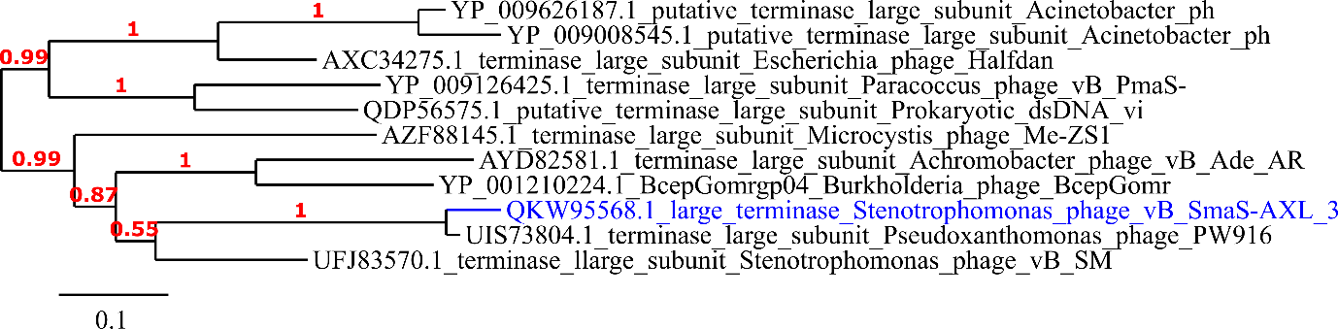

VipTree (https://www.genome.jp/viptree/) [5] analysis of AXL3 and related Pseudoxanthomonas phage PW916 against dsDNA phages. Tree shows a subset of phages with S_{G} scores to AXL3 greater than 0.05.

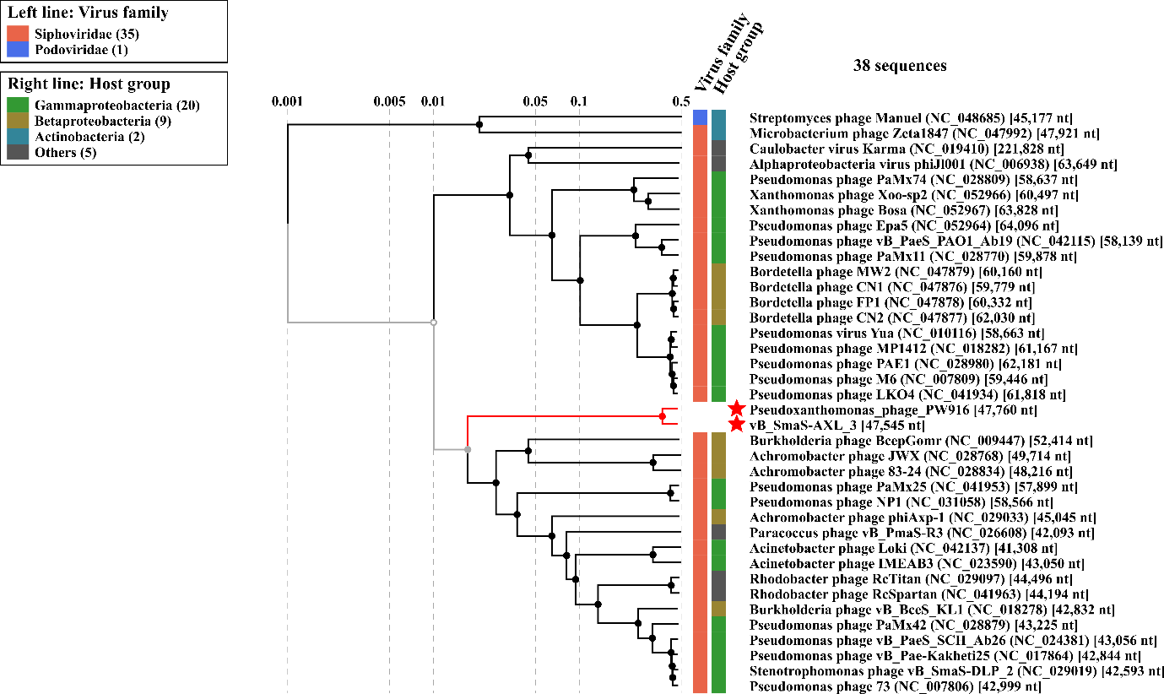

References
1. Altschul SF, Gish W, Miller W, Myers EW, Lipman DJ (1990) Basic local alignment search tool. J Mol Biol 215:403-410. https://doi.org/10.1016/S0022-2836(05)80360-2 PMID:2231712.
2. Moraru C, Varsani A, Kropinski AM (2020) VIRIDIC-A novel tool to calculate the intergenomic similarities of prokaryote-infecting viruses. Viruses. 12:1268. https://doi.org/10.3390/v12111268. PMID: 33172115. http://rhea.icbm.uni-oldenburg.de/VIRIDIC/
3. Turner D, Kropinski AM, Adriaenssens EM (2021) A roadmap for genome-based phage taxonomy. Viruses 13:506. https://doi.org/10.3390/v13030506
4. Dereeper A, Guignon V, Blanc G, Audic S, Buffet S, Chevenet F, Dufayard JF, Guindon S, Lefort V, Lescot M, Claverie JM, Gascuel O (2008) Phylogeny.fr: robust phylogenetic analysis for the non-specialist. Nucleic Acids Res 36(Web Server issue):W465-469. https://doi.org/10.1093/nar/gkn180. PMID:18424797.
5. Nishimura Y, Yoshida T, Kuronishi M, Uehara H, Ogata H, Goto S (2017) ViPTree: the viral proteomic tree server. Bioinformatics 33:2379-2380. https://doi.org/10.1093/bioinformatics/btx157. PMID: 28379287.

