

Part 1: TITLE, AUTHORS, APPROVALS, etc

Code assigned: | 2022.008B
Short title: Create one new species in the genus Berlinvirus (Autographiviridae) and one new species in the genus Epseptimavirus (Demerecviridae) (Caudoviricetes)

- P pbv mhgg
- Bh httm m Author(s) and email address(es)
Imklin N, Nasanit R | faiimklin@gmail.com; nasanit_r@su.ac.th
Author(s) institutional address(es) (optional)
Department of Biotechnology, Silpakorn University, Thailand [NI, RN]

Corresponding author
Rujikan Nasanit
List the ICTV Study Group(s) that have seen this proposal

ICTV Study Group comments and response of proposer

ICTV Study Group votes on proposal
Study Group | Number of members
Study Group | Votes support | Votes against | No vote
Authority to use the name of a living person

Is any taxon name used here derived from that of a living person (Y/N) | N

Taxon name | Person from whom the name is derived | Permission attached (Y/N)

Submission dates
Date first submitted to SC Chair | Feb 16, 2022
Date of this revision (if different to above)
ICTV-EC comments and response of the proposer

Part 2: NON-TAXONOMIC PROPOSAL
Text of proposal

Part 3: TAXONOMIC PROPOSAL
Name of accompanying Excel module
2022.008B.N.v1.Autographiviridae_2nsp.xlsx
Abstract
Genomes of Salmonella phage vB_STy-RN5i1 and Salmonella phage vB_STy-RN5i1 were fully sequenced and identified as two novel species to be included in the genus Berlinvirus and Epseptimavirus, respectively.

Text of proposal
Species demarcation criteria:
We have chosen 95% DNA sequence identity as the criterion for demarcation of species in a genus. Each of the proposed species differs from the others with more than 5% at the DNA level as confirmed with the BLASTN algorithm.

Supporting evidence
Proposal 1: To create new species Salmonella virus RN5i1 in the genus Berlinvirus (Autographiviridae)

History: Salmonella phage vB_STy-RN5i1 was isolated from a drain water sample collected from an open market in Nakhon Pathom province, Thailand. Phage isolation and propagation used Salmonella Typhimurium ATCC13311, DMST 562.

Specific Reference: Imklin N, Nasanit R (2020) Characterization of Salmonella bacteriophages and their potential use in dishwashing materials. J Appl Microbiol 129:266–277. DOI: 10.1111/jam.14617. PMID: 32073713

GenBank Summary: Salmonella phage vB_STy-RN5i1 and its closely related sequences in Berlinvirus [1]

Phage name | RefSeq | INSDC | Size (kb) | GC% | No. of CDSs | No. tRNA | % nt seq. ident. with RN5i1  **
Erwinia phage FE44 | NC_022744.1 | KF700371.1 | 39.86 | 48.6 | 51 | 0 | 81.00
Salmonella phage BP12A | NC_031258.1 | KM366096.1 | 39.70 | 49.0 | 47 | 0 | 80.49
Salmonella phage BSP161 | NC_048105.1 | MG471392.1 | 39.69 | 48.7 | 49 | 0 | 80.43
Enterobacteria phage BA14 | NC_011040.1 | EU734171.1 | 39.82 | 48.8 | 52 | 0 | 79.99
Enterobacteria phage 285P | NC_015249.1 | GQ468526.1 | 39.27 | 48.7 | 47 | 0 | 79.55
Escherichia phage vB_EcoP_S523 | NC_047984.1 | MH031343.1 | 39.83 | 48.8 | 45 | 0 | 79.36
Yersinia phage PYPS50 | NC_048108.1 | MH809534.1 | 39.65 | 48.7 | 44 | 0 | 79.00
Escherichia phage PhiV-1 | - | MT542512.1 | 39.46 | 48.7 | 49 | 0 | 78.58
Salmonella phage LPST144 | - | MN252582.1 | 39.05 | 49.1 | 43 | 0 | 78.57
Salmonella phage vB_SalM-LPST153 | - | MK907285.1 | 39.18 | 49.1 | 48 | 0 | 78.39
Salmonella phage vB_STy-RN5i1 | - | OL800603.1 | 39.43 | 48.4 | 47 | 0*
* Aragorn (v1∙2∙41) was employed to find tRNAs on the genome (http://www.ansikte.se/ARAGORN/) [2]
** The overall nucleotide identity was obtained by PAirwise Sequence Comparison (PASC) [3]

BLASTN homologs: A neighbour joining tree between complete genome sequence of Salmonella phage vB_STy-RN5i1 and its closely related sequences in Berlinvirus was constructed on the basis of BLASTN analysis at NCBI.

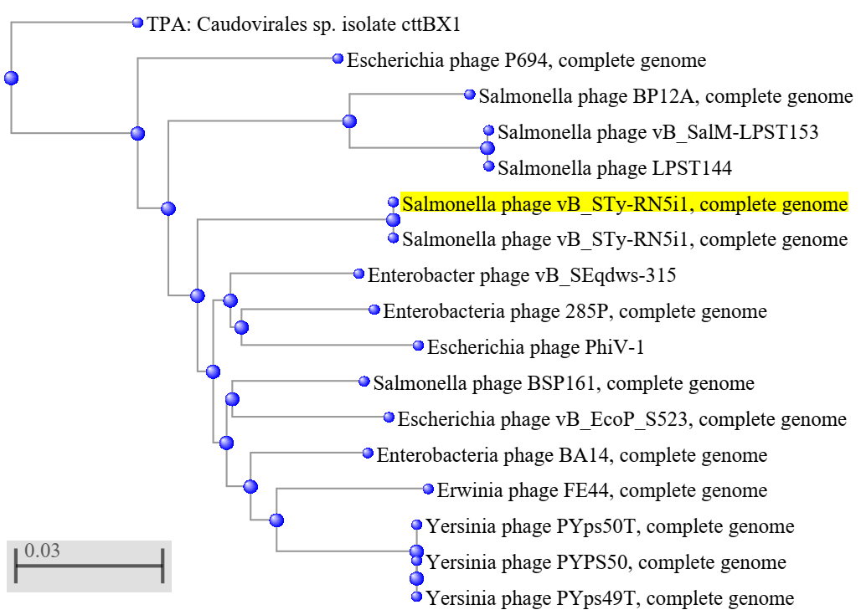

Phylogeny: Phylogenetic analyses of the major capsid proteins (A) and terminase large subunit (B) of Salmonella phage vB_STy-RN5i1, other closely related phages in Berlinvirus and other genera. All sequences were aligned using MUSCLE [4]. The trees were constructed by MEGA7 [5] running on neighbor-joining method with 1,000 bootstrap replication [6]. Numbers on branches represent the bootstrap percentage greater than 50%.

A) MCP
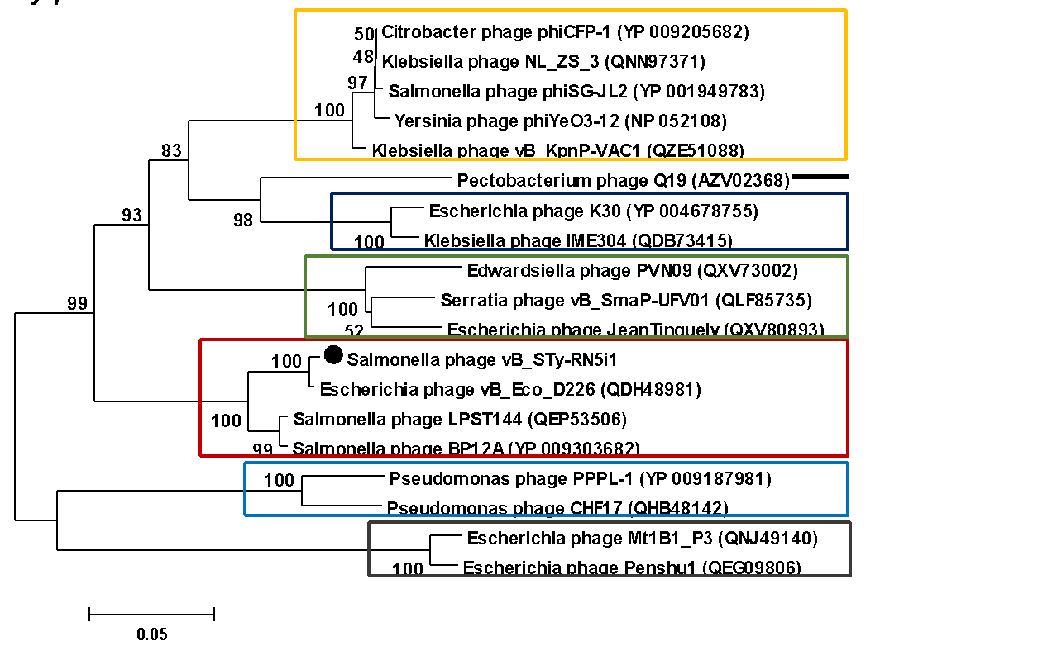

B) TerL
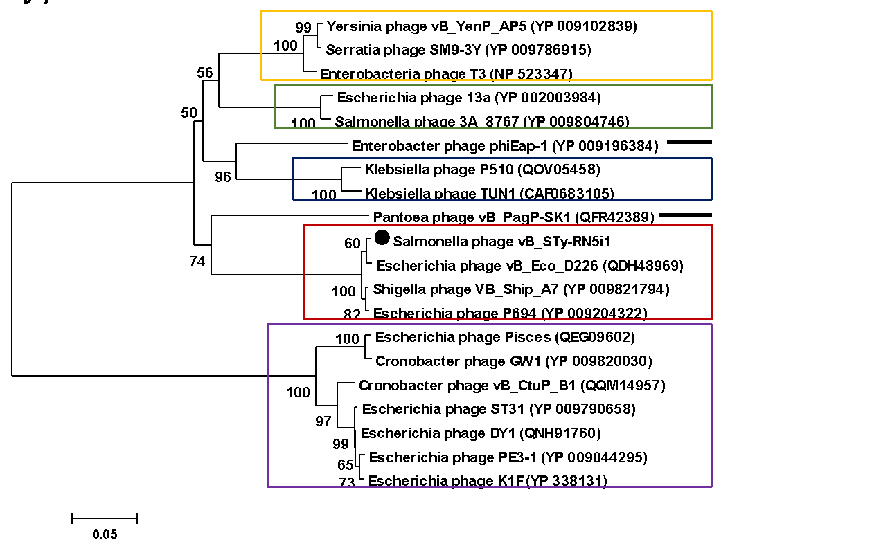

Proposal 2: To create new species Salmonella virus RN29 in the genus Epseptimavirus (Demerecviridae)

History: Salmonella phage vB_STy-RN29 was isolated from a drain water sample collected from an open market in Nonthaburi province, Thailand. Phage isolation and propagation used Salmonella Typhimurium ATCC13311, DMST 562.

Specific Reference: Imklin N, Nasanit R (2020) Characterization of Salmonella bacteriophages and their potential use in dishwashing materials. J Appl Microbiol 129:266–277. DOI: 10.1111/jam.14617. PMID: 32073713

GenBank Summary: Salmonella phage vB_STy-RN29 and its closely related sequences in Epseptimavirus [1]

Phage name | RefSeq | INSDC | Size (kb) | GC% | No. of CDSs | No. tRNA | % nt seq. ident. with RN29  **
Salmonella phage STWB21 | - | MW567727.1 | 112.83 | 40.4 | 166 | 22 | 81.95
Salmonella phage STG2 | NC_048089.1 | MK005300.1 | 114.28 | 40.1 | 161 | 30 | 77.47
Salmonella phage S124 | NC_048013.1 | MH370375.1 | 112.56 | 40.1 | 156 | 28 | 77.38
Salmonella phage Seabear | - | MK728824.1 | 112.47 | 40.4 | 178 | 29 | 77.32
Salmonella phage faergetype | NC_048867.1 | MT074450.1 | 110.18 | 40.0 | 161 | 23 | 76.81
Salmonella phage Seafire | NC_048110.1 | MK050846.2 | 111.85 | 40.0 | 172 | 28 | 76.68
Salmonella phage vB_SenS_SB13 | NC_048781.1 | MK947459.1 | 112.51 | 39.9 | 207 | 15 | 76.57
Escherichia coli phage vB_EcoS_Ace | - | MT833283.1 | 112.79 | 40.0 | 165 | 29 | 76.55
Salmonella phage oselot | NC_048871.1 | MT074465.1 | 113.5 | 39.9 | 171 | 28 | 75.91
Salmonella phage Stitch | NC_027297.1 | KM236244.1 | 123.48 | 40.3 | 179 | 25 | 74.40
Salmonella phage vB_STy-RN29 | - | OL800604.1 | 110.59 | 39.6 | 162 | 19*
* Aragorn (v1∙2∙41) was employed to find tRNAs on the genome (http://www.ansikte.se/ARAGORN/) [2]
** The overall nucleotide identity was obtained by PAirwise Sequence Comparison (PASC) [3]

BLASTN homologs: A neighbour joining tree between complete genome sequence of Salmonella phage vB_STy-RN29 and its closely related sequences in Epseptimavirus was constructed on the basis of BLASTN analysis at NCBI.

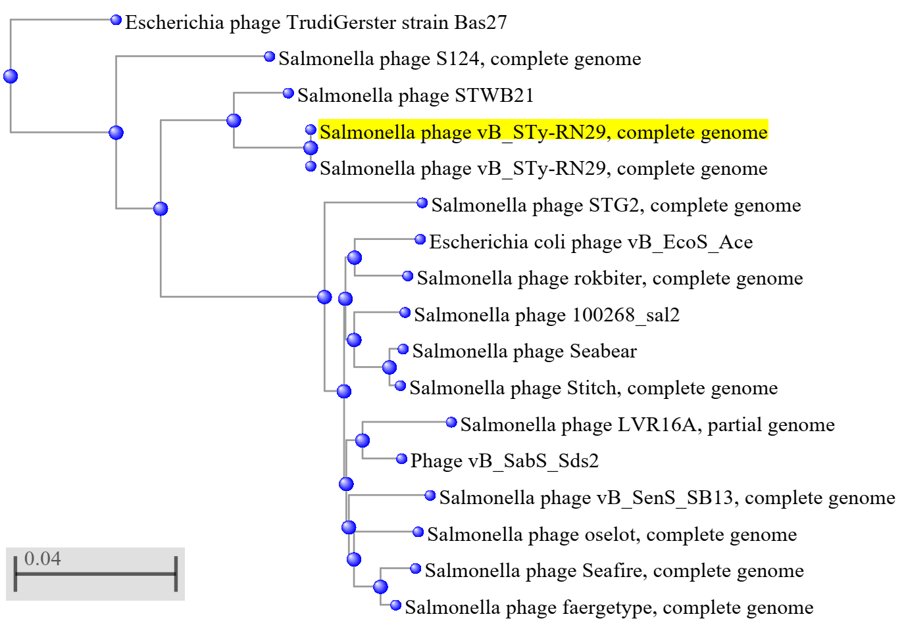

Phylogeny: Phylogenetic analyses of the major capsid proteins (A) and terminase large subunit (B) of Salmonella phage vB_STy-RN29, other closely related phages in Epseptimavirus and other genera. All sequences were aligned using MUSCLE [4]. The trees were constructed by MEGA7 [5] running on neighbor-joining method with 1,000 bootstrap replication [6]. Numbers on branches represent the bootstrap percentage greater than 50%.

A) MCP
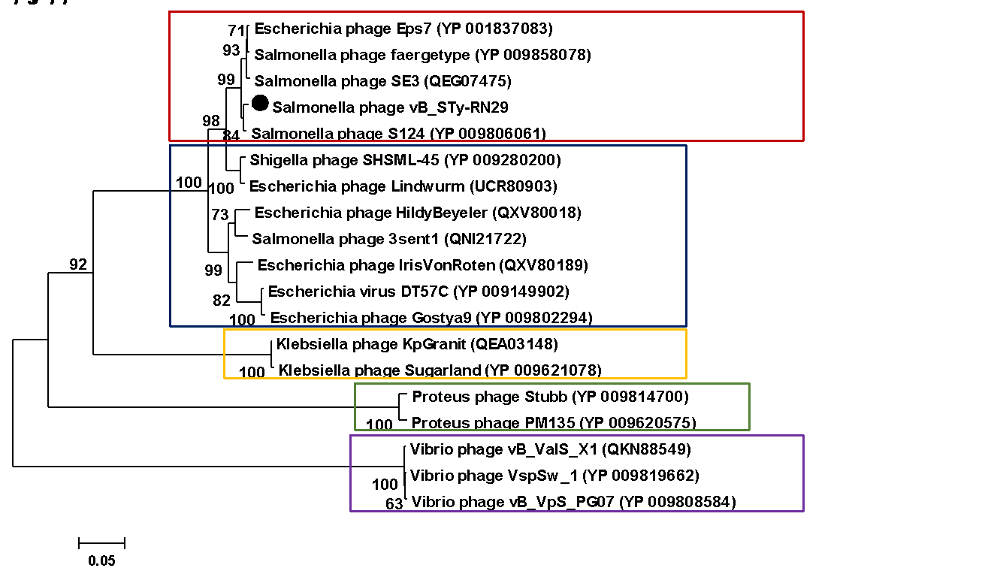

B) TerL

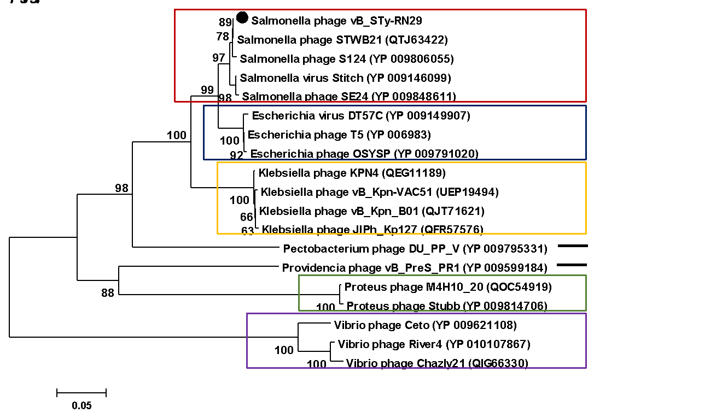

References
1. Sayers EW, Beck J, Brister JR, Bolton EE, Canese K, Comeau DC, et al. (2020) Database resources of the National Center for Biotechnology Information. Nucleic Acids Res 48:D9-D16. doi: 10.1093/nar/gkz899. PMID: 31602479.

2. Laslett D, Canback B (2004) ARAGORN, a program to detect tRNA genes and tmRNA genes in nucleotide sequences. Nucleic Acids Res 32: 11–16. DOI: 10.1093/nar/gkh152. PMID: 14704338

3. Bao Y, Chetvernin V, Tatusova T (2014) Improvements to pairwise sequence comparison (PASC): a genome-based web tool for virus classification. Arch Virol 159: 3293–3304. DOI: 10.1007/s00705-014-2197-x. PMID: 25119676

4. Edgar RC (2004) MUSCLE: multiple sequence alignment with high accuracy and high throughput. Nucleic Acids Res 32:1792–1797. DOI: 10.1093/nar/gkh340.

5. Kumar S, Stecher G, Tamura K (2016) MEGA7: Molecular Evolutionary Genetics Analysis version 7.0 for bigger datasets. Mol Biol Evol 33: 1870–1874. DOI: 10.1093/molbev/msw054. PMID: 27004904

6. Felsenstein J (1985) Confidence limits on phylogenies: an approach using the bootstrap. Evolution 39:783–791. DOI: 10.2307/2408678.

