
This Word module should be used for all taxonomic proposals.
Please complete Part 1 and:
either Part 3 for proposals to create new taxa or change existing taxa
or Part 2 for proposals of a general nature.
Submit the completed Word module, together with the accompanying Excel module named in Part 3, to the appropriate ICTV Subcommittee Chair.
The Word module explains and justifies your proposal. The Excel module is a critical document that will be used to implement the proposed taxonomic changes once they are approved and ratified. If proposals presented in the Word module are not presented accurately in the Excel module, the taxonomic changes cannot proceed.
For guidance, see the notes written in blue, below, and the Help Notes in file Taxonomic_Proposals_Help_2019.
Part 1: TITLE, AUTHORS, etc

Code assigned: | 2019.032B
Short title: Create one new genus (Shizishanvirus) including one new species in the family Podoviridae
Author(s) and email address(es):
List authors in a single line Archives of Virology citation format (e.g. Smith AB, Huang C-L, Santos, F) |  | Provide email address for each author in a single line separated by semi-colons
Kropinski AM, Adriaenssens EM, Wittmann J |  | Phage.Canada@gmail.com;  evelien.adriaenssens@quadram.ac.uk;  jow12@dsmz.de
Author(s) institutional address(es) (optional):
Provide institutional addresses, each on a single line followed by author(s) initials (e.g. University of Woolloomooloo [SAB, HCL])
University of Guelph, Canada [AMK]
Quadram Institute Bioscience, UK [EMA]
DSMZ, Germany [JW]

Corresponding author
Johannes Wittmann

List the ICTV study group(s) that have seen this proposal:
A list of study groups and contacts is provided at http://www.ictvonline.org/subcommittees.asp . If in doubt, contact the appropriate subcommittee chair (there are six virus subcommittees: animal DNA and retroviruses, animal ssRNA-, animal ssRNA+, fungal and protist, plant, bacterial and archaeal) |  | Bacterial and Archaeal Viruses Subcommittee  Caudovirales Study Group
ICTV Study Group comments (if any) and response of the proposer:
Date first submitted to ICTV:
Date of this revision (if different to above):

ICTV-EC comments and response of the proposer:

Part 2: NON-STANDARD
Template for any proposal regarding ICTV procedures, rules or policy, not involving the creation of new taxonomy.
Text of proposal:

Part 3: PROPOSED TAXONOMY

Name of accompanying Excel module: 2019.032B.A.v1.Shizishanvirus
The taxonomic changes you are proposing should be presented on an accompanying Excel module, 2019_TP_Template_Excel_module. Please enter the file name of the completed module in this box.
Supporting material:
additional material in support of this proposal
Please explain the reasons for the taxonomic changes you are proposing and provide evidence to support them. The following information should be provided, where relevant:
- Species demarcation criteria: Explain how new species differ from others in the genus and demonstrate that these differences meet the criteria previously established for demarcating between species. If no criteria have previously been established, and if there will now be more than one species in the genus, please state the demarcation criteria you are proposing.
- Higher taxa:
  - There is no formal requirement to state demarcation criteria when proposing new genera or other higher taxa. However, a similar concept should apply in pursuit of a rational and consistent virus taxonomy.
  - Please indicate the origin of names assigned to new taxa at genus level and above.
  - For each new genus a type species must be designated to represent it. Please explain your choice.
- Supporting evidence: The use of Figures and Tables is strongly recommended (note that copying from publications will require permission from the copyright holder). For phylogenetic analysis, please provide a tree where branch length is proportional to genetic distance, generated using an appropriate algorithm (Neighbour-Joining, Maximum Likelihood, or Bayesian) and provide evidence of the reliability of the branching (e.g., by bootstrapping).
Please refer to the Help Notes file (Taxonomic_Proposals_Help_2019) for more information.
Species demarcation criteria We have chosen 95% DNA sequence identity as the criterion for demarcation of species in this new genus. Each of the proposed species differs from the others with more than 5% at the DNA level as confirmed with the BLASTN algorithm.

Source of the name of this taxon: The name is derived from the address of the Biotechnology and Nuclear Technology Research Institute, Sichuan Academy of Agricultural Sciences, Chengdu, Sichuan, China (106# Shizishan Rd) where this phage was isolated from soil using Pseudomonas fluorescens CS1 as the host bacterium.

History: Pseudomonas phage phCDa is a member of the Podoviridae family. It was isolated from soil in China.

GenBank Summary:

Phage name | RefSeq No. | INSDC | Size (Kb) | GC% | Protein | tRNA
Pseudomonas phage phCDa |  | MH382836 | 72.8 | 53.3 | 98 | -

BLASTN homologs: None, genomic orphan/singleton

Electron micrograph: not available

Genome organisation:
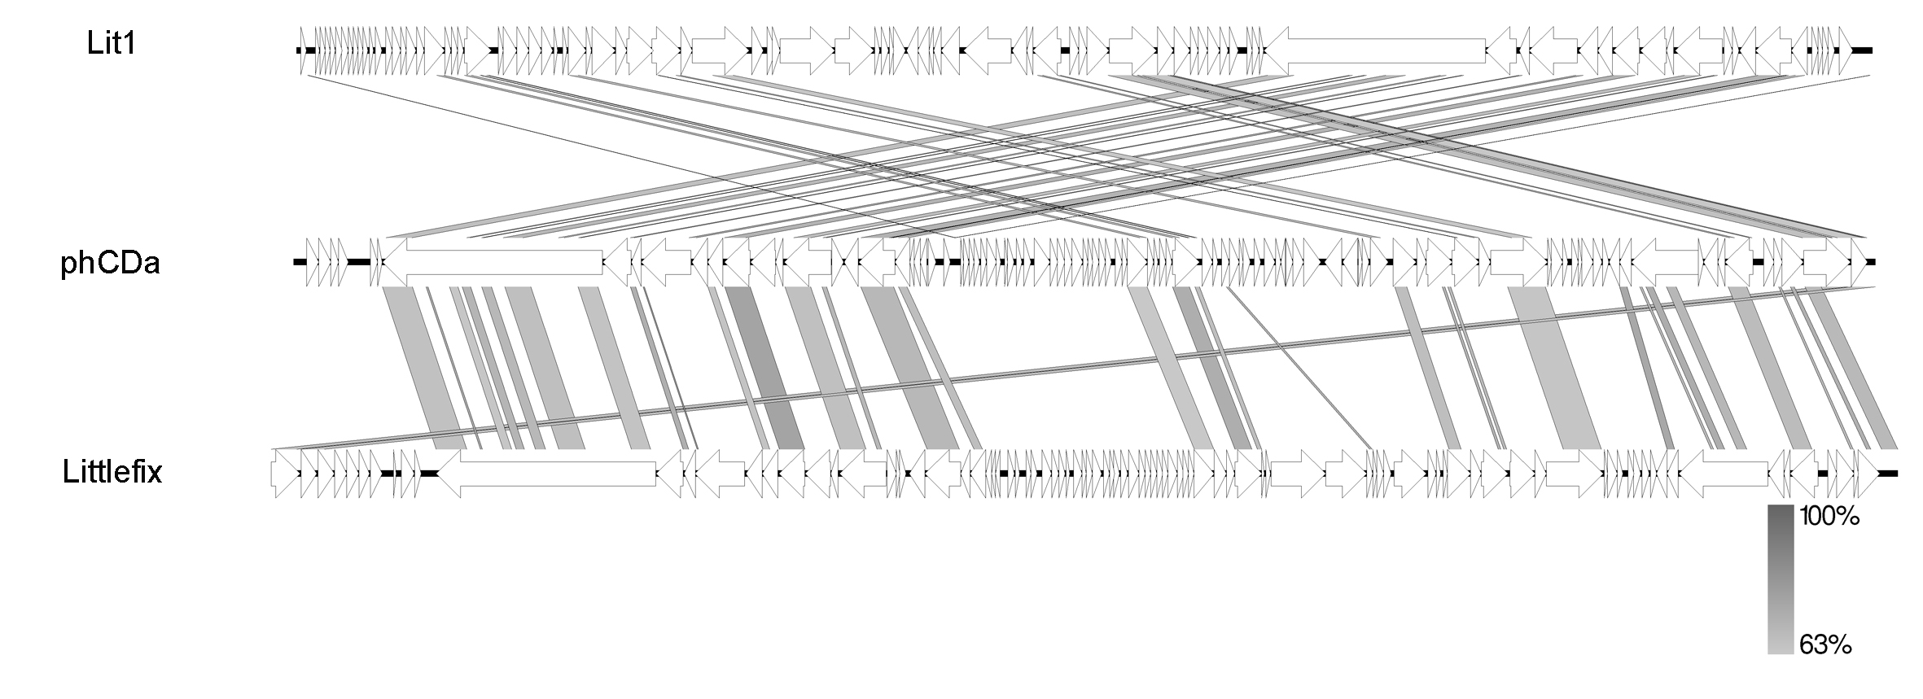
Comparison of different N4-like Pseudomonas phage genomes at the nucleotide level using EasyFig [1].

References:
Sullivan MJ, Petty NK, Beatson SA. Easyfig: a genome comparison visualizer. Bioinformatics. 2011 Apr 1;27(7):1009-10.
Brister, J. R., Ako-adjei, D., Bao, Y. & Blinkova, O. NCBI Viral Genomes Resource. Nucleic Acids Res. 43, D571–D577 (2015).
Sayers EW, Agarwala R, Bolton EE, Brister JR, Canese K, Clark K, et al. Database resources of the National Center for Biotechnology Information. Nucleic Acids Res. 2019;47(D1):D23-D28.
Tolstoy I, Kropinski AM, Brister JR. Bacteriophage Taxonomy: An Evolving Discipline. Methods Mol Biol. 2018;1693:57-71.
O'Leary NA, Wright MW, Brister JR, Ciufo S, Haddad D, McVeigh R, et al. Reference sequence (RefSeq) database at NCBI: current status, taxonomic expansion, and functional annotation. Nucleic Acids Res. 2016;44(D1):D733-45.

