
This Word module should be used for all taxonomic proposals.
Please complete Part 1 and:
either Part 3 for proposals to create new taxa or change existing taxa
or Part 2 for proposals of a general nature.
Submit the completed Word module, together with the accompanying Excel module named in Part 3, to the appropriate ICTV Subcommittee Chair.
For guidance, see the notes written in blue, below, and the help notes in file Taxonomic_Proposals_Help_2018.
Part 1: TITLE, AUTHORS, etc

Code assigned: | 2018.133B |  | (to be completed by ICTV officers)
Short title: (e.g. “6 new species in the genus Zetavirus”)
To add one (1) new genus, and five new species to the subfamily Vequintavirinae, family Myoviridae.
Author(s):
Evelien M. Adriaenssens, University of Liverpool, UK
Andrew M. Kropinski, University of Guelph, Canada

Corresponding author with e-mail address:
Andrew M. Kropinski Phage.Canada@gmail.com
List the ICTV study group(s) that have seen this proposal:
A list of study groups and contacts is provided at http://www.ictvonline.org/subcommittees.asp . If in doubt, contact the appropriate subcommittee chair (there are six virus subcommittees: animal DNA and retroviruses, animal ssRNA-, animal ssRNA+, fungal and protist, plant, bacterial and archaeal) |  | Bacterial and Archaeal Viruses Subcommittee
ICTV Study Group comments (if any) and response of the proposer:
Date first submitted to ICTV: |  |  | June 2018
Date of this revision (if different to above):

ICTV-EC comments and response of the proposer:

Part 2: NON-STANDARD
Template for any proposal regarding ICTV procedures, rules or policy, not involving the creation of new taxonomy.
Text of proposal:

Part 3: PROPOSED TAXONOMY

Name of accompanying Excel module: 2018.133B.N.v2.Vequintavirinae_1gen5sp
The taxonomic changes you are proposing should be presented on an accompanying Excel module, 2017_TP_Template_Excel_module. Please enter the file name of the completed module in this box.
Supporting material:
additional material in support of this proposal
Please explain the reasons for the taxonomic changes you are proposing and provide evidence to support them. The following information should be provided, where relevant:
- Species demarcation criteria: Explain how new species differ from others in the genus and demonstrate that these differences meet the criteria previously established for demarcating between species. If no criteria have previously been established, and if there will now be more than one species in the genus, please state the demarcation criteria you are proposing.
- Higher taxa:
  - There is no formal requirement to state demarcation criteria when proposing new genera or other higher taxa. However, a similar concept should apply in pursuit of a rational and consistent virus taxonomy.
  - Please indicate the origin of names assigned to new taxa at genus level and above.
  - For each new genus a type species must be designated to represent it. Please explain your choice.
- Supporting evidence: The use of Figures and Tables is strongly recommended (note that copying from publications will require permission from the copyright holder). For phylogenetic analysis, try to provide a tree where branch length is related to genetic distance.

Species demarcation criteria We have chosen 95% DNA sequence identity as the criterion for demarcation of species in this new genus. Each of the proposed species differs from the others with more than 5% at the DNA level as confirmed with the BLASTN algorithm.

Source of the name of this taxon: The new genus name is directly derived from the first type, Escherichia phage Av-05.

History: Currently the myoviral subfamily Vequintavirinae, consists of three genera, Certrevirus (renamed from Cr3virus in proposal 2018.007B), Seunavirus (renamed from Se1virus in proposal 2018.007B, with its type species being renamed in proposal 2018.132B) and Vequintavirus (renamed from V5virus in proposal 2018.007B), and 13 species. As the numbers increase, we realize that this classification does not accurately reflect the diversity of V5-like viruses. Colin Buttimer et al. in a separate TaxoProp have recognized a new genus – Rounavirus, containing Klebsiella phage vB_KpnM_KB57, Klebsiella phage vB_KpnM_BIS47 and Raoultella phage Ro1. Furthermore, our analyses reveal that Escherichia phage Av-05 which has yet to be placed in this subfamily is sufficiently different from the other phages to warrant placement in its own genus, Avquintavirus. This phage lyses Escherichia coli O157 and Salmonella serovars and “was obtained from the strain collection of the National Research Laboratory for Food Safety (LANIIA) at the Research Center for Food and Development (CIAD, Mexico).” [1] Lastly, the genus V5virus (Vequintavirus) has increased by four members.

GenBank Summary:

- Avquintavirus
Phage name | RefSeq No. | INSDC | Size (Kb) | GC% | Protein | tRNA (*) | % DNA sequence identity (**) | % common proteins (***)
Av-05 | NC_025830.1 | KM190144.1 | 120.94 | 40.0 | 209 | 17 | 28 | 47.5
PVP-SE1 | NC_016071.1 | GU070616.1 | 145.96 | 45.6 | 244 | 24 | 100 | 100
(*) None listed in GenBank genome summary, these found using tRNAscan-SE; (**) determined using BLASTN at NCBI to its nearest type phage; (***) determined using CoreGenes 3.5 to its nearest type phage

- Vequintavirus – new species
Phage name | RefSeq No. | INSDC | Size (Kb) | GC% | Protein | tRNA (*) | % DNA sequence identity (**) | % common proteins (***)
rV5 | NC_011041.1 | DQ832317.1 | 137.95 | 43.6 | 233 | 6 | 100 | 100
slur16 [2] | NC_028248.1 | LN881727.1 | 136.9 | 43.6 | 206 | 7 | 94 | 85.4
Murica [3] |  | KT001917.1 | 135.39 | 43.6 | 212 | 7 | 92 | 88.4
APECc02 [4] |  | KR698074.1 | 135.4 | 43.6 | 219 | 5 | 89 | 88.8
V18 [5] |  | KY683736.1 | 129.45 | 43.6 | 207 | 3 | 89 | 82.0
(**) determined using BLASTN at NCBI to its nearest type phage; (***) determined using CoreGenes 3.5 to its nearest type phage

Phylogeny: The phylogenetic tree was constructed, using phylogeny.fr, using the major capsid protein homologs of V5 and related viruses. The single member of the genus Avquintavirus is boxed in blue, while the Vequintavirus genus is boxed in red.

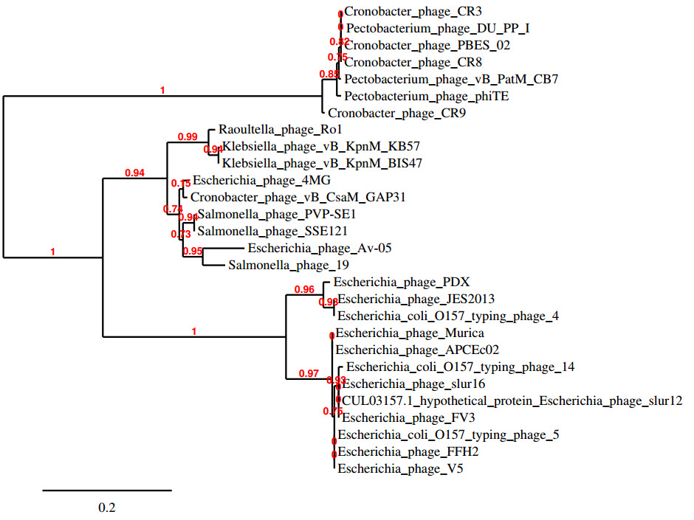

References:
1: Amarillas L, López-Cuevas O, León-Félix J, Castro-Del Campo N, Gerba CP,
Chaidez C. Genomic Analysis of Broad-Host-Range Enterobacteriophage Av-05. Genome
Announc. 2015;3(3). pii: e00282-15.

2: Smith R, O'Hara M, Hobman JL, Millard AD. Draft Genome Sequences of 14
Escherichia coli Phages Isolated from Cattle Slurry. Genome Announc. 2015;3(6). pii: e01364-15.

3: Wilder JN, Lancaster JC, Cahill JL, Rasche ES, Kuty Everett GF. Complete
Genome Sequence of Enterotoxigenic Escherichia coli Myophage Murica. Genome
Announc. 2015;3(5). pii: e01135-15.

4: Dalmasso M, Strain R, Neve H, Franz CM, Cousin FJ, Ross RP, Hill C. Three New
Escherichia coli Phages from the Human Gut Show Promising Potential for Phage
Therapy. PLoS One. 2016;11(6):e0156773.

5: Aleshkin AV, Rubalskii EO, Volozhantsev NV, Verevkin VV, Svetoch EA, Kiseleva
IA, Bochkareva SS, Borisova OY, Popova AV, Bogun AG, Afanas'ev SS. A small-scale
experiment of using phage-based probiotic dietary supplement for prevention of E.
coli traveler's diarrhea. Bacteriophage. 2015;5(3):e1074329.

