
This Word module should be used for all taxonomic proposals.
Please complete Part 1 and:
either Part 3 for proposals to create new taxa or change existing taxa
or Part 2 for proposals of a general nature.
Submit the completed Word module, together with the accompanying Excel module named in Part 3, to the appropriate ICTV Subcommittee Chair.
For guidance, see the notes written in blue, below, and the help notes in file Taxonomic_Proposals_Help_2018.
Part 1: TITLE, AUTHORS, etc

Code assigned: | 2018.044B |  | (to be completed by ICTV officers)
Short title: (e.g. “6 new species in the genus Zetavirus”)
To add an additional species to the genus Amigovirus in the family Siphoviridae
Author(s):
Andrew M. Kropinski, University of Guelph, Canada
Evelien M. Adriaenssens, University of Liverpool, UK
Corresponding author with e-mail address:
Andrew M. Kropinski Phage.Canada@gmail.com
List the ICTV study group(s) that have seen this proposal:
A list of study groups and contacts is provided at http://www.ictvonline.org/subcommittees.asp . If in doubt, contact the appropriate subcommittee chair (there are six virus subcommittees: animal DNA and retroviruses, animal ssRNA-, animal ssRNA+, fungal and protist, plant, bacterial and archaeal) |  | Bacterial and Archaeal Viruses Subcommittee
ICTV Study Group comments (if any) and response of the proposer:
Date first submitted to ICTV: |  |  | May 2018
Date of this revision (if different to above):

ICTV-EC comments and response of the proposer:

Part 2: NON-STANDARD
Template for any proposal regarding ICTV procedures, rules or policy, not involving the creation of new taxonomy.
Text of proposal:

Part 3: PROPOSED TAXONOMY

Name of accompanying Excel module: 2018.044B.N.v1.Amigovirus_sp
The taxonomic changes you are proposing should be presented on an accompanying Excel module, 2017_TP_Template_Excel_module. Please enter the file name of the completed module in this box.
Supporting material:
additional material in support of this proposal
Please explain the reasons for the taxonomic changes you are proposing and provide evidence to support them. The following information should be provided, where relevant:
- Species demarcation criteria: Explain how new species differ from others in the genus and demonstrate that these differences meet the criteria previously established for demarcating between species. If no criteria have previously been established, and if there will now be more than one species in the genus, please state the demarcation criteria you are proposing.
- Higher taxa:
  - There is no formal requirement to state demarcation criteria when proposing new genera or other higher taxa. However, a similar concept should apply in pursuit of a rational and consistent virus taxonomy.
  - Please indicate the origin of names assigned to new taxa at genus level and above.
  - For each new genus a type species must be designated to represent it. Please explain your choice.
- Supporting evidence: The use of Figures and Tables is strongly recommended (note that copying from publications will require permission from the copyright holder). For phylogenetic analysis, try to provide a tree where branch length is related to genetic distance.

Species demarcation criteria We have chosen 95% DNA sequence identity as the criterion for demarcation of species in this new genus. Each of the proposed species differs from the others with more than 5% at the DNA level as confirmed with the BLASTN algorithm.

History: Lytic phage Amigo was isolated in 2016 by Yasmene Warrad (Spring, TX, USA) as part of the Science Education Alliance-Phage Hunters Advancing Genomics and Evolutionary Science program using Arthrobacter sp. ATCC 21022 as the host bacterium. The genome has direct terminal repeats of ca. 1580 bp. Phage Molivia has been included in this genus though it contains 1467 bp DTR. These phages belong to subcluster AQ in The Actinobacteriophage Database.

GenBank Summary:

Phage name | INSDC | Size (Kb) | GC% | Protein | tRNA | Overall DNA sequence identity (*) | % Common proteins (**)
Amigo | KU160638.1 | 59.17 | 52.9 | 86 | 7 | 100 | 100
Molivia | MF185731.1 | 58.25 | 53.5 | 92 | 6 | 55 | 83.7
(*) determined using NCBI BLASTN; (**) determined using CoreGenes 3.5
Arthrobacter phages Rings, Anansi, SorJuana and Gorgeous should be considered strains in the taxon.

BLASTN homologs: None; genomic orphan/singleton. Its relationship to other Arthrobacter phages is illustrated in this neighbour joining tree generated using NCBI BLASTN.

Electron micrograph: Electron micrograph of negatively stained Arthrobacter phage Molivia (http://phagesdb.org/phages/Molivia/) - Limited permission was granted by The
Actinobacteriophages Database, funded by the Howard Hughes Medical Institute, to use these
electron micrographs for this taxonomy proposal; it cannot be reused without permission of The
Actinobacteriophages Database.

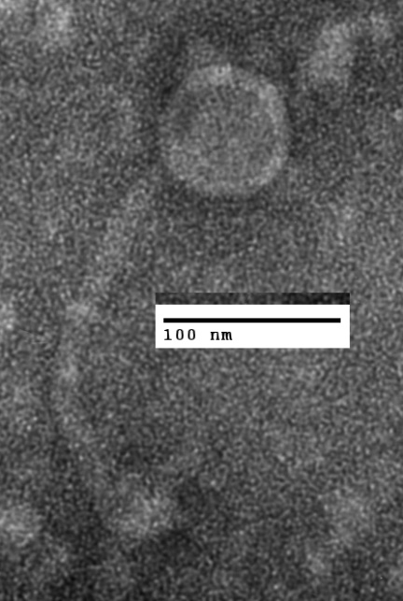

Phylogeny: The phylogenetic tree was constructed, using phylogeny.fr, using the helicase (TOP) and major capsid protein (BOTTOM) homologs of Amigo and related phages.

References:
None

