

Part 1: TITLE, AUTHORS, APPROVALS, etc

Code assigned: | 2022.002S
Short title: Create eight new species in the genus Pestivirus (Flaviviridae)

Author(s) and email address(es)
Postel A, Becher P, Smith DB | Alexander.Postel@tiho-hannover.de; Paul.Becher@tiho-hannover.de; donald.smith.mail@gmail.com
Author(s) institutional address(es) (optional)
Institut für Virologie, Hannover (AP, PB), Universities of Oxford and Edinburgh (DBS)

Corresponding author
Donald Smith

List the ICTV Study Group(s) that have seen this proposal

Sent to Hepaciviridae SG chair and SC chair on 15th December 2021 and 19th April 2022

ICTV Study Group comments and response of proposer
ICTV Study Group votes on proposal

Study Group | Number of members
Study Group | Votes support | Votes against | No vote
Authority to use the name of a living person
Is any taxon name used here derived from that of a living person (Y/N) | N

Taxon name | Person from whom the name is derived | Permission attached (Y/N)

Submission dates
Date first submitted to SC Chair | 19/04/2022
Date of this revision (if different to above)
ICTV-EC comments and response of the proposer

Part 2: NON-TAXONOMIC PROPOSAL
Text of proposal

Part 3: TAXONOMIC PROPOSAL
Name of accompanying Excel module
2022.002S.N.v1.Pestivirus_8nsp.xlsx
Abstract
Eight additional species proposed for the genus Pestivirus (family Flaviviridae) based on phylogeny, pathology and host species of newly reported pestiviruses.

Text of proposal
As a result of an analysis of sequences of recently reported novel pestiviruses (Table 1) we propose to establish eight additional species (Pestivirus L, Pestivirus M, Pestivirus N, Pestivirus O, Pestivirus P, Pestivirus Q, Pestivirus R, and Pestivirus S), expanding the number of pestivirus species to 19 [6]. This proposal is an extension of previous work in which reference sequences and species demarcation criteria were proposed on the basis of phylogenetic and distance comparisons between complete genome sequences [7]. We have only proposed new species where a complete coding sequence is available. Current species demarcation criteria in the genus take into account nucleotide and deduced amino acid sequence relatedness, antigenic relatedness and host of origin (https://talk.ictvonline.org/ictv-reports/ictv_online_report/positive-sense-rna-viruses/w/flaviviridae/361/genus-pestivirus).

Table 1. Recently reported pestivirus sequences.
Proposed Species | Virus Name | Abbrevi-ation ¹ | Host  Species | Isolates |  |  |  | Ref.
 |  |  |  |  | GenBank | Region² | Length [b] | Ref.
Pestivirus L | Linda virus | LindaV | Sus scrofa | Austria1 | KY436034 | CG | 12,614 | [4]
Pestivirus M | Phocoena  pestivirus | PhoPeV | Phocoena  phocoena | PhoPeV-1 | MK910227 | CG | 11,880 | [3]
 |  |  |  | PhoPeV-2 | MK910228 | CG | 11,880 | [3]
 |  |  |  | PhoPeV-3 | MK910229 | CG | 12,060 | [3]
Pestivirus N | Tunisian sheep-like pestivirus | TSV | Capra aegagrus hircus | 70292/2007/EN | MZ664273 | CCS | 12,268 | [5]
Pestivirus N | Tunisian sheep-like pestivirus | TSV | Ovis gmelini aries | 92019/2007/AG | MZ664274 | CG | 12,286 | [5]
Pestivirus O | ovine/IT  pestivirus | ovIT PeV | Ovis gmelini  aries | 338710-2/2017 | MK618725 | PG | 11,143 | [8]
 |  |  |  | 338710-3/2017 | MK618726 | CCS | 12,173 | [8]
 |  |  |  | 1756/2017 | MG770617 | CCS | 12,173 | [8]
Pestivirus P | pangolin  pestivirus | DYPV | Amblyomma javanense | DYAJ1 | MK636874 | CG | 12,443 | [2]
Pestivirus P | pangolin  pestivirus | DYPV | Manis javanica | DYCS | MK636875 | CG | 12,446 | [2]
Pestivirus Q | rodent pestivirus | RtNn-PeV | Niviventer  niviventer | HuB2014 | KY370101 | CCS | 13,220 | [10]
Pestivirus R | rodent pestivirus | RtAp-PeV | Apodemus peninsulae | JL2014 | KY370100 | CCS | 12,768 | [10]
n.a. | rodent pestivirus | RtNe-PeV | Niviventer  excelsior | SC2014 | KY370099 | PG | 11,644 | [10]
n.a. | rodent pestivirus | RtAd-PeV | Apodemus  draco | SAX2015 | KY370102 | PG | 11,551 | [10]
n.a. | rodent pestivirus | RtNn-PeV | Niviventer  niviventer | SAX2015 | KY370103 | PG | 11,435 | [10]
Pestivirus S | bat pestivirus | BtSk-PeV | Scotophilus  kuhlii | 1/GX2017 | MH282908 | CCS | 11,921 | [9]
n.a. | bat pestivirus | BtSk-PeV | Scotophilus  kuhlii | 3/GX2017 | MH282910 | PG | 7266 | [9]
n.a. | bat pestivirus | BtSk-PeV | Scotophilus  kuhlii | 4/GX2017 | MH282911 | PG | 7132 | [9]
n.a., not assigned (no complete cds available); ¹ Given is the first proposed or commonly used abbreviation. ² CG complete genome, CCS complete coding sequence, PG partial genome

Members of additional species proposed here are generally distinguished by the phylogeny of (Figure 1B) and distances between complete coding sequences (Table 2), with members of different species belonging to well-demarcated clades and having distances of >0.24 (nucleotide) or >0.15 (amino acid). Most of the viruses assigned to new species are genetically very distinct from members of the previously approved species Pestivirus A through Pestivirus K.

Members of different species are also generally distinguished on the basis of the phylogeny or distance comparisons for a highly conserved part of NS5B (NS5B_{3312–3837}), with distances of >0.13 as the demarcation point. An advantage of using NS5B_{3312–3837} region is that this region is not prone to large-scale insertion or deletion and so no additional editing of sequences is required.

Table 2. Minimum p-distances between members of selected pestivirus species.

 |  | Minimum p-Distances
 |  | CDS | Polyprotein | NS5B_{3312–3837}
Pestivirus A | Pestivirus B | >0.30 | >0.24 | >0.17
Pestivirus C | Pestivirus D | >0.29 | >0.21 | >0.14
Pestivirus C | Pestivirus I | >0.28 | >0.20 | >0.14
Pestivirus D | Pestivirus I | >0.28 | >0.19 | >0.14
Pestivirus L | Pestivirus F | 0.35 | 0.31 | 0.22
Pestivirus M | Pestivirus F,  Pestivirus L | >0.37 | >0.36 | >0.22
Pestivirus N | Pestivirus C | >0.24 | >0.16 | >0.09
Pestivirus N | Pestivirus I | >0.26 | >0.18 | >0.13
Pestivirus N | Pestivirus O | 0.23 | >0.14 | 0.11
Pestivirus O | Pestivirus C | >0.22 | >0.14 | >0.11
Pestivirus P | Pestivirus F,  Pestivirus M | >0.41 | >0.47 | >0.33
Pestivirus Q | Pestivirus R | 0.40 | 0.42 | 0.33
Pestivirus Q | Pestivirus J | 0.30 | 0.22 | 0.17
Pestivirus R | Pestivirus Q | 0.40 | 0.42 | 0.33
Pestivirus R | Pestivirus J | 0.40 | 0.42 | 0.31
Pestivirus S | Pestivirus K | >0.40 | >0.40 | >0.29

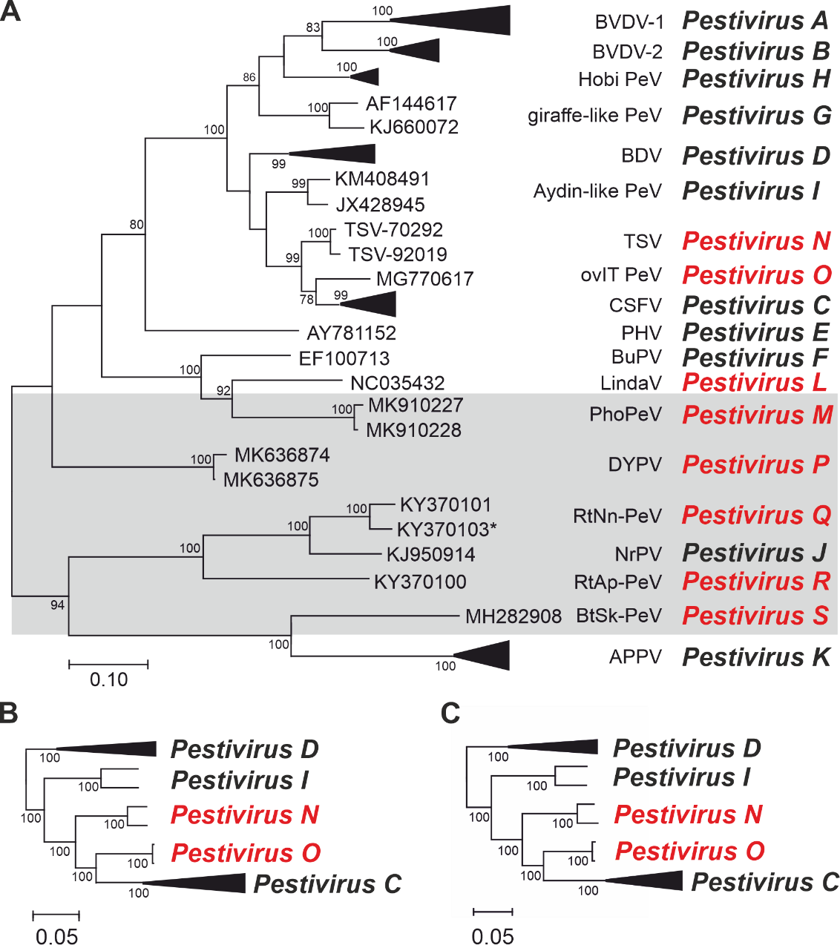

Figure 1. Phylogenetic analysis of pestivirus sequences. (A) Maximum likelihood tree was based on the conserved partial NS5B peptide (positions 3312–3837 in the polyprotein of BVDV-1 (Pestivirus A) reference strain SD-1). With one exception (KY370103, indicated by asterisk), the sequences were derived from complete coding sequences. For clarity, the clades for viruses in the species Pestivirus A, Pestivirus B, Pestivirus C, Pestivirus D, Pestivirus H, and Pestivirus K are collapsed. Proposed species are indicated using red.
Pestivirus sequences identified in non-ungulate hosts are highlighted (grey shaded box). Bootstrap values >70% are shown. (B) A subset of pestiviruses closely related to TSV (Pestivirus N) and ovIT PeV (Pestivirus O) was analyzed separately by Maximum likelihood analyses for complete coding sequences or (C) polyprotein sequences. Figure reproduced from [6].

Members of the proposed species Pestivirus N and Pestivirus O are not as divergent from CSFV isolates in the species Pestivirus C for either complete coding region sequences or for the NS5B_{3312–3837} region. These viruses are also antigenically related [1]. Nevertheless, we argue that these isolates represent three different species for the following reasons:

- Phylogenetic analysis of complete coding nucleotide or polyprotein sequences (Figure 1B, 1C) or NS5B_{3312–3837} sequences (Figure 1A) shows that ovIT PeV (Pestivirus O) shares a common branch with, but is distinct from, CSFV (Pestivirus C). Similarly, TSV (Pestivirus N) shares a common branch with both ovIT PeV and CSFV, but is distinct from both.
- Natural infection with CSFV (Pestivirus C) is confined to pigs, while ovIT PeV (Pestivirus O) and TSV (Pestivirus N) have only been detected in small ruminants. Both viruses have been known for more than 15 years.
- Experimental infection of pigs with TSV (Pestivirus N) results in no CSF-like symptoms [39], while studies on porcine cells in vitro revealed rather inefficient replication. Pigs exposed to infection with ovIT PeV (Pestivirus O) showed only mild, unspecific clinical signs and pathological alterations, with very limited replication, these features resembling the outcome of horizontal infections of pigs with other ruminant pestiviruses, e.g., BVDV-1 (Pestivirus A) or BDV (Pestivirus D) [1, 5].
- Regulatory considerations in the control of CSF require a clear differentiation of CSFV from other pestiviruses.

References
1. Bohórquez JA, Sozzi E, Wang M, Alberch M, Abad X, Gaffuri A, Lelli D, Rosell R, Pérez LJ, Moreno A, Ganges L (2021) The new emerging ovine pestivirus can infect pigs and confers strong protection against classical swine fever virus. Transbound Emerg Dis[PMID 33896109]
2. Gao WH, Lin XD, Chen YM, Xie CG, Tan ZZ, Zhou JJ, Chen S, Holmes EC, Zhang YZ (2020) Newly identified viral genomes in pangolins with fatal disease. Virus Evol 6:veaa020 [PMID 32296543]
3. Jo WK, van Elk C, van de Bildt M, van Run P, Petry M, Jesse ST, Jung K, Ludlow M, Kuiken T, Osterhaus A (2019) An evolutionary divergent pestivirus lacking the N(pro) gene systemically infects a whale species. Emerg Microbes Infect 8:1383-1392 [PMID 31526243]
4. Lamp B, Schwarz L, Högler S, Riedel C, Sinn L, Rebel-Bauder B, Weissenböck H, Ladinig A, Rümenapf T (2017) Novel pestivirus species in pigs, Austria, 2015. Emerg Infect Dis 23:1176-1179 [PMID 28628456]
5. Meyer D, Postel A, Wiedemann A, Cagatay GN, Ciulli S, Guercio A, Becher P (2021) Comparative analysis of Tunisian sheep-like virus, Bungowannah virus and border disease virus infection in the porcine host. Viruses 13:e1539 [PMID 34452404]
6. Postel A, Smith DB, Becher P (2021) Proposed update to the taxonomy of pestiviruses: eight additional species within the genus Pestivirus, family Flaviviridae. Viruses 13:e1542 [PMID 34452407]
7. Smith DB, Meyers G, Bukh J, Gould EA, Monath T, Scott Muerhoff A, Pletnev A, Rico-Hesse R, Stapleton JT, Simmonds P, Becher P (2017) Proposed revision to the taxonomy of the genus Pestivirus, family Flaviviridae. J Gen Virol 98:2106-2112 [PMID 28786787]
8. Sozzi E, Lavazza A, Gaffuri A, Bencetti FC, Prosperi A, Lelli D, Chiapponi C, Moreno A (2019) Isolation and full-length sequence analysis of a pestivirus from aborted lamb fetuses in Italy. Viruses 11:e0744 [PMID 31412585]
9. Wu Z, Liu B, Du J, Zhang J, Lu L, Zhu G, Han Y, Su H, Yang L, Zhang S, Liu Q, Jin Q (2018) Discovery of diverse rodent and bat pestiviruses with distinct genomic and phylogenetic characteristics in several Chinese provinces. Front Microbiol 9:2562 [PMID 30405596]
10. Wu Z, Lu L, Du J, Yang L, Ren X, Liu B, Jiang J, Yang J, Dong J, Sun L, Zhu Y, Li Y, Zheng D, Zhang C, Su H, Zheng Y, Zhou H, Zhu G, Li H, Chmura A, Yang F, Daszak P, Wang J, Liu Q, Jin Q (2018) Comparative analysis of rodent and small mammal viromes to better understand the wildlife origin of emerging infectious diseases. Microbiome 6:doi: 10.1186/s40168-40018-40554-40169 [PMID 30285857]

