

The International Committee on Taxonomy of Viruses
Taxonomy Proposal Form, 2024
Part 1a: Details of taxonomy proposals

Title: | Create one new species in the genus Dianlovirus (Mononegavirales: Filoviridae)
Code assigned: | 2024.007M.Ac.v2.Filoviridae_1nsp

Author(s), affiliation and email address(es):
Name | Affiliation | Email address | Corresponding author(s)
Kuhn, JH | Integrated Research Facility at Fort Detrick, National Institute of Allergy and Infectious Diseases, National Institutes of Health, Fort Detrick, Frederick, Maryland, USA | kuhnjens@mail.nih.gov | X
Liu, Y | National Genomics Data Center, Beijing Institute of Genomics, Chinese Academy of Sciences, China | liuyiyun@big.ac.cn
Bao, Y | National Genomics Data Center, Beijing Institute of Genomics, Chinese Academy of Sciences, China | baoym@big.ac.cn

Part 1b: Taxonomy Proposal Submission
ICTV Subcommittee:
Animal DNA Viruses and Retroviruses |  | Bacterial viruses
Animal minus-strand and dsRNA viruses | X | Fungal and protist viruses
Animal positive-strand RNA viruses |  | Plant viruses
Archaeal viruses |  | General -Submit to Proposals Secretary

List the ICTV Study Group(s) that have seen or have been involved in creating this proposal:.
ICTV Filovirida Study Group
Optional – complete only if formally voted on by an ICTV Study Group:
Study Group | Number of members
Study Group | Votes in support | Votes against | No vote
ICTV Filovirida Study Group | 13 | 0 | 0

Submission date: | 21/06/2024

Part 1c: Feedback from ICTV Executive Committee (EC) meeting <To be completed by the subcommittee chair after EC evaluation>
Executive Committee Meeting Decision code: | X
A – Accept
Ac – Accept subject to revision by relevant subcommittee chair. No further vote required | X
U – Accept without revision but with re-evaluation and email vote by the EC
Uc – Accept subject to revision and re-evaluation and email vote by the EC
Ud – Deferred to the next EC meeting, with an invitation to revise based on EC comments
J - Reject
W - Withdrawn

Comments from the Executive Committee:
Please add a screenshot of the VISTA graphical results. Please review and confirm the results of VISTA are comparable to PASC.

Part 1d: Revised Taxonomy Proposal Submission <To be completed for the revised version>
Response of proposer: Please describe in detail how you have responded to the EC meeting feedback
The suggested revisions have been made as well as a supplementary document detailing VISTA data.

Revision date: | 17/09/2024

Enter date of the revised version.

Part 3: TAXONOMIC PROPOSAL
.

Name of accompanying Excel module:
2024.007M.Ac.v2.Filoviridae_1nsp.xlsx

Taxonomic changes proposed:
Establish new taxon | x | Split taxon
Abolish taxon |  | Merge taxon
Move taxon |  | Promote taxon
Rename taxon |  | Demote taxon
Move and rename

Is any taxon name used here derived from that of a living person: authorization. |  | N
Taxon name | Person from whom the name is derived | Attached X

Abstract of Taxonomy Proposal:
Taxonomic rank(s) affected: Genus (Dianlovirus)

Description of current taxonomy: Riboviria: Orthornavirae: Negarnaviricota: Haploviricotina: Monjiviricetes: Mononegavirales: Filoviridae: Dianlovirus: Dianlovirus menglaense

Proposed taxonomic change(s): add one species (Dianlovirus dehongense)

Justification: The complete genome sequence of Déhóng virus (DEHV) fulfills the pairwise-sequence-based demarcation criterion for the establishment of a novel species.

Text of Taxonomy proposal:
Taxonomic rank(s) affected: Genus (Dianlovirus)

Description of current taxonomy: Riboviria: Orthornavirae: Negarnaviricota: Haploviricotina: Monjiviricetes: Mononegavirales: Filoviridae: Dianlovirus: Dianlovirus menglaense

Proposed taxonomic change(s): add one species (Dianlovirus dehongense)

Demarcation criteria: ≥23% pairwise coding-complete genome sequence divergence.

Justification: Déhóng virus (DEHV) was discovered by metagenomic sequencing in a Leschenault's rousette (Rousettus leschenaultii Desmarest, 1820) sampled in in 2016 in Déhóng Dǎi and Jǐngpǒ Autonomous Prefecture (德宏傣族景颇族自治州), Yúnnán Province (云南省 ), China. RNA-directed RNA polymerase phylogenetic analyses and genomic organization confidently placed DEHV into mononegaviral family Filoviridae as a close relative of dianloviruses and marburgviruses and the first filovirid from a bat of this species (1).

The current filovirid species demarcation criterion is based on comparisons using at least coding-complete genomes with the NCBI PAirwise Sequence Comparison (PASC) tool (2). Genomic sequences of filovirids of different species differ from each other by ≥23% (3). Unfortunately, PASC is no longer supported by NCBI.

The developers of PASC replaced the tool with an improved tool, VIrus Sequence-based Taxonomy Assignment (VISTA; https://ngdc.cncb.ac.cn/vista). VISTA uses a novel pairwise sequence comparison system that integrates alignment-free methods with machine learning techniques to automate virus taxonomy, focusing on the analysis of at least coding-complete genomes. This system includes a computational framework that automatically identifies demarcation thresholds, allowing for the objective selection of classification criteria across different viral ranks. Unlike PASC, which utilizes manually set, fixed thresholds, VISTA offers superior classification capabilities, faster computational speeds, and is better suited for handling large-scale data, enhancing both the efficiency and objectivity of virus classification.

Re-analysis of filovirid genome sequences with VISTA (https://ngdc.cncb.ac.cn/vista/family_results?family=Filoviridae) confirmed the current Filoviridae taxonomy originally established with PASC, i.e., all currently established nine genera and their included 16 species are “re-established” in the VISTA analysis with the exception of one: based on VISTA, Fiwi virus, currently assigned to species Thamnovirus percae, would possibly represent a novel genus (Figure 1). However, the divergence of Fiwi virus from other thamnoviruses is minimal even in this analysis and the analysis is likely skewed as the two other viruses in the genus, Huángjiāo virus and Kander virus, have previously been classified using incomplete genomes (a partial genome sequence in the case of Kander virus and a coding-complete genome sequence in the case of Huángjiāo virus). Since VISTA is designed for complete viral genomes, using only partial sequences weakens the training model's ability to identify the optimal k-mer features that exhibit the strongest associations among different species. Thus, this issue will have to be revisited once (more) complete sequences become available for Huángjiāo virus and Kander virus.

VISTA analysis confidently placed DEHV into a novel species within genus Dianlovirus (Figure 2). Together with establishment of this new species, we propose to change the PASC-based filovirid genus and species demarcation criteria to 0.492 and 0.137 in VISTA analysis, respectively. The demarcation value of 0.492 for genera indicates that sequences with genetic distances greater than this value belong to different genera, reflecting substantial evolutionary differences. Conversely, the 0.137 threshold for species implies that sequences with distances below this value are classified within the same species, while those with distances between 0.137 and 0.492 belong to the same genus but different species. The VISTA-determined pairwise distances between DEHV and all other filovirids are cosubmitted with this proposal in a Supplementary Excel file (2024.007M.Ac.v2.Filoviridae_1nsp Suppl) but can also be downloaded directly from the VISTA webpage.

References:
1. He B, Hu T, Yan X, Pa Y, Liu Y, Liu Y, Li N, Yu J, Zhang H, Liu Y, Chai J, Sun Y, Mi S, Liu Y, Yi L, Tu Z, Wang Y, Sun S, Feng Y, Zhang W, Zhao H, Duan B, Gong W, Zhang F, Tu C. 2024. Isolation, characterization, and circulation sphere of a filovirus in fruit bats. Proc Natl Acad Sci U S A 121:e2313789121.
2. Bào Y, Amarasinghe GK, Basler CF, Bavari S, Bukreyev A, Chandran K, Dolnik O, Dye JM, Ebihara H, Formenty P, Hewson R, Kobinger GP, Leroy EM, Mühlberger E, Netesov SV, Patterson JL, Paweska JT, Smither SJ, Takada A, Towner JS, Volchkov VE, Wahl-Jensen V, Kuhn JH. 2017. Implementation of objective PASC-derived taxon demarcation criteria for official classification of filoviruses. Viruses 9:106.
3. Biedenkopf N, Bukreyev A, Chandran K, Di Paola N, Formenty PBH, Griffiths A, Hume AJ, Mühlberger E, Netesov SV, Palacios G, Pawęska JT, Smither S, Takada A, Wahl V, Kuhn JH. 2024. ICTV virus taxonomy profile: Filoviridae 2024. J Gen Virol 105:001955.

Tables, Figures

Figure 1. VISTA analysis of filovirids (vis-à-vis PASC results). The proposed taxonomy is identical to that established with PASC except for one discrepancy (red arrow) within genus Thamnovirus
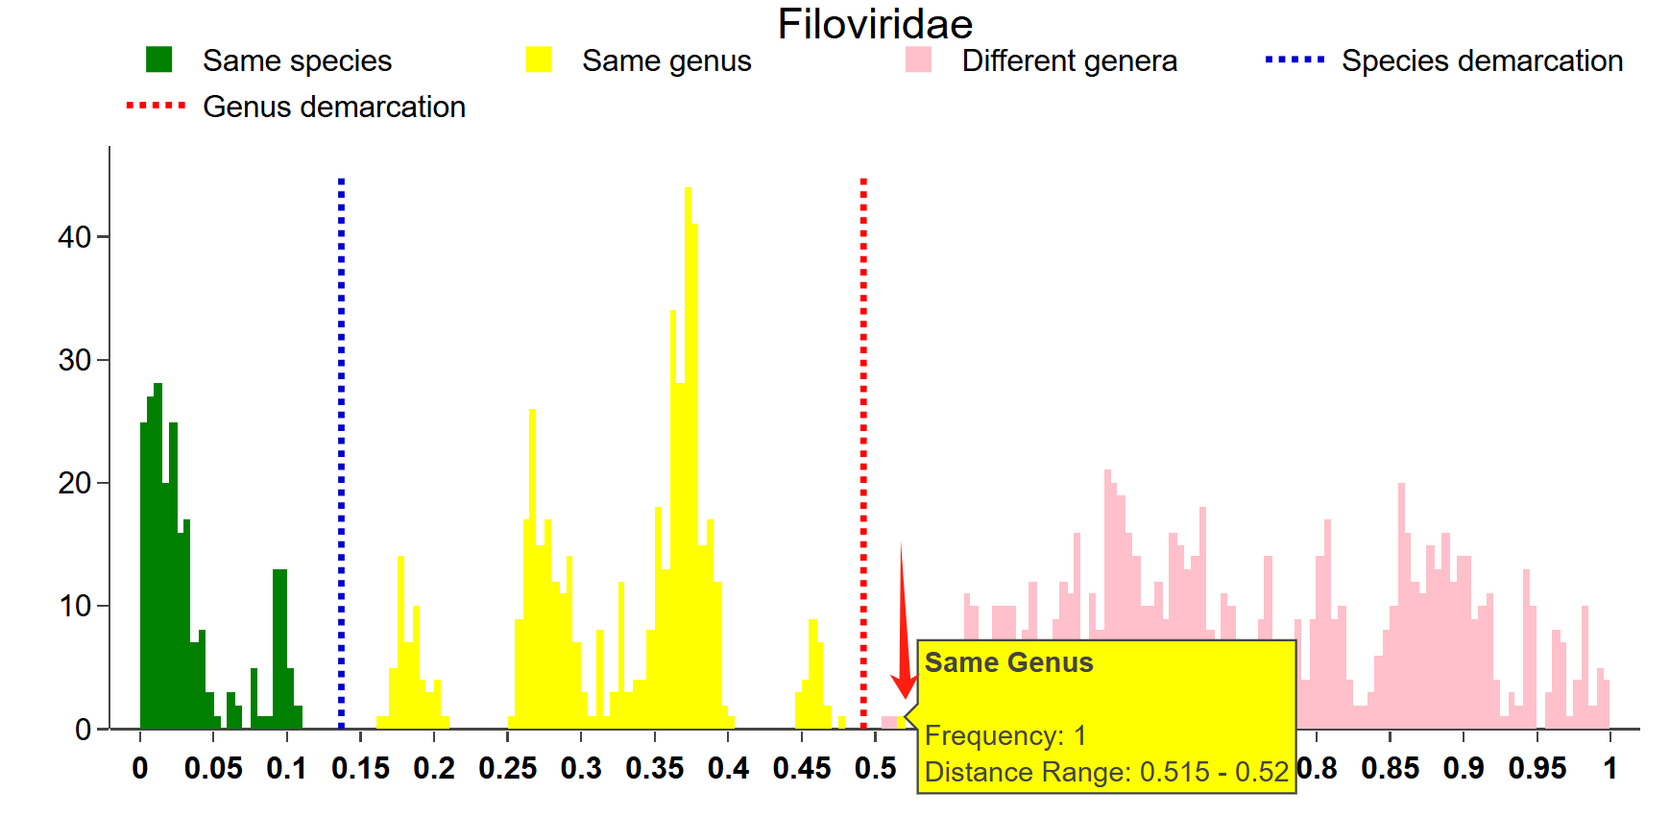

Figure 2. Screenshot of VISTA analysis for DEHV:
