

Part 1: TITLE, AUTHORS, APPROVALS, etc

Code assigned: | 2022.010M
Short title: New free-floating negarnaviricot family, genus, and species
Author(s) and email address(es)
Kuhn JH, Koonin E, Wolf Y, Rodrigues TCS, Waltzek TB | kuhnjens@mail.nih.gov; koonin@ncbi.nlm.nih.gov; wolf@ncbi.nlm.nih.gov; thaiscarneiro_25@hotmail.com; tomwaltzek@gmail.com
Author(s) institutional address(es) (optional)
Corresponding author
Waltzek TB
List the ICTV Study Group(s) that have seen this proposal
ICTV Negarnaviricota Study Group
ICTV Study Group comments and response of proposer
Approved
ICTV Study Group votes on proposal
Study Group | Number of members
Study Group | Votes support | Votes against | No vote
ICTV Negarnaviricota Study Group | 4 | 0 | 0
Authority to use the name of a living person
Is any taxon name used here derived from that of a living person (Y/N) | Y

Taxon name | Person from whom the name is derived | Permission attached (Y/N)
Fraservirus | William A. Fraser | Y

Submission dates
Date first submitted to SC Chair | May 27, 2022
Date of this revision (if different to above)
ICTV-EC comments and response of the proposer
Part 2: NON-TAXONOMIC PROPOSAL
Text of proposal

Part 3: TAXONOMIC PROPOSAL
Name of accompanying Excel module
2022.010M.N.v1.Fraservirus_1nfam_1ngen_1nsp.xlsx
Abstract
We propose classification of a novel virus, turtle fraservirus 1 (TFV-1). TFV-1 was isolated from diseased freshwater and softshell turtles in cell culture, its particles were characterized by electron microscopy, and its coding-complete genome sequence and genome organization was determined. Although superficially resembling the ambisense genome organization of arenavirids (Negarnaviricota: Polyploviricotina: Bunyavirales),
phylogenetic analysis of TVF-1’s RNA-directed RNA polymerase (RdRP) demonstrates it to be highly diverged from the RdRPs of all classified negarnaviricots. In contrast, TVF-1’s glycoprotein precursor (GPC) is affiliated with those of actinoviruses (Negarnaviricota: Polyploviricotina: Bunyavirales: Hantaviridae). Consequently, TFV-1 can currently not be assigned to established negarnaviricot taxa and we propose it to represent a novel floating family, genus, and species in phylum Negarnaviricota.
Text of proposal
A novel virus, turtle fraservirus 1 (TFV-1) was isolated in terrapene heart (TH-1) cells (Figure 1) from diseased freshwater turtles from a Florida farm in 2007 and from a 2022 epizootic among free-ranging populations of Florida softshell turtles (trionychid Apalone ferox (Schneider, 1783)), Florida red-bellied cooters (emydid Pseudemys nelson Carr, 1938), and peninsula cooters (emydid Pseudemys peninsularis Carr, 1938) [1]. Ultrastructurally, TFV-1 particles were round to pleomorphic with prominent surface projections (Figures 2 and 3) [1]. The TFV-1 genome was sequenced from cDNA libraries of two nearly identical isolates and determined to be bi-segmented, with an ambisense coding arrangement. The larger segment encodes a predicted RNA-directed RNA polymerase (RdRP) and a putative zinc-binding matrix (Z) protein. The smaller segment encodes a putative nucleoprotein (NP) and an envelope glycoprotein precursor (GPC) (Figure 4) [1]. Thus, the genome organization of TFV-1 resembles that of arenavirids (Negarnaviricota: Polyploviricotina: Bunyavirales). Phylogenetic analysis, however, demonstrates the TFV-1 RdRP to be highly divergent from the RdRPs of all classified negarnaviricots and to form a deep branch within phylum Negarnaviricota that is not affiliated with any known clade of viruses even at the class or possibly subphylum rank (interestingly, in this n=1 dataset, TFV-1 appears to be more closely related to haploviricotines than to polyploviricotines) (Figure 5A). In contrast, TVF-1’s glycoprotein precursor (GPC) is affiliated with those of actinoviruses (Negarnaviricota: Bunyavirales: Hantaviridae) (Figure 5B) [1]. Consequently, TFV-1 can currently not be assigned to established negarnaviricot taxa and we propose it to represent a novel floating family (Tosoviridae), genus (Fraservirus), and species (Fraservirus testudinis) in phylum Negarnaviricota. The unusual, apparently chimeric genome organization of TFV-1 and the extreme divergence of its RdRP from those of other negarnaviricots suggest the possibility that TFV-1 becomes the founder of an even higher rank taxon, perhaps, at the class rank. However, we consider it premature to propose a new class or order at this stage until additional, related viruses are described and the phylogenetic position and the main features of this new group of viruses are more strongly supported.

Supporting evidence
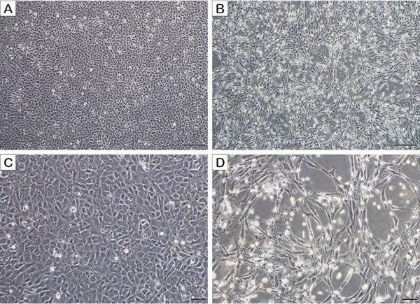
Figure 1. In vitro growth characteristics of TFV-1 in terrapene heart (TH-1) cells (viral passage 2). A) and C) uninfected TH-1 cells, 8 days post-inoculation (dpi). B) and D) appearance of plaques within the TH-1 monolayer 8 dpi. Affected cells appear refractile and either elongated and spindly or rounded. Scale bars in A and B = 200 μm, C and D = 50 μm [1].

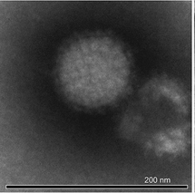
Figure 2. Negative stain electron photomicrograph illustrating the ultrastructural features of a TFV-1 spherical particle with prominent glycoprotein spikes [1].

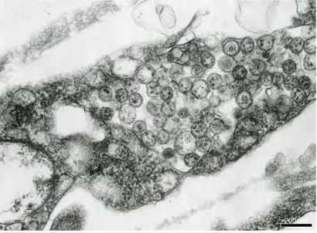
Figure 3. Thin section electron photomicrograph illustrating a cluster of round to oval TFV-1 particles present in a cytoplasmic vesicle of an infected terrapene heart (TH-1) cell [1].

Figure 4. Schematic representation of the TFV-1 genome. Open reading frames (ORFs) are shown as light blue boxes, the endonuclease domain in the RNA-directed RNA polymerase is indicated by an olive-green box and the conserved motifs are indicated by dark blue boxes. The glycosylation sites in the glycoprotein precursor polyprotein are marked by black lines above the ORF, the signal peptide is indicated by a red box and the transmembrane domain is indicated by an orange box. Abbreviations: Z, zinc-finger protein; RdRP, RNA-directed RNA polymerase; GPC, glycoprotein precursor polyprotein; N, nucleoprotein; IGR, non-coding intergenic region; EN, endonuclease; Pre A, premotif A; A, motif A; B, motif B; C, motif C; D, motif D; SP, signal peptide; TM, transmembrane domain [1].

Figure 5. Phylogenies of the RdRP and GPC of TVF-1. A) Maximum likelihood tree (inferred with IQ-tree and the rtREV+F+R9 model) constructed from a collection of custom profiles for the RdRPs of all known negarnaviricots. Only the seven established order-rank clades are shown (lower taxa in each clade are collapsed). B) Maximum likelihood tree (inferred with IQ-tree and the WAG+F+R9 model) constructed from a collection of bunyaviral-like glycoproteins. Only the 7 family-rank clades of order Bunyavirales are shown (lower taxa in each clade are collapsed). Scale bars indicate average amino acid substitutions per site. Both trees are unrooted [1].

References
1. Waltzek TB, Stacy BA, Ossiboff RJ, Stacy NI, Fraser WA, Yan A, Mohan S, Koonin EV, Wolf YI, Rodrigues TCS, Viadanna PHO, Subramaniam K, Popov VL, Guzman-Vargas V, Shender LA (2022) A novel group of negative-sense RNA viruses associated with epizootics in managed and free-ranging freshwater turtles in Florida, USA. PLoS Pathog 18:e1010258. PMID: 35275967. PMCID: PMC8916662. doi: 10.1371/journal.ppat.1010258.

