

Code assigned: | 2019.001M
Short title: Create one new species in the genus Lyssavirus
Modules attached |  | 1 2 3 4
Author(s):
Ivan V. Kuzmin
Corresponding author with e-mail address:
ivkuzmin@yandex.ru
List the ICTV study group(s) that have seen this proposal:
 |  |  | Rhabdoviridae Study Group
ICTV Study Group comments (if any) and response of the proposer:
Supported by 11 of 13 SG members with limited corrections related to formatting and spelling errors. There were two non-responders.
Date first submitted to ICTV:
Date of this revision (if different to above):

ICTV-EC comments and response of the proposer:

Part 2: PROPOSED TAXONOMY
Present the proposed new taxonomy on accompanying spreadsheet
Name of accompanying spreadsheet: 2019.001M.A.v1.Lyssavirus.xlsx

Part 4: APPENDIX: supporting material
Taiwan bat lyssavirus (TWBLV) was isolated twice, in 2016 and 2017, from moribund and dead Japanese pipistrelle bats (Pipistrellus abramus) in Taiwan. Complete genome sequences of both isolates available, MF472709 and MF472710.

The present species demarcation criteria within Lyssavirus genus include:

1. Genetic distances, with the threshold of 80–82% nucleotide identity for the complete N gene, that provides better quantitative resolution compared to other genes, or 80–81% nucleotide identity for concatenated coding regions of N+P+M+G+L Globally, all isolates belonging to the same species have higher identity values than the threshold, except the viruses currently assigned to the species Lagos bat lyssavirus.

2. Topology and consistency of phylogenetic trees, obtained with various evolutionary models.

3. Antigenic patterns in reactions with anti-nucleocapsid monoclonal antibodies (preceded by serologic cross-reactivity and definition of lyssavirus serotypes, using polyclonal antisera).

4. Whenever available, additional characters, such as ecological properties, host and geographic range, pathological features are used.

Based on these, TWBLV should be assigned to a new lyssavirus species:

1. The TWBLV demonstrates genetic identity values below the demarcation threshold indicated above. It is most similar genetically to Irkut virus (N gene, 79.0-80.6%; concatenated coding N+P+M+G+L sequences, 74.0%) followed by European bat lyssavirus 1 (N gene, 78.8-79.4%; concatenated coding N+P+M+G+L sequences, 75.1%) and Duvenhage virus (N gene77.7-77.9%; concatenated coding N+P+M+G+L sequences, 73.2%); Appendix, Table 1.

2. Phylogenetically, TWBLV is placed ancestrally in the cluster joining the aforementioned Irkut virus, European bat lyssavirus 1 and Duvenhage virus; Appendix, Figure 1.

3. The most related genetically Irkut virus was repeatedly isolated in north-eastern Asia (Russia, China) from bats of another genus, Murina spp. Another related virus, European bat lyssavirus 1, circulates in Europe, and the primary reservoir host of this virus is also bat from another genus, Eptesicus serotinus. Finally, the third member of this cluster, Duvenhage virus, was isolated on several occasions in Africa, from an unidentified insectivorous bat and humans succumbed from rabies after bat bites. Therefore, ecologically and geographically TWBLV is separated substantially from the most genetically-related viruses.

Table 1. Genetic identities between TWBLV and lyssaviruses from other species based on separate gene sequences and concatenated coding N+P+M+G+L sequences (Hu et al., 2018).
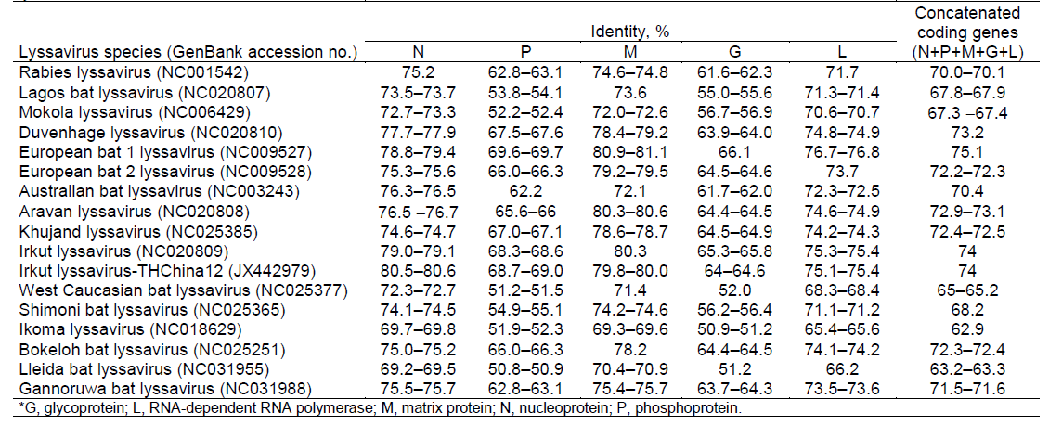

Figure 1. Phylogenetic position of TWBLV within Lyssavirus genus based on concatenated coding N+P+M+G+L gene sequences (Hu et al., 2018).
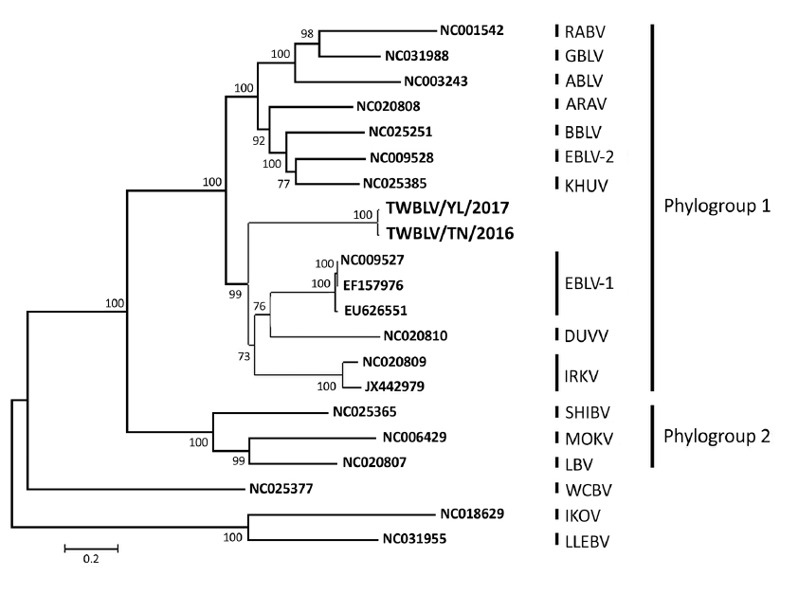
References:
Hu SC, Hsu CL, Lee MS, Tu YC, Chang JC, Wu CH, Lee SH, Ting LJ, Tsai KR, Cheng MC, Tu WJ, Hsu WC. Lyssavirus in Japanese Pipistrelle, Taiwan. Emerg Infect Dis. 2018. 24(4):782-785.

