
This Word module should be used for all taxonomic proposals.
Please complete Part 1 and:
either Part 3 for proposals to create new taxa or change existing taxa
or Part 2 for proposals of a general nature.
Submit the completed Word module, together with the accompanying Excel module named in Part 3, to the appropriate ICTV Subcommittee Chair.
For guidance, see the notes written in blue, below, and the help notes in file Taxonomic_Proposals_Help_2018.
Part 1: TITLE, AUTHORS, etc

Code assigned: | 2018.016M |  | (to be completed by ICTV officers)
Short title: One (1) new genus including one (1) new species in the family Bornaviridae (order Mononegavirales)
Author(s):
Dennis Rubbenstroth, dennis.rubbenstroth@fli.de
Thomas Briese, tb2047@cumc.columbia.edu
Ralf Dürrwald, ralf.duerrwald@t-online.de
Masayuki Horie, horie.masayuki.3m@kyoto-u.ac.jp
Tim Hyndman, T.Hyndman@murdoch.edu.au
Norbert Nowotny, norbert.nowotny@vetmeduni.ac.at
Susan Payne, SPayne@cvm.tamu.edu
Mark Stenglein, mark.stenglein@colostate.edu
Keizo Tomonaga, tomonaga@virus.kyoto-u.ac.jp
Jens H. Kuhn, kuhnjens@mail.nih.gov
Corresponding author with e-mail address:
Dennis Rubbenstroth, dennis.rubbenstroth@fli.de
List the ICTV study group(s) that have seen this proposal:
A list of study groups and contacts is provided at http://www.ictvonline.org/subcommittees.asp . If in doubt, contact the appropriate subcommittee chair (there are six virus subcommittees: animal DNA and retroviruses, animal ssRNA-, animal ssRNA+, fungal and protist, plant, bacterial and archaeal) |  | ICTV Bornaviridae Study Group
ICTV Study Group comments (if any) and response of the proposer:
Date first submitted to ICTV: |  |  | June 6, 2018
Date of this revision (if different to above):

ICTV-EC comments and response of the proposer:

Part 3: PROPOSED TAXONOMY

Name of accompanying Excel module: 2018.016M.N.v1.Cultervirus

As of 2018, the family Bornaviridae includes two genera: Orthobornavirus including eight species and Carbovirus including two species. At least four additional bornaviruses remain unclassified due to insufficient sequence information.

Criteria for bornavirus species demarcation are based on genomic characteristics, including PAirwise Sequence Comparison (PASC) (Bao et al., 2012, 2014), in combination with biological characteristics, such as antigenic relationships (Zimmermann et al., 2014) and natural host ranges (Kuhn et al., 2015). In agreement with these additional criteria, the range of the species differentiation cut-off for PASC of coding-complete genome sequences was defined as 72–75% pairwise nucleotide identity (Kuhn et al., 2015). A genus demarcation cut-off was initially set to ~45% pairwise nucleotide identity (Kuhn et al., 2017).

Recently, a coding-complete bornavirus genome was identified in a sharpbelly (Hemiculter leucisculus) from Wǔhàn, China, using metagenomic next generation sequencing (Shi et al., 2018). The virus was tentatively named Wǔhàn sharpbelly bornavirus (here abbreviated WhSBV). The virus has not been isolated in cell culture and no antigenicity data are available.

The genome organization of WhSBV is similar to that of the members of the genus Carbovirus (Figure 1), supporting its classification as a member of the family Bornaviridae. However, phylogenetic analysis and PASC analysis support its designation as a member of a new genus within the Bornaviridae.

PASC analysis using the WhSBV coding-complete genome sequence (GenBank MG599939.1) indicates that WhSBV represents a genus in the family distinct from Orthobornavirus and Carbovirus (Figure 2). The genome’s identity is well below the pairwise identities within the two established bornavirus genera (Orthobornavirus: >≈57%; Carbovirus: 69%) and below the initial genus-demarcation cut-off of ~45%.

Phylogenies inferred from alignments of the predicted L and N protein sequences of WhSBV and related bornavirus and endogenous bornavirus-like sequences (EBLS) show that WhSBV forms a clade together with a group of EBLS, but clearly distinct from the orthobornavirus-like and carbovirus-like clades.
The name of the new genus is proposed to be Cultervirus (from sharpbelly, species Hemiculter leucisculus in the subfamily Cultrinae). The species into which WhSBV is proposed to be classified is proposed to be called Sharpbelly cultervirus.

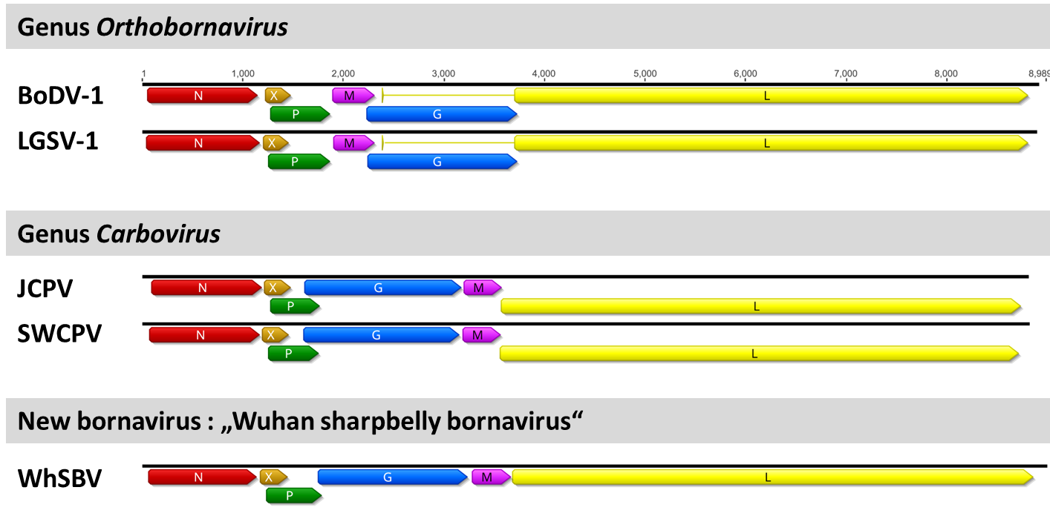

Figure 1. Genome organization of WhSBV and selected members of the genera Orthobornavirus and Carbovirus. Note that the genome organization of WhSBV resembles that of the members of the genus Carbovirus. BoDV-1: Borna disease virus 1; LGSV-1: Loveridge´s garter snake virus 1; JCPV: jungle carpet python virus; SWCPV: southwest carpet python virus.

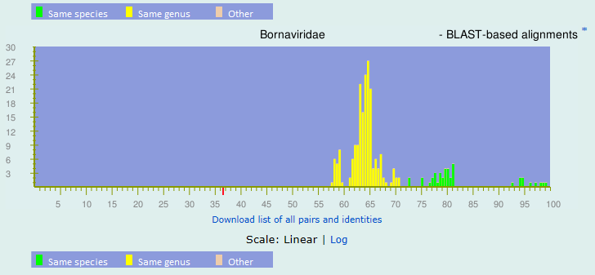

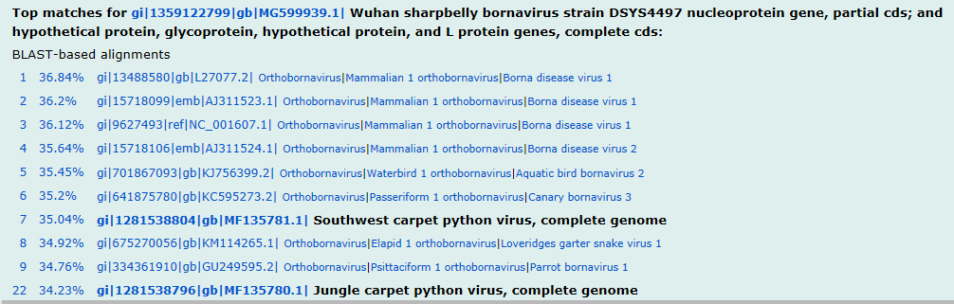

Figure 2. Histogram of Bornaviridae PASC analysis. Distribution of pairwise identities among complete sequences of viruses in the family Bornaviridae. Peaks above 72% identity (green) represent genome pairs belonging to the same species. Peaks below 71% and above 45% identity (yellow) represent genome pairs belonging to different species but the same genus. X-axis, percentage of identity; y-axis, number of genome pairs. The WhSBV genome shares < 37% pairwise identity with any of the previously described extant bornavirus genomes (indicated by red tick mark).

Figure 3. Phylogeny based on alignment of bornavirus N sequences. Putative protein sequences of members of the Bornaviridae (depicted in orange, blue, and green) and endogenous bornavirus-like sequences (depicted in black) are presented.

Figure 4. Phylogeny based on alignment of bornavirus L sequences and related sequences. Putative protein sequences of selected members of the families Bornaviridae and Nyamiviridae and endogenous bornavirus-like L (EBLL) sequences are presented. ABBV = aquatic bird bornavirus; BoDV = Borna disease virus; CnBV = canary bornavirus; JCPV = jungle carpet python virus; LGSV = Loveridge´s garter snake virus; NYMV = Nyamaninivirus; PaBV = parrot bornavirus; SbCNV = soybean cyst nematode virus; SWCPV = Southwest carpet python virus; VSBV = variegated squirrel bornavirus;

References:
Bao, Y., Chetvernin, V., Tatusova, T., 2012. PAirwise Sequence Comparison (PASC) and its application in the classification of filoviruses. Viruses 4, 1318-1327.

Bao, Y., Chetvernin, V., Tatusova, T., 2014. Improvements to pairwise sequence comparison (PASC): a genome-based web tool for virus classification. Arch Virol 159, 3293-3304.

Kuhn, J.H., Dürrwald, R., Bao, Y., Briese, T., Carbone, K., Clawson, A.N., deRisi, J.L., Garten, W., Jahrling, P.B., Kolodziejek, J., Rubbenstroth, D., Schwemmle, M., Stenglein, M., Tomonaga, K., Weissenböck, H., Nowotny, N., 2015. Taxonomic reorganization of the family Bornaviridae. Arch. Virol. 160, 621-632.

Kuhn, J.H., Stenglein, M., Wellehan, J., Rubbenstroth, D., Briese, T., Dürrwald, R., Horie, M., Nowotny, N., Payne, S.L., Schwemmle, M., Tomonaga, K., Hyndman, T., 2017. One (1) new genus including two (2) new species in the family Bornaviridae (order Mononegavirales). ICTV Taxonomic Proposal: 2017.005M. https://talk.ictvonline.org/files/ictv_official_taxonomy_updates_since_the_8th_report/m/animal-dsrna-and-ssrna--viruses/7145

Shi, M., Lin, X.D., Chen, X., Tian, J.H., Chen, L.J., Li, K., Wang, W., Eden, J.S., Shen, J.J., Liu, L., Holmes, E.C., Zhang, Y.Z., 2018. The evolutionary history of vertebrate RNA viruses. Nature. 556, 197-202

Zimmermann, V., Rinder, M., Kaspers, B., Staeheli, P., Rubbenstroth, D., 2014. Impact of antigenic diversity on laboratory diagnosis of Avian bornavirus infections in birds. J. Vet. Diagn. 26, 769-777.

