
This form should be used for all taxonomic proposals. Please complete all those modules that are applicable.
For guidance, see the notes written in blue and the separate document “Help with completing a taxonomic proposal”

Please try to keep related proposals within a single document.

Part 1: TITLE, AUTHORS, etc

Code assigned: | 2018.005M |  |  |  | (to be completed by ICTV officers)
Short title: One (1) new genus including two (2) new species in the family Arenaviridae
Modules attached  (Modules 1, 4 and either 2 or 3 are required. |  | 1 2 3 4
Author(s):
ICTV Arenaviridae Study Group:

Buchmeier, Michael J., m.buchmeier@uci.edu
Charrel, Rémi N., remi.charrel@univ-amu.fr
Clegg, Christopher S., cleggjcs@yahoo.fr
de la Torre, Juan C., juanct@scripps.edu
Gonzalez, Jean-Paul J., jpgonzalez2808@gmail.com
Günther, Stephan, guenther@bni.uni-hamburg.de
Kuhn, Jens H., kuhnjens@mail.nih.gov
Lukashevich, Igor S., isluka01@louisville.edu
Radoshitzky, Sheli R., sheli.r.radoshitzky.ctr@mail.mil
Romanowski, Víctor, vromanowski@gmail.com
Salvato, Maria S., msalvato@ihv.umaryland.edu
Sironi, Manuela, msironi@bp.lnf.it
Stenglein, Mark D., mark.stenglein@colostate.edu
Corresponding author with e-mail address:
de la Torre, Juan C., juanct@scripps.edu
List the ICTV study group(s) that have seen this proposal:
A list of study groups and contacts is provided at http://www.ictvonline.org/subcommittees.asp . If in doubt, contact the appropriate subcommittee chair (there are six virus subcommittees: animal DNA and retroviruses, animal ssRNA-, animal ssRNA+, fungal and protist, plant, bacterial and archaeal) |  |  | ICTV Arenaviridae Study Group
ICTV Study Group comments (if any) and response of the proposer:
The names proposed for the new genus (Antennavirus) and new two species (Striated antennavirus and Hairy antennavirus) were determined based on consensus by the majority of the ICTV Arenaviridae Study Group members (11 in favor, 1 abstention, 1 no vote registered).
Date first submitted to ICTV: |  |  |  | June 6, 2018
Date of this revision (if different to above):

ICTV-EC comments and response of the proposer:

Name of accompanying Excel module: 2018.005M.N.v1.Antennavirus

Part 2: PROPOSED TAXONOMY
Shi and colleagues (1) used a large-scale meta-transcriptomic approach to examine the evolutionary history of RNA viruses in vertebrates, including basal vertebrate lineages whose viromes had been rarely examined. These studies identified two novel arenaviruses, tentatively referred to as Wēnlǐng frogfish arenavirus 1 and Wēnlǐng frogfish arenavirus 2, in striated/hairy frogfish (Antennarius striatus). For both viruses the authors presented complete genome sequences in RNA samples prepared from three different tissues (gut, liver and lung). These sequences have been deposited into GenBank. Currently, there are no biological isolates of these two viruses.

The genomic termini of both L and S segments of these two newly identified arenaviruses are predicted to form the characteristic panhandles seen in mammarenavirus, reptarenavirus, and hartmanivirus genomes. However, unlike other arenaviruses, the NP and GPC ORFs are encoded on different segments (NP on the shortest (S) segment and GPC on a slightly longer (M) segment), indicating that, like most other bunyaviruses, these two fish arenaviruses have tri-segmented genomes.

Amino acid alignments of NP and L were used to generate Phylogenetic trees in RAxML 8.2.4 with 1,000 bootstraps (Fig 1 A and 1B). In both phylogenies, the two ray-finned fish arenaviruses form a distinct evolutionary branch with Haartman Institute snake virus and fall basal to all known mammarenaviruses and reptarenaviruses.

The ICTV Arenaviridae Study Group has recommended the use of the NCBI PAirwise Sequence Comparison (PASC) tool (https://www.ncbi.nlm.nih.gov/sutils/pasc/viridty.cgi?textpage=overview) for the assessment of novel arenaviruses (Radoshitzky et al.). Cut-off values chosen for classifying arenaviruses belonging to the same species using this tool are >80% and >76% nucleotide sequence identity in the S and L segments, respectively. Cut-off values chosen for classifying arenaviruses belonging to the same genus using this tool are >29-40% and >30-35% nucleotide sequence identity in the S and L segments, respectively. PASC analyses was done to compare both Wēnlǐng frogfish arenavirus 1 and Wēnlǐng frogfish arenavirus 2 to other GenBank-deposited arenaviruses (Fig. 2). Because Wēnlǐng frogfish arenavirus 1 and Wēnlǐng frogfish arenavirus 2 have tri-segmented genomes, we used the terms S and M to refer to segments encoding for the nucleoprotein (NP) and glycoprotein (GP), respectively, and compared both against deposited ambisense arenavirus S segments. Results from PASC showed that Wēnlǐng frogfish arenavirus 1 and Wēnlǐng frogfish arenavirus 2 had <20% nucleotide sequence identity in their L segments compared to other arenaviruses. Likewise, both Wēnlǐng frogfish arenavirus 1 and Wēnlǐng frogfish arenavirus 2 had <22% and <14% nucleotide sequence identity in their S and M segments, respectively, when compared to the S segment of other arenaviruses. Moreover, Wēnlǐng frogfish arenavirus 1 and Wēnlǐng frogfish arenavirus 2 have <46%, <39%, and <20% nucleotide sequence identity between their L, S, and M segments, respectively. These results justify the creation of a novel genus (Antennavirus) including two new species (Striated antennavirus and Hairy antennavirus) for Wēnlǐng frogfish arenavirus 1 and Wēnlǐng frogfish arenavirus 2, respectively. The names of the genus (Antennavirus) and its two proposed species (Striated antennavirus and Hairy antennavirus) are derived from the host in which both viruses were found, the striated/hairy frogfish (Antennarius striatus). Until further antennaviruses are identified, we propose to apply the species demarcation criteria for mammarenaviruses/reptarenaviruses to this novel genus (antennaviruses belong to the same species if there is >80% and >76% nucleotide sequence identity in the S and L segments by PASC, respectively).

Figure 1A:
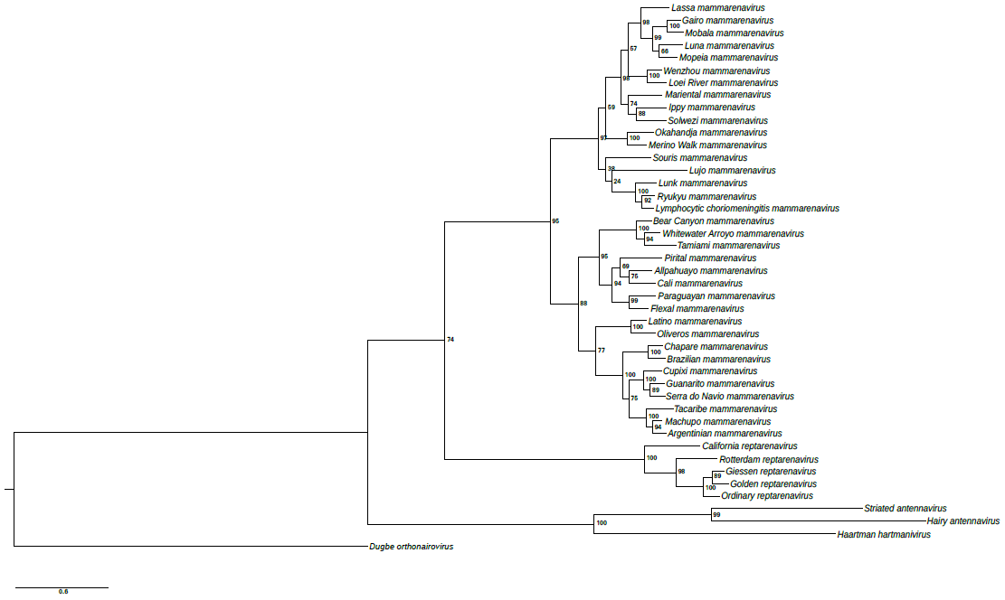Figure 1B:
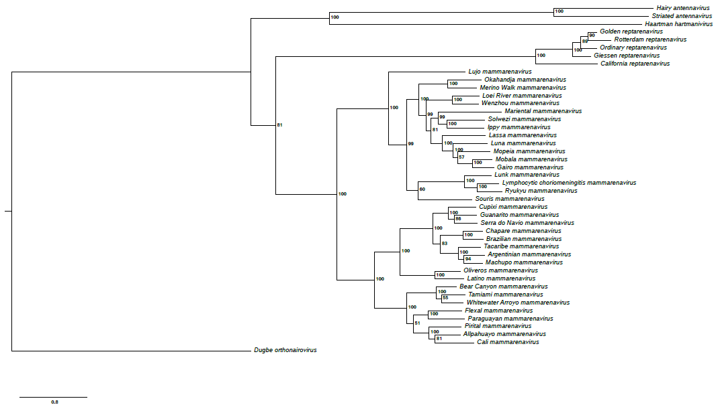

Figure 2:
Top matches for gi|1359122962|gb|MG599863.1| Wēnlǐng frogfish arenavirus 1 strain XYHYG11303 segment L, complete sequence:
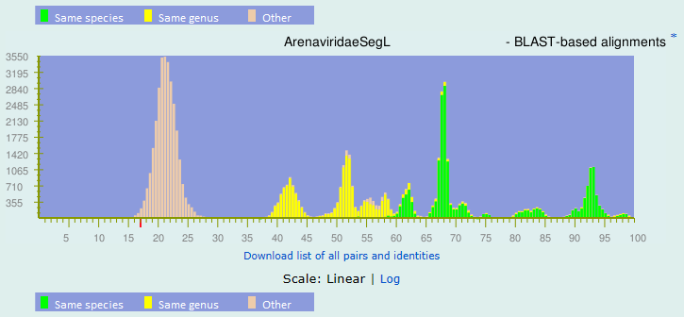BLAST-based alignments
1 |  | 17.02% |  | gi|821492023|gb|KP071485.1| Reptarenavirus|unclassified Reptarenavirus|unidentified Reptarenavirus
2 |  | 16.96% |  | gi|821492041|gb|KP071491.1| Reptarenavirus|unclassified Reptarenavirus|unidentified Reptarenavirus
3 |  | 16.88% |  | gi|821492281|gb|KP071569.1| Reptarenavirus|unclassified Reptarenavirus|unidentified Reptarenavirus
4 |  | 16.8% |  | gi|821492440|gb|KP071617.1| Reptarenavirus|unclassified Reptarenavirus|unidentified Reptarenavirus
5 |  | 16.69% |  | gi|821492361|gb|KP071591.1| Reptarenavirus|unclassified Reptarenavirus|unidentified Reptarenavirus
6 |  | 16.57% |  | gi|821492342|gb|KP071586.1| Reptarenavirus|unclassified Reptarenavirus|unidentified Reptarenavirus
7 |  | 16.42% |  | gi|821492236|gb|KP071554.1| Reptarenavirus|unclassified Reptarenavirus|unidentified Reptarenavirus
8 |  | 16.31% |  | gi|821492075|gb|KP071505.1| Reptarenavirus|unclassified Reptarenavirus|unidentified Reptarenavirus
9 |  | 16.23% |  | gi|821492026|gb|KP071486.1| Reptarenavirus|unclassified Reptarenavirus|unidentified Reptarenavirus
10 |  | 16.22% |  | gi|821492512|gb|KP071634.1| Reptarenavirus|unclassified Reptarenavirus|unidentified Reptarenavirus
11 |  | 16.21% |  | gi|821492494|gb|KP071629.1| Reptarenavirus|unclassified Reptarenavirus|unidentified Reptarenavirus
12 |  | 16.18% |  | gi|821492305|gb|KP071576.1| Reptarenavirus|unclassified Reptarenavirus|unidentified Reptarenavirus
13 |  | 16.17% |  | gi|821492289|gb|KP071572.1| Reptarenavirus|unclassified Reptarenavirus|unidentified Reptarenavirus
14 |  | 16.13% |  | gi|821492692|gb|KP071679.1| Reptarenavirus|unclassified Reptarenavirus|unidentified Reptarenavirus
15 |  | 16.01% |  | gi|821492499|gb|KP071631.1| Reptarenavirus|unclassified Reptarenavirus|unidentified Reptarenavirus

Top matches for gi|1359122964|gb|MG599864.1| Wēnlǐng frogfish arenavirus 1 strain XYHYG11303 segment S, complete sequence:
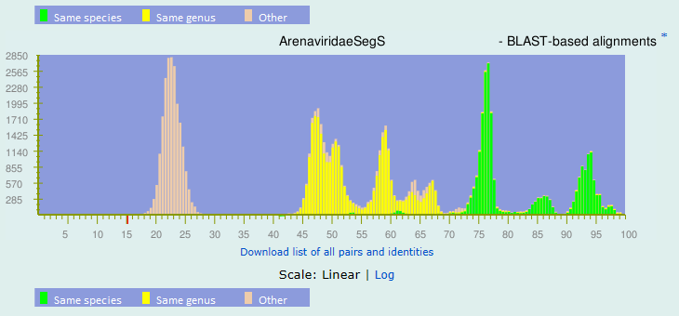
BLAST-based alignments
1 |  | 15.49% |  | gi|529367599|gb|KF297880.1| Reptarenavirus|Alethinophid 2 reptarenavirus|University of Helsinki virus
2 |  | 15.4% |  | gi|821492864|gb|KP071524.1| Reptarenavirus|unclassified Reptarenavirus|unidentified Reptarenavirus
3 |  | 15.4% |  | gi|401466642|gb|JQ717264.1| Reptarenavirus|Alethinophid 1 reptarenavirus|Golden Gate virus
4 |  | 15.17% |  | gi|846118720|gb|KR870011.1| Reptarenavirus|Alethinophid 2 reptarenavirus|University of Helsinki virus
5 |  | 15.17% |  | gi|821492911|gb|KP071541.1| Reptarenavirus|unclassified Reptarenavirus|unidentified Reptarenavirus
6 |  | 14.97% |  | gi|1134943167|gb|KX527575.1| Reptarenavirus|unclassified Reptarenavirus|Tavallinen suomalainen mies virus
7 |  | 14.56% |  | gi|115383200|gb|DQ868485.1| Mammarenavirus|Lymphocytic choriomeningitis mammarenavirus
8 |  | 14.27% |  | gi|23334588|ref|NC_004294.1| Mammarenavirus|Lymphocytic choriomeningitis mammarenavirus
9 |  | 14.23% |  | gi|186970541|gb|EU486821.1| Mammarenavirus|Tamiami mammarenavirus
10 |  | 14.1% |  | gi|408354939|gb|JX560798.1| Mammarenavirus|Whitewater Arroyo mammarenavirus|North American arenavirus
11 |  | 13.75% |  | gi|13274351|gb|AF277659.1| Mammarenavirus|Pirital mammarenavirus
12 |  | 13.75% |  | gi|22901281|gb|AF485257.1| Mammarenavirus|Flexal mammarenavirus
13 |  | 13.39% |  | gi|50981062|gb|AY575850.1| Mammarenavirus|Pirital mammarenavirus
14 |  | 13.18% |  | gi|821493088|gb|KP071619.1| Reptarenavirus|unclassified Reptarenavirus|unidentified Reptarenavirus
15 |  | 13.14% |  | gi|189043026|ref|NC_010756.1| Mammarenavirus|Paraguayan mammarenavirus

Top matches for gi|1359122966|gb|MG599865.1| Wēnlǐng frogfish arenavirus 1 strain XYHYG11303 segment M, complete sequence:
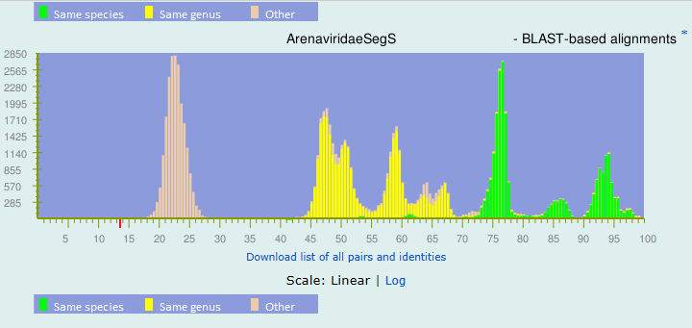
BLAST-based alignments
1 |  | 13.67% |  | gi|49037392|gb|AY628205.1| Mammarenavirus|Lassa mammarenavirus
2 |  | 13.53% |  | gi|695314004|gb|KM821871.1| Mammarenavirus|Lassa mammarenavirus
3 |  | 13.5% |  | gi|316308883|gb|GU481076.1| Mammarenavirus|Lassa mammarenavirus
4 |  | 13.43% |  | gi|695314820|gb|KM821961.1| Mammarenavirus|Lassa mammarenavirus
5 |  | 13.28% |  | gi|695315656|gb|KM822089.1| Mammarenavirus|Lassa mammarenavirus
6 |  | 13.15% |  | gi|49037380|gb|AY628201.1| Mammarenavirus|Lassa mammarenavirus
7 |  | 13.1% |  | gi|12007537|gb|AY012686.1| Mammarenavirus|Allpahuayo mammarenavirus
8 |  | 13.09% |  | gi|695314987|gb|KM821977.1| Mammarenavirus|Lassa mammarenavirus
9 |  | 13% |  | gi|695313681|gb|KM821835.1| Mammarenavirus|Lassa mammarenavirus
10 |  | 12.94% |  | gi|695314956|gb|KM821974.1| Mammarenavirus|Lassa mammarenavirus
11 |  | 12.93% |  | gi|695314975|gb|KM821976.1| Mammarenavirus|Lassa mammarenavirus
12 |  | 12.91% |  | gi|821493098|gb|KP071630.1| Reptarenavirus|unclassified Reptarenavirus|unidentified Reptarenavirus
13 |  | 12.77% |  | gi|695315400|gb|KM822057.1| Mammarenavirus|Lassa mammarenavirus
14 |  | 12.63% |  | gi|164682564|ref|NC_010253.1| Mammarenavirus|Allpahuayo mammarenavirus
15 |  | 12.53% |  | gi|695315788|gb|KM822103.1| Mammarenavirus|Lassa mammarenavirus

Top matches for gi|1359122969|gb|MG599866.1| Wēnlǐng frogfish arenavirus 2 strain XYHYG24857 segment L, complete sequence:
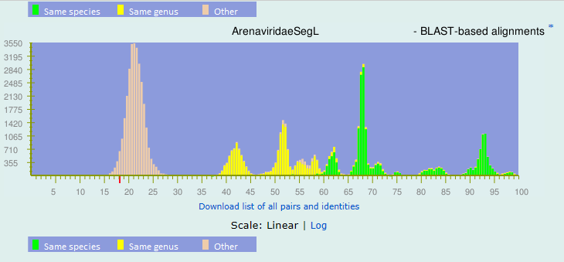BLAST-based alignments
1 |  | 18.38% |  | gi|695313564|gb|KM821821.1| Mammarenavirus|Lassa mammarenavirus
2 |  | 16.85% |  | gi|164607196|ref|NC_010250.1| Mammarenavirus|Oliveros mammarenavirus
3 |  | 16.75% |  | gi|34365526|ref|NC_005080.1| Mammarenavirus|Junin mammarenavirus
4 |  | 16.65% |  | gi|172088174|ref|NC_010563.1| Mammarenavirus|Chapare mammarenavirus
5 |  | 16.55% |  | gi|695313581|gb|KM821823.1| Mammarenavirus|Lassa mammarenavirus
6 |  | 16.51% |  | gi|164519632|gb|AY216503.2| Mammarenavirus|Bear Canyon mammarenavirus
7 |  | 16.5% |  | gi|821492369|gb|KP071594.1| Reptarenavirus|unclassified Reptarenavirus|unidentified Reptarenavirus
8 |  | 16.46% |  | gi|821492327|gb|KP071584.1| Reptarenavirus|unclassified Reptarenavirus|unidentified Reptarenavirus
9 |  | 16.45% |  | gi|821492201|gb|KP071544.1| Reptarenavirus|unclassified Reptarenavirus|unidentified Reptarenavirus
10 |  | 16.35% |  | gi|1134943188|gb|KX527582.1| Reptarenavirus|unclassified Reptarenavirus|Tavallinen suomalainen mies virus
11 |  | 16.27% |  | gi|821492476|gb|KP071624.1| Reptarenavirus|unclassified Reptarenavirus|unidentified Reptarenavirus
12 |  | 16.19% |  | gi|821492268|gb|KP071566.1| Reptarenavirus|unclassified Reptarenavirus|unidentified Reptarenavirus
13 |  | 16.12% |  | gi|162945387|gb|EU136039.1| unclassified Arenaviridae|Arenavirus|Old world arenaviruses|unclassified Old world arenaviruses|Dandenong virus
14 |  | 16.12% |  | gi|821491999|gb|KP071477.1| Reptarenavirus|unclassified Reptarenavirus|unidentified Reptarenavirus
15 |  | 15.94% |  | gi|821492286|gb|KP071570.1| Reptarenavirus|unclassified Reptarenavirus|unidentified Reptarenavirus

Top matches for gi|1359122971|gb|MG599867.1| Wēnlǐng frogfish arenavirus 2 strain XYHYG24857 segment S, complete sequence:
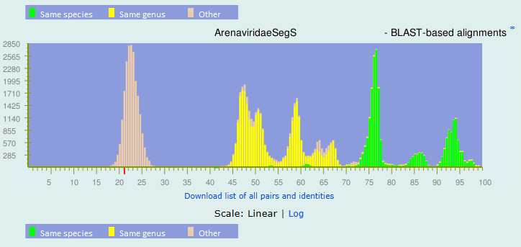
BLAST-based alignments
1 |  | 21.17% |  | gi|162945384|gb|EU136038.1| unclassified Arenaviridae|Arenavirus|Old world arenaviruses|unclassified Old world arenaviruses|Dandenong virus
2 |  | 20.22% |  | gi|399769793|dbj|AB697691.1| Mammarenavirus|Luna mammarenavirus
3 |  | 20.06% |  | gi|89902998|ref|NC_007905.1| Mammarenavirus|Ippy mammarenavirus
4 |  | 19.82% |  | gi|383212114|dbj|AB627953.1| Mammarenavirus|Lymphocytic choriomeningitis mammarenavirus
5 |  | 19.66% |  | gi|308097146|gb|GQ862982.1| Mammarenavirus|Lymphocytic choriomeningitis mammarenavirus
6 |  | 18.86% |  | gi|108743534|dbj|AB261990.1| Mammarenavirus|Lymphocytic choriomeningitis mammarenavirus
7 |  | 18.75% |  | gi|383385891|gb|JN872495.1| Mammarenavirus|Lymphocytic choriomeningitis mammarenavirus
8 |  | 18.68% |  | gi|258489117|gb|FJ607029.1| Mammarenavirus|Lymphocytic choriomeningitis mammarenavirus
9 |  | 18.66% |  | gi|695313449|gb|KM821808.1| Mammarenavirus|Lassa mammarenavirus
10 |  | 18.48% |  | gi|238890537|ref|NC_012776.1| Mammarenavirus|Lujo mammarenavirus
11 |  | 18.48% |  | gi|85542276|gb|DQ328874.1| Mammarenavirus|Mopeia mammarenavirus
12 |  | 18.45% |  | gi|115383206|gb|DQ868487.1| Mammarenavirus|Lymphocytic choriomeningitis mammarenavirus
13 |  | 18.45% |  | gi|1032562884|gb|KT992421.1| Mammarenavirus|Lassa mammarenavirus
14 |  | 18.38% |  | gi|323147114|gb|GU830848.1| unclassified Arenaviridae|Arenavirus|Old world arenaviruses|unclassified Old world arenaviruses|Gbagroube virus
15 |  | 18.37% |  | gi|570339355|gb|KC669699.1| Mammarenavirus|Loei River mammarenavirus

Top matches for gi|1359122973|gb|MG599868.1| Wēnlǐng frogfish arenavirus 2 strain XYHYG24857 segment M, complete sequence:
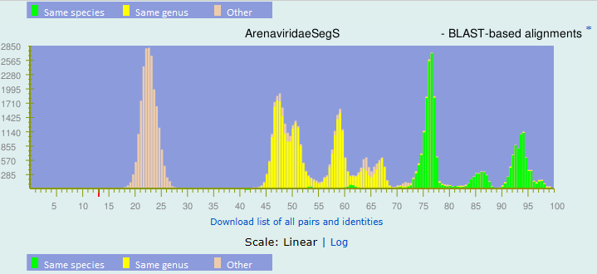BLAST-based alignments
1 |  | 13.06% |  | gi|695314603|gb|KM821933.1| Mammarenavirus|Lassa mammarenavirus
2 |  | 12.85% |  | gi|48696000|ref|NC_005894.1| Mammarenavirus|Pirital mammarenavirus
3 |  | 12.84% |  | gi|529367599|gb|KF297880.1| Reptarenavirus|Alethinophid 2 reptarenavirus|University of Helsinki virus
4 |  | 12.81% |  | gi|13274351|gb|AF277659.1| Mammarenavirus|Pirital mammarenavirus
5 |  | 12.68% |  | gi|695314415|gb|KM821912.1| Mammarenavirus|Lassa mammarenavirus
6 |  | 12.55% |  | gi|695315531|gb|KM822074.1| Mammarenavirus|Lassa mammarenavirus
7 |  | 12.46% |  | gi|695315091|gb|KM821988.1| Mammarenavirus|Lassa mammarenavirus
8 |  | 12.26% |  | gi|695315341|gb|KM822043.1| Mammarenavirus|Lassa mammarenavirus
9 |  | 12.19% |  | gi|164607193|ref|NC_010248.1| Mammarenavirus|Oliveros mammarenavirus
10 |  | 12.06% |  | gi|695315409|gb|KM822059.1| Mammarenavirus|Lassa mammarenavirus
11 |  | 12.04% |  | gi|695315292|gb|KM822029.1| Mammarenavirus|Lassa mammarenavirus
12 |  | 12.02% |  | gi|695315509|gb|KM822071.1| Mammarenavirus|Lassa mammarenavirus
13 |  | 12.01% |  | gi|695314804|gb|KM821959.1| Mammarenavirus|Lassa mammarenavirus
14 |  | 11.97% |  | gi|695315265|gb|KM822020.1| Mammarenavirus|Lassa mammarenavirus
15 |  | 11.94% |  | gi|695315731|gb|KM822097.1| Mammarenavirus|Lassa mammarenavirus

Top matches for gi|1359122962|gb|MG599863.1| Wēnlǐng frogfish arenavirus 1 strain XYHYG11303 segment L, complete sequence:
BLAST-based alignments
1 |  | 45.65% |  | gi|1359122969|gb|MG599866.1| Wēnlǐng frogfish arenavirus 2 strain XYHYG24857 segment L, complete sequence

Top matches for gi|1359122964|gb|MG599864.1| Wēnlǐng frogfish arenavirus 1 strain XYHYG11303 segment S, complete sequence:
BLAST-based alignments
1 |  | 38.35% |  | gi|1359122971|gb|MG599867.1| Wēnlǐng frogfish arenavirus 2 strain XYHYG24857 segment S, complete sequence

Top matches for gi|1359122966|gb|MG599865.1| Wēnlǐng frogfish arenavirus 1 strain XYHYG11303 segment M, complete sequence:
BLAST-based alignments
1 |  | 19.75% |  | gi|1359122973|gb|MG599868.1| Wēnlǐng frogfish arenavirus 2 strain XYHYG24857 segment M, complete sequence

Part 4: APPENDIX: supporting material

References:
The evolutionary history of vertebrate RNA viruses.
Shi M, Lin XD, Chen X, Tian JH, Chen LJ, Wang W, Eden JS, Shen JJ, Liu L, Holmes EC, Zhang YZ. Nature 556, 197-202 (2018). Doi: 10.1038/s41586-018-0012-7.

Past, present, and future of arenavirus taxonomy.
Radoshitzky SR, Bào Y, Buchmeier MJ, Charrel RN, Clawson AN, Clegg CS, DeRisi JL, Emonet S, Gonzalez JP, Kuhn JH, Lukashevich IS, Peters CJ, Romanowski V, Salvato MS, Stenglein MD, de la Torre JC.
Arch Virol. 2015 Jul;160(7):1851-74. doi: 10.1007/s00705-015-2418-y.
PMID: 25935216

