

The International Committee on Taxonomy of Viruses
Taxonomy Proposal Form, 2024

Part 1a: Details of taxonomy proposals

Title: | Create a new phylum ‘Commensaviricota’ for the kingdom Shotokuvirae and family Anelloviridae
Code assigned: | 2024.012D.N.v1.Shotokuvirae_newphylum

Author(s), affiliation and email address(es):
Name | Affiliation | Email address | Corresponding author(s) X
Varsani A | The Biodesign Center for Fundamental and Applied Microbiomics, Center for Evolution and Medicine, School of Life Sciences, Arizona State University, Tempe, AZ, USA | arvind.varsani@asu.edu
Anamarija Butkovic | Institut Pasteur, Université Paris Cité, Archaeal Virology Unit, Paris, France | anamarija.butkovic@pasteur.fr
Simona Kraberger | The Biodesign Center for Fundamental and Applied Microbiomics, Center for Evolution and Medicine, School of Life Sciences, Arizona State University, Tempe, AZ, USA | Simona.kraberger@asu.edu
Eugene V. Koonin | National Center for Biotechnology Information, National Library of Medicine, Bethesda, MD, USA | koonin@ncbi.nlm.nih.gov
Mart Krupovic | Institut Pasteur, Université Paris Cité, Archaeal Virology Unit, Paris, France | mart.krupovic@pasteur.fr | X

Part 1b: Taxonomy Proposal Submission
ICTV Subcommittee:
Animal DNA Viruses and Retroviruses | X | Bacterial viruses
Animal minus-strand and dsRNA viruses |  | Fungal and protist viruses
Animal positive-strand RNA viruses |  | Plant viruses
Archaeal viruses |  | General -

List the ICTV Study Group(s) that have seen or have been involved in creating this proposal:
Anelloviridae SG

Optional – complete only if formally voted on by an ICTV Study Group:
Study Group | Number of members
Study Group | Votes in support | Votes against | No vote

Submission date: | 24/06/2024

Part 1c: Feedback from ICTV Executive Committee (EC) meeting
Executive Committee Meeting Decision code: | X
A – Accept
Ac – Accept subject to revision by relevant subcommittee chair. No further vote required
U – Accept without revision but with re-evaluation and email vote by the EC
Uc – Accept subject to revision and re-evaluation and email vote by the EC
Ud – Deferred to the next EC meeting, with an invitation to revise based on EC comments
J - Reject
W - Withdrawn

Comments from the Executive Committee:

Part 1d: Revised Taxonomy Proposal Submission
Response of proposer:
Revision date: | DD/MM/YYYY

Part 3: TAXONOMIC PROPOSAL

Name of accompanying Excel module:
2024.012D.N.v1.1.Shotokuvirae_newphylum.xlsx

Taxonomic changes proposed:
Establish new taxon |  | Split taxon
Abolish taxon |  | Merge taxon
Move taxon |  | Promote taxon
Rename taxon |  | Demote taxon
Move and rename

Is any taxon name used here derived from that of a living person: |  | N
Taxon name | Person from whom the name is derived | Attached X

Abstract of Taxonomy Proposal:
Taxonomic rank(s) affected:
Monodnaviria, Shotokuvirae

Description of current taxonomy:
Currently, kingdom Shotokuvirae includes 2 phyla, with eukaryotic ssDNA and related dsDNA viruses classified into phyla Cressdnaviricota and Cossaviricota, respectively. Anelloviridae is the only family of eukaryotic ssDNA viruses not assigned to the realm Monodnaviria.

Proposed taxonomic change(s):
Move family Anelloviridae into a new order, within a new class and a new phylum ‘Commensaviricota’ within the kingdom Shotokuvirae. The intermediate taxa between the phylum and family, will be order ‘Sanitavirales’ and a class ‘Cardeaviricetes’.

Justification:
Sequence and structural comparisons suggest that anelloviruses have evolved from a circovirus-like ancestor through gradual augmentation of the capsid protein and loss of the Rep protein genes.

- Text of Taxonomy proposal:
Taxonomic rank(s) affected:
Monodnaviria, Shotokuvirae

Description of current taxonomy:
Currently, kingdom Shotokuvirae includes 2 phyla, with eukaryotic ssDNA and related dsDNA viruses classified into phyla Cressdnaviricota and Cossaviricota, respectively. Anelloviridae is the only family of eukaryotic ssDNA viruses not assigned to the realm Monodnaviria.

Proposed taxonomic change(s):
Move family Anelloviridae into a new order, within a new class and a new phylum ‘Commensaviricota’ within the kingdom Shotokuvirae. The intermediate taxa between the phylum and family, will be order ‘Sanitavirales’ and a class ‘Cardeaviricetes’.

Demarcation criteria:
Not applicable.

Justification:
Anelloviruses are highly prevalent in diverse mammals, including humans, but so far have not been linked to any disease and are considered to be part of the ‘healthy virome’. These viruses have small circular single-stranded DNA (ssDNA) genomes and encode several proteins with no detectable sequence similarity to proteins of other known viruses. Consequently, in the absence of an identifiable Rep or a capsid protein typical of other eukaryotic ssDNA viruses, Anelloviridae is the only family of eukaryote-infecting viruses with circular ssDNA genomes currently not included in the phylum Cressdnaviricota of the realm Monodnaviria (Koonin et al., 2020). Although anelloviruses appear not to encode a homolog of the typical Rep of the HUH endonuclease superfamily, recent sequence and structure-based comparisons showed that ORF1 orthologs from all Anelloviridae genera adopt a jelly-roll fold typical of cressdnaviricot capsid proteins, establishing an evolutionary link to other eukaryotic ssDNA viruses, specifically, circoviruses (Butkovic et al., 2023).

In particular, searches queried with the ORF1 sequence of torque teno virus 1 (TTV1; NP_817122) against the PDB and viral protein profile databases using HHsearch yielded a highly significant hit (Probability=95.8) to the CP of a bat circovirus (PDB id: 6RPO). Importantly, the aligned regions encompassed nearly the entirety of the circovirus CP but only ~30% of the anellovirus protein, highlighting the disparity in their respective sizes (233 versus 770 aa). Significant hits were also obtained with ORF1 sequences from viruses of other anellovirus genera (Butkovic et al., 2023).

Circovirus CPs contain an N-terminal arginine-rich region involved in DNA-binding (Sarker et al., 2016) and a single jelly-roll (SJR) domain comprising 8 antiparallel β-strands (B through I), which form 2 juxtaposed β-sheets, BIDG and CHEF (Fig. 1a). The anellovirus ORF1 protein also contains an arginine-rich N-terminal region similar to that of circovirus CPs. Structural modeling of representative ORF1 protein sequences from each of the established Anelloviridae genera with AlphaFold2 (Jumper et al., 2021) confirmed that in all ORF1 protein homologs, the arginine-rich domain is followed by the conserved SJR domain (Fig. 1b, 1c). Comparison of the ORF1 structural models from anelloviruses belonging to different genera explained their remarkable size variation and evolution of ORF1 proteins. It was found that the SJR domain shared with the circovirus CPs represents a conserved part of the proteins. The variation in ORF1 size (and sequence) could be attributed to a specific insertion (Projection domain) within a loop connecting the β-strands H and I (Fig. 2). Thus, it was proposed that anelloviruses evolved from a circovirus-like ancestor through a gradual augmentation of the Projection domain.

Given the shared evolutionary history between anelloviruses and other members of the Cressdnaviricota, in particular, we propose that anelloviruses should be included into the realm Monodnaviria, as a separate new phylum within the kingdom Shotokuvirae, alongside Cressdnaviricota and Cossaviricota. We propose assigning Anelloviridae to the order ‘Sanitavirales’ (after Latin sanitas for health, referring to anelloviruses being part of the healthy human virome), within class ‘Cardeaviricetes’ (after Cardea, Roman goddess of health) and phylum ‘Commensaviricota’, referring to the commensal lifestyle of anelloviruses.

References:
Butkovic A, Kraberger S, Smeele Z, Martin DP, Schmidlin K, Fontenele RS, Shero MR, Beltran RS, Kirkham AL, Aleamotu'a M, Burns JM, Koonin EV, Varsani A, Krupovic M. Evolution of anelloviruses from a circovirus-like ancestor through gradual augmentation of the jelly-roll capsid protein.
Virus Evol. 2023; 9(1):vead035. doi: 10.1093/ve/vead035. PMID: 37325085

Jumper J, Evans R, Pritzel A, Green T, Figurnov M, Ronneberger O, Tunyasuvunakool K, Bates R, Žídek A, Potapenko A, Bridgland A, Meyer C, Kohl SAA, Ballard AJ, Cowie A, Romera-Paredes B, Nikolov S, Jain R, Adler J, Back T, Petersen S, Reiman D, Clancy E, Zielinski M, Steinegger M, Pacholska M, Berghammer T, Bodenstein S, Silver D, Vinyals O, Senior AW, Kavukcuoglu K, Kohli P, Hassabis D. Highly accurate protein structure prediction with AlphaFold. Nature. 2021; 596(7873):583-589. doi: 10.1038/s41586-021-03819-2. PMID: 34265844

Koonin EV, Dolja VV, Krupovic M, Varsani A, Wolf YI, Yutin N, Zerbini FM, Kuhn JH. Global Organization and Proposed Megataxonomy of the Virus World. Microbiol Mol Biol Rev. 2020; 84(2):e00061-19. doi: 10.1128/MMBR.00061-19. PMID: 32132243

Sarker S, Terrón MC, Khandokar Y, Aragão D, Hardy JM, Radjainia M, Jiménez-Zaragoza M, de Pablo PJ, Coulibaly F, Luque D, Raidal SR, Forwood JK. Structural insights into the assembly and regulation of distinct viral capsid complexes. Nat Commun. 2016; 7:13014. doi: 10.1038/ncomms13014.
PMID: 27698405

Tables, Figures:
<Start here>
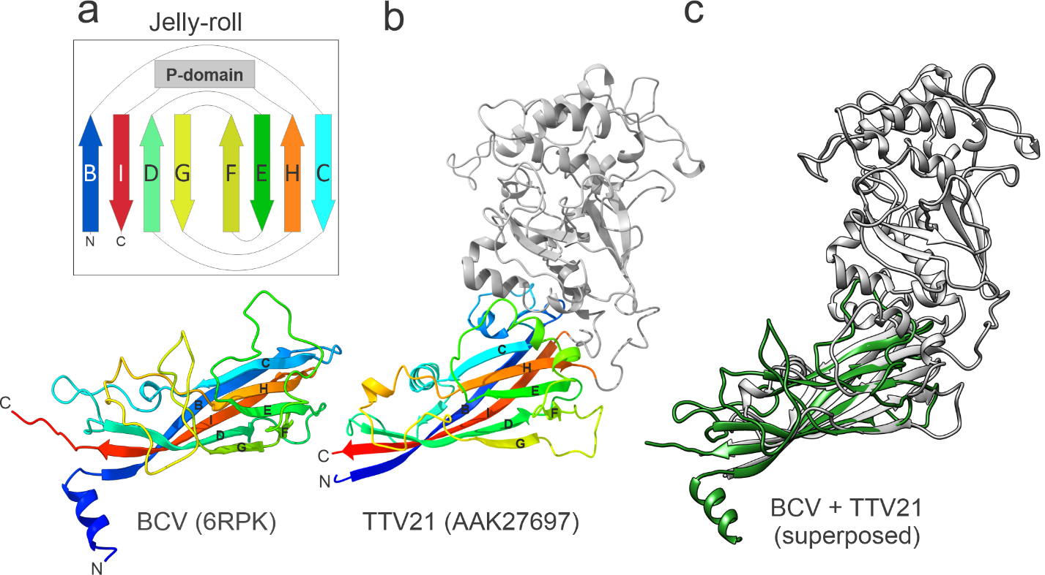
Figure 1. Structure of the circovirus jelly-roll capsid protein and structural model of anellovirus ORF1. A. Capsid protein of bat circovirus (BCV, family Circoviridae; PDB id: 6RPK) colored using the rainbow scheme from blue N-terminus to red C-terminus. The inset shows the schematic topology of the jelly-roll fold. The 8 -strands are labeled from B to I and form two antiparallel -sheets BIDG and CHEF. The location of the projection (P-)domain is shown as a grey rectangle. B. Structural model of ORF1 from torque teno virus 21 (TTV21, genus Alphatorquevirus; GenBank accession number: AAK27697). The jelly-roll domain shared with circoviruses is colored using the rainbow scheme, whereas the P-domain is shown in grey. C. The superposed structures of the BCV (green) and TTV21 (grey) structures.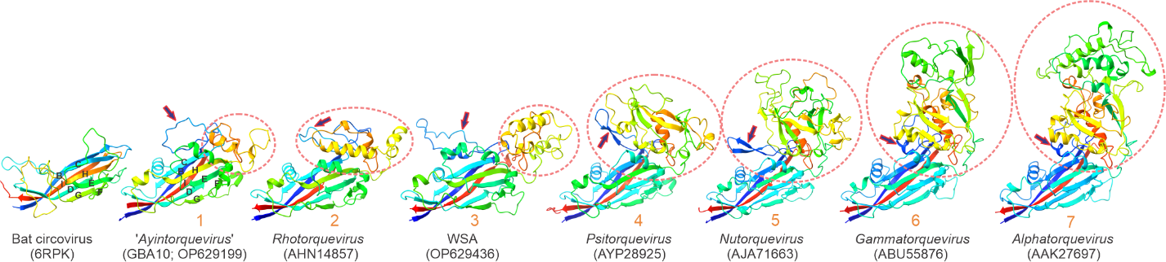

Figure 2. Evolution of the anellovirus capsid protein by the projection domain augmentation. Examples of ORF1 structures with the circled projection domains inserted between strands H-I and arrow indicating additional smaller insertion between strands B-C are also shown. The anellovirus ORF1 proteins are numbered in the order of increasing size. The models are colored using the rainbow scheme, from blue N-terminus to red C-terminus.

