

The International Committee on Taxonomy of Viruses
Taxonomy Proposal Form, 2024

Part 1a: Details of taxonomy proposals

Title: | Establish 4 new genera, 70 new species and abolish one genus in the family Anelloviridae
Code assigned: | 2024.009D.N.v1.1.Anelloviridae_4ngen_70nsp

Author(s), affiliation and email address(es):
Name | Affiliation | Email address | Corresponding author(s) X
Kraberger S | The Biodesign Center for Fundamental and Applied Microbiomics, Center for Evolution and Medicine, School of Life Sciences, Arizona State University, 1001 S. McAllister Ave, Tempe, AZ 85287-5001, USA | simona.kraberger@asu.edu | x
Opriessnig T | Moredun Research Institute, Pentland Science Park, Bush Loan, Penicuik, Midlothian, EH26 0PZ, United Kingdom | tanja.opriessnig@moredun.ac.uk
Maggi F | Department of Medicine and Surgery, University of Insubria, 21100 Varese, Italy | fabrizio.maggi63@gmail.com
Celer V | Faculty of Veterinary Medicine, University of Veterinary Sciences Brno, Palackeho 1946, 612 42, Brno, Czech Republic | celerv@vfu.cz
Okamoto H | Division of Virology, Department of Infection and Immunity, Jichi Medical University School of Medicine, 3311-1 Yakushiji, Shimotsuke-shi, Tochigi 329-0498, Japan | hokamoto@jichi.ac.jp
Biagini P | Equipe Biologie des Groupes Sanguins, UMR 7268 ADES, Aix-Marseille Université, CNRS, EFS, 27 Bd. Jean Moulin, 13005 Marseille, France | philippe.biagini@efs.sante.fr
Krupovic M | Institut Pasteur, Université Paris Cité, CNRS UMR6047, Archaeal Virology Unit, 25 rue du Dr Roux, 75015 Paris, France | mart.krupovic@pasteur.fr
Varsani A | The Biodesign Center for Fundamental and Applied Microbiomics, Center for Evolution and Medicine, School of Life Sciences, Arizona State University, 1001 S. McAllister Ave, Tempe, AZ 85287-5001, USA | arvind.varsani@asu.edu

Part 1b: Taxonomy Proposal Submission
ICTV Subcommittee:
Animal DNA Viruses and Retroviruses | X | Bacterial viruses
Animal minus-strand and dsRNA viruses |  | Fungal and protist viruses
Animal positive-strand RNA viruses |  | Plant viruses
Archaeal viruses |  | General -

List the ICTV Study Group(s) that have seen or have been involved in creating this proposal:
Optional – complete only if formally voted on by an ICTV Study Group:
Study Group | Number of members
Study Group | Votes in support | Votes against | No vote
Anelloviridae study group | 6 | 0 | 0

Submission date: | 14/06/2024

Part 1c: Feedback from ICTV Executive Committee (EC) meeting
Executive Committee Meeting Decision code: | X
A – Accept
Ac – Accept subject to revision by relevant subcommittee chair. No further vote required
U – Accept without revision but with re-evaluation and email vote by the EC
Uc – Accept subject to revision and re-evaluation and email vote by the EC
Ud – Deferred to the next EC meeting, with an invitation to revise based on EC comments
J - Reject
W - Withdrawn

Comments from the Executive Committee:
some typos, confusing sentence to be corrected

Part 1d: Revised Taxonomy Proposal Submission
Response of proposer:
None

Revision date: | 04/10/2024

Part 3: TAXONOMIC PROPOSAL

Name of accompanying Excel module:
2024.009D.N.v1.1.Anelloviridae_4ngen_70nsp.xlsx

Taxonomic changes proposed:
Establish new taxon | X | Split taxon
Abolish taxon |  | Merge taxon
Move taxon |  | Promote taxon
Rename taxon |  | Demote taxon
Move and rename | X

Is any taxon name used here derived from that of a living person: |  | N
Taxon name | Person from whom the name is derived | Attached X

Abstract of Taxonomy Proposal:
Taxonomic rank(s) affected:
New genera (n=4) and species (n=70).

Description of current taxonomy:
The family Anelloviridae currently comprises of 34 genera and 173 species [1]. Over the last few years, a large number diverse of anelloviruses have been identified in various animals. Here we update the current anellovirus taxonomy by undertaking an analysis of anelloviruses whose full genome sequences have been determined. Classification is based on the species demarcation criteria of 69% ORF1 nucleotide pairwise identity and phylogenetic analyses [1].

Proposed taxonomic change(s):
Based on our analyses we propose to establish 70 new species to accommodate the unclassified anelloviruses. Further we propose the establishment of 4 new genera.

Justification:
These changes are based on the species demarcation criteria of 69% ORF1 nucleotide pairwise identity and updated phylogenetic analyses of the ORF1 protein sequences.

- Text of Taxonomy proposal:
Taxonomic rank(s) affected:
New genera (n=3) genus and species (n=70).

Description of current taxonomy:
Anelloviruses are circular negative sense single-stranded DNA viruses with genomes ranging in size from 1.6-3.9 kb. Anelloviruses encode at least one large and typically 2-3 smaller open reading frames. The Anelloviridae family is currently comprised of 173 species that fall into 34 genera:
- Aleptorquevirus
- Alphatorquevirus
- Betatorquevirus
- Chitorquevirus
- Dalettorquevirus
- Deltatorquevirus
- Epsilontorquevirus
- Etatorquevirus
- Gammatorquevirus
- Gimeltorquevirus
- Gyrovirus
- Hetorquevirus
- Iotatorquevirus
- Kappatorquevirus
- Lambdatorquevirus
- Lamedtorquevirus
- Memtorquevirus
- Mutorquevirus
- Nutorquevirus
- Omegatorquevirus
- Omicrontorquevirus
- Pitorquevirus
- Psitorquevirus
- Rhotorquevirus
- Samektorquevirus
- Sigmatorquevirus
- Tettorquevirus
- Thetatorquevirus
- Upsilontorquevirus
- Wawtorquevirus
- Xitorquevirus
- Yodtorquevirus
- Zayintorquevirus
- Zetatorquevirus

Classification guidelines for anelloviruses is based on the species demarcation criteria of 69% ORF1 nucleotide pairwise identity threshold coupled with phylogenetic analyses [1].

Proposed taxonomic change(s):
Here we undertook an analysis of unclassified full anellovirus genome sequences by compiling a dataset of the ORF1 nucleotide sequences from these genomes together with those from representative anellovirus species from GenBank. A pairwise identity analyses of this ORF1 nucleotide dataset (n=243) was undertaken using SDT1.3 [2] (Figure 1). Further, since the pairwise identity analysis alone does not give a clear demarcation threshold for genus, a phylogeny-based approach was taken using the ORF1 amino acid sequences of the representative member of each species. This dataset was then aligned using MAFFT [3], trimmed with TrimAL v 1.4.1 [4] using the 0.2 gap option and a maximum-likelihood tree was constructed with PhyML 3.0 [5] and the best fit substitution model LG+F+G4 (Figure 2).

Based on this phylogenetic analysis (figure 1), 4 additional genera (Ayintorquevirus, Sadetorquevirus Petorquevirus and Qoptorquevirus) need to be established, see table 1 for summary.

The Ayintorquevirus genus will be comprises of species Ayintorquevirus ursid28.

The Sadetorquevirus and Petorquevirus genera are being proposed to be established for two groups of anelloviruses that in the updated phylogeny sit outside their previously assigned genus grouping and therefore will be moved into a new genus. For the proposed Sadetorquevirus genus this will encompass the anellovirus species previously known as Hetorquevirus hominid8 and Hetorquevirus hominid7 which are supported phylogenetically in a new genus, and for the

Petorquevirus genus this will encompass the anellovirus species that are being moved and renamed to (species Thetatorquevirus ixodi1, Thetatorquevirus canid1, Thetatorquevirus viver4) Petorquevirus ixodi1, Petorquevirus canid1 and Petorquevirus viver4 which are also phylogenetically supported.

The species Dalettorquevirus ursid6 is being moved and renamed to Upsilontorquevirus ursid6 in the genus Upsilontorquevirus as this better supports its classification with strong phylogenetic support. (Table 1).
As a result of this Dalettorquevirus no longer has a species assigned to it and this genus is being dissolved.
The newly proposed genus Qoptorquevrius will be comprised of 69 anelloviruses from various Delphinidae species.

Based on the species demarcation criteria of 69% ORF1 nucleotide pairwise identity 70 new species have been established. Distribution plot of pairwise identities for representative species supports that this 69% threshold has been maintained (Figure 1).

Demarcation criteria:
Classification guidelines for anelloviruses is based on the species demarcation criteria cutoff of 69% ORF1 nucleotide pairwise identity and phylogenetic analyses [1].

Justification:
The proposed changes are in accordance with the stipulated anellovirus classification guidelines stated above.
References:
1. Varsani, A.; Kraberger, S.; Opriessnig, T.; Maggi, F.; Celer, V.; Okamoto, H.; Biagini, P., Anelloviridae taxonomy update 2023. Arch Virol 2023, 168, (11), 277.
2. Muhire, B. M.; Varsani, A.; Martin, D. P., SDT: a virus classification tool based on pairwise sequence alignment and identity calculation. PLoS One 2014, 9, (9), e108277.
3. Katoh, K.; Standley, D. M., MAFFT multiple sequence alignment software version 7: improvements in performance and usability. Molecular biology and evolution 2013, 30, (4), 772-780.
4. Capella-Gutierrez, S.; Silla-Martinez, J. M.; Gabaldon, T., trimAl: a tool for automated alignment trimming in large-scale phylogenetic analyses. Bioinformatics 2009, 25, (15), 1972-3.
5. Guindon, S.; Dufayard, J.-F.; Lefort, V.; Anisimova, M.; Hordijk, W.; Gascuel, O., New algorithms and methods to estimate maximum-likelihood phylogenies: assessing the performance of PhyML 3.0. Syst. Biol. 2010, 59, (3), 307-321.

Tables, Figures:
<Start here>

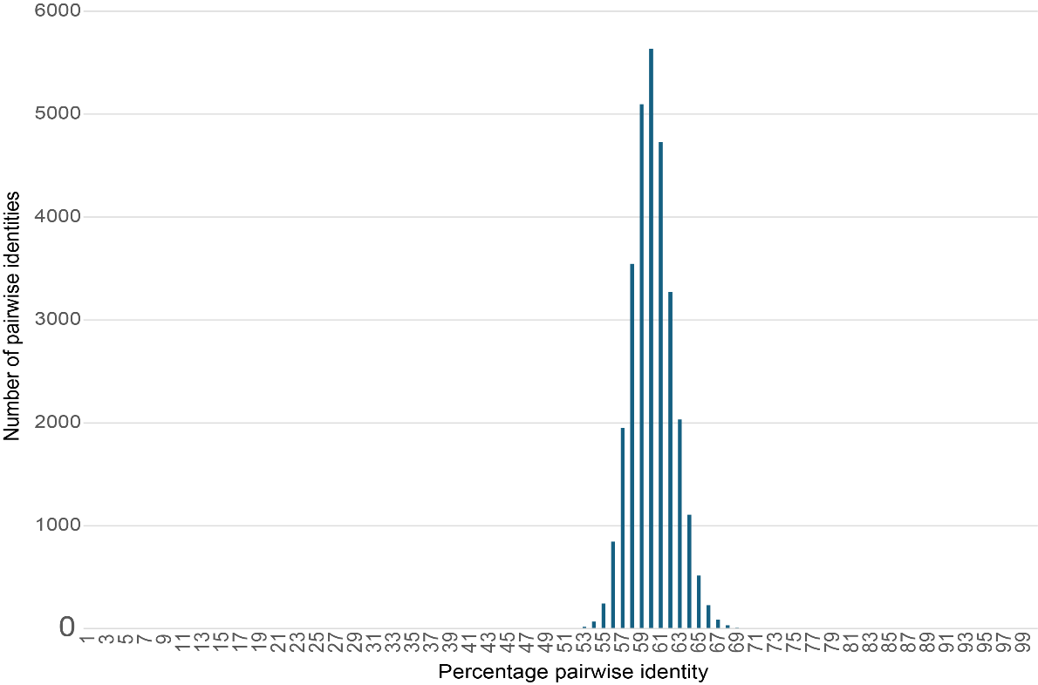

Figure 1: Percentage pairwise identity distribution plot of ORF1 sequence for representative anellovirus species (n=243).

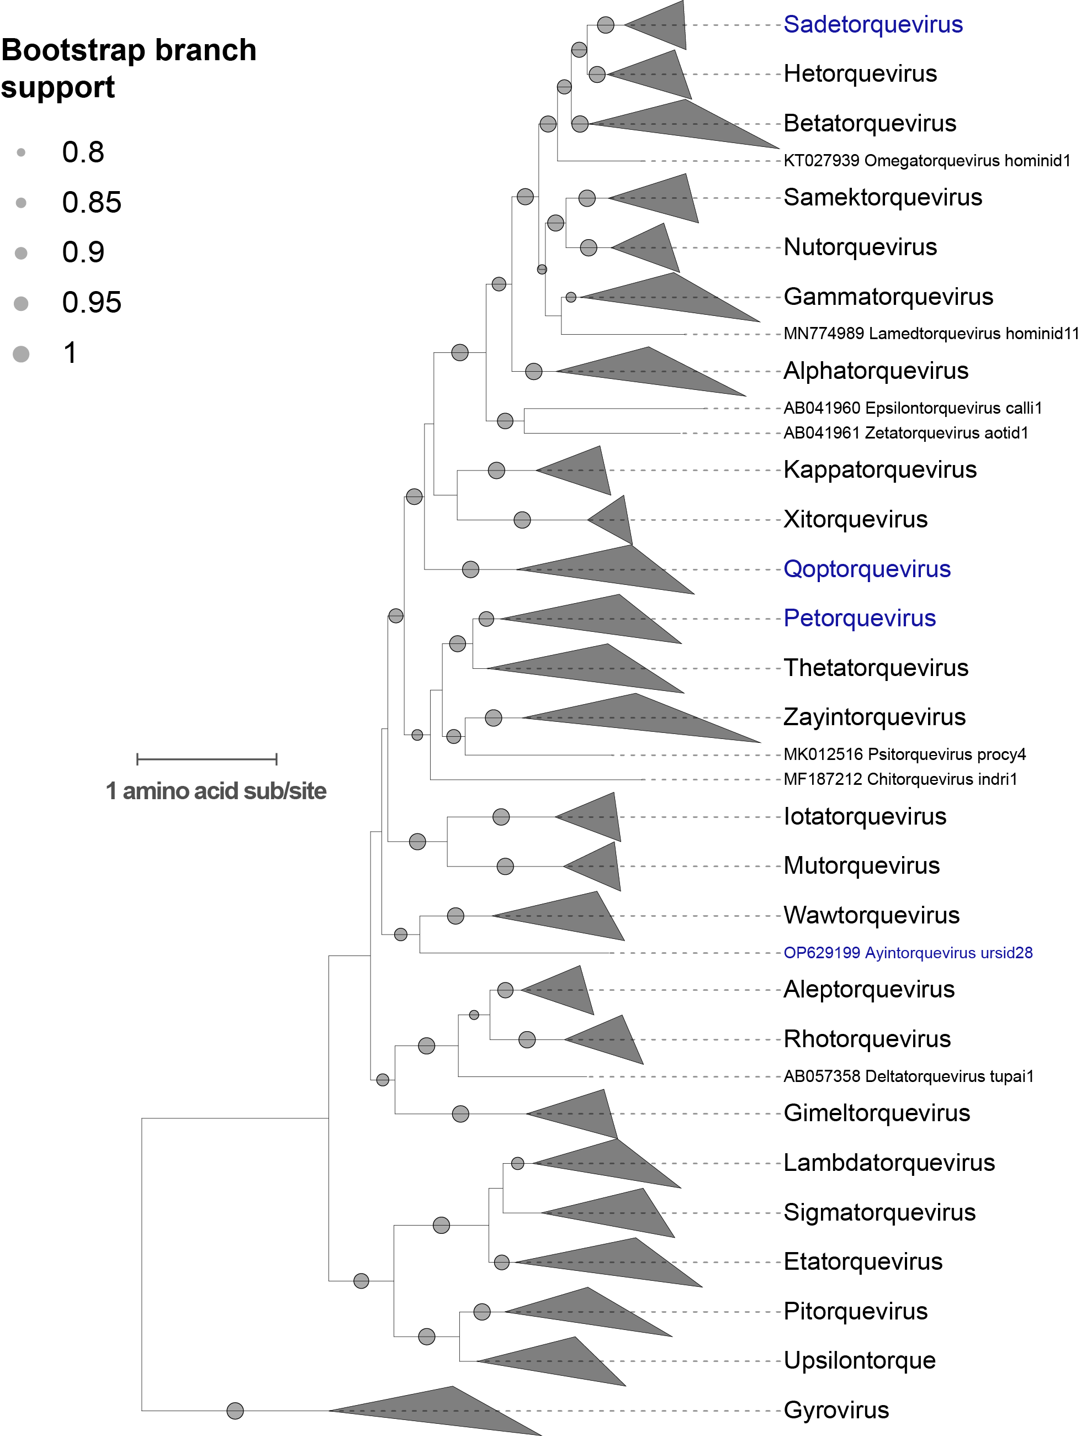

Figure 2: Maximum likelihood phylogenetic tree of the ORF1 amino acid sequences of representative anelloviruses species. The sequences of gyroviruses were used to root the phylogeny. Those in blue denote newly proposed genera.

Table 1: information of updated taxonomy and change that is proposed.

Genus | Species name | Accession | Changes | Exemplar  virus name | Exemplar  isolate  designation
Qoptorquevirus | - | - | New genus
 | Qoptorquevirus delphin18 | PP790224 | New species | Torque teno Delphinidae virus 48 | USW2_C1
 | Qoptorquevirus delphin14 | PP790225 | New species | Torque teno Delphinidae virus 1 | USW2_C2
 | Qoptorquevirus delphin22 | PP790227 | New species | Torque teno Delphinidae virus 51 | USW5_C1
 | Qoptorquevirus delphin21 | PP790229 | New species | Torque teno Delphinidae virus 52 | USW7_C1
 | Qoptorquevirus delphin19 | PP790230 | New species | Torque teno Delphinidae virus 53 | USW7_C2
 | Qoptorquevirus delphin16 | PP790231 | New species | Torque teno Delphinidae virus 54 | USW7_C3
 | Qoptorquevirus delphin20 | PP790232 | New species | Torque teno Delphinidae virus 50 | USW8_C1
 | Qoptorquevirus delphin3 | PP790249 | New species | Torque teno Delphinidae virus 40 | USW16_C2
 | Qoptorquevirus delphin6 | PP790253 | New species | Torque teno Delphinidae virus 30 | USW18_A1
 | Qoptorquevirus delphin4 | PP790254 | New species | Torque teno Delphinidae virus 44 | USW18_C1
 | Qoptorquevirus delphin2 | PP790255 | New species | Torque teno Delphinidae virus 7 | USW18_C2
 | Qoptorquevirus delphin1 | PP790261 | New species | Torque teno Delphinidae virus 45 | USW25_C1
 | Qoptorquevirus delphin13 | PP790266 | New species | Torque teno Delphinidae virus 2 | USW28_C1
 | Qoptorquevirus delphin8 | PP790267 | New species | Torque teno Delphinidae virus 23 | USW29_C1
 | Qoptorquevirus delphin7 | PP790268 | New species | Torque teno Delphinidae virus 31 | USW30_A1
 | Qoptorquevirus delphin11 | PP790269 | New species | Torque teno Delphinidae virus 4 | USW30_C1
 | Qoptorquevirus delphin17 | PP790271 | New species | Torque teno Delphinidae virus 56 | USW35_C1
 | Qoptorquevirus delphin15 | PP790272 | New species | Torque teno Delphinidae virus 55 | USW36_C1
 | Qoptorquevirus delphin10 | PP790279 | New species | Torque teno Delphinidae virus 6 | USW44_A1
 | Qoptorquevirus delphin12 | PP790288 | New species | Torque teno Delphinidae virus 3 | USW50_C2
 | Qoptorquevirus delphin9 | PP790291 | New species | Torque teno Delphinidae virus 5 | USW54_A1
 | Qoptorquevirus delphin5 | PP790292 | New species | Torque teno Delphinidae virus 29 | USW55_A1
Etatorquevirus | Etatorquevirus felid28 | MT538050 | New species | Torque teno felis virus LSF9_anello5 | LSF9_anello5
 | Etatorquevirus felid25 | MT538051 | New species | Torque teno felis virus LSF12_anello3 | LSF12_anello3
 | Etatorquevirus felid26 | MT538062 | New species | Torque teno felis virus LSF30_anello7 | LSF30_anello7
 | Etatorquevirus felid17 | MT538083 | New species | Torque teno felis virus LSF125_anello3 | LSF125_anello3
 | Etatorquevirus felid21 | MT538084 | New species | Torque teno felis virus LSF125_anello4 | LSF125_anello4
 | Etatorquevirus felid27 | MT538089 | New species | Torque teno felis virus LSF129_anello1 | LSF129_anello1
 | Etatorquevirus felid24 | MT538121 | New species | Torque teno felis virus LSF_162_anello1 | LSF_162_anello1
 | Etatorquevirus felid18 | MT538124 | New species | Torque teno felis virus LSF_170_anello1 | LSF_170_anello1
 | Etatorquevirus felid22 | MT538131 | New species | Torque teno felis virus UoA1_anello4 | UoA1_anello4
 | Etatorquevirus felid19 | MT538141 | New species | Torque teno felis virus x262_anello3 | x262_anello3
 | Etatorquevirus felid20 | MT538175 | New species | Torque teno felis virus x1523_anello3 | x1523_anello3
 | Etatorquevirus felid35 | ON556614 | New species | Torque teno felis virus cov_24.72173 | cov_24.72173
Gimeltorquevirus | Gimeltorquevirus ursid26 | MZ357148 | New species | Giant panda anellovirus Gpb08AV02-5 | Gpb08AV02-5
 | Gimeltorquevirus ursid27 | OR779982 | New species | Torque teno virus UTUChV/2022 | UTUChV/2022
Gyrovirus | Gyrovirus chauna1 | MH016740 | New species | Gyrovirus 10 | GyV10.1
 | Gyrovirus anas1 | MT318123 | New species | Gyrovirus 9 | VC1
 | Gyrovirus anas2 | MT318125 | New species | Avian gyrovirus 13 | VC3
Iotatorquevirus | Iotatorquevirus ursid17 | OP129719 | New species | Torque teno virus GB3_pi2 | TTV_GB3_pi2
Pitorquevirus | Pitorquevirus ursid19 | ON638692 | New species | Anelloviridae sp. gpa-20 | gpa-20
 | Pitorquevirus ursid25 | OP629190 | New species | Grizzly bear anellovirus 1 | Gbear3_525
 | Pitorquevirus ursid21 | OP629191 | New species | Grizzly bear anellovirus 2 | Gbear3_520
 | Pitorquevirus ursid23 | OP629192 | New species | Grizzly bear anellovirus 3 | Gbear3_519
 | Pitorquevirus ursid24 | OP629193 | New species | Grizzly bear anellovirus 4 | Gbear3_491
 | Pitorquevirus ursid20 | OP629194 | New species | Grizzly bear anellovirus 5 | Gbear3_460
 | Pitorquevirus ursid18 | OP629195 | New species | Grizzly bear anellovirus 6 | Gbear3_432
 | Pitorquevirus ursid22 | OP629196 | New species | Grizzly bear anellovirus 7 | Gbear3_354
 | Pitorquevirus ursid29 | OP629197 | New species | Grizzly bear anellovirus 8 | Gbear3_351
Rhotorquevirus | Rhotorquevirus rodfelid1 | MT538139 | New species | Torque teno felis virus UoA20_55 | UoA20_55
Thetatorquevirus | Thetatorquevirus ursid14 | MZ357157 | New species | Giant panda anellovirus Gpb09AV05-5 | Gpb09AV05-5
 | Thetatorquevirus ursid15 | MZ357160 | New species | Giant panda anellovirus Gpb10AV02-5 | Gpb10AV02-5
Omicrontorquevirus | Omicrontorquevirus ursid16 | OP629198 | New species | Grizzly bear anellovirus 9 | Gbear3_304
Zayintorquevirus | Zayintorquevirus felid31 | MT537977 | New species | Torque teno felis virus CCB28_anello1 | CCB28_anello1
 | Zayintorquevirus felid8 | MT537978 | New species | Torque teno felis virus CCB29_anello1 | CCB29_anello1
 | Zayintorquevirus felid32 | MT537980 | New species | Torque teno felis virus CCB36_anello1 | CCB36_anello1
 | Zayintorquevirus felid7 | MT537993 | New species | Torque teno felis virus CCB53_anello1 | CCB53_anello1
 | Zayintorquevirus felid11 | MT537996 | New species | Torque teno felis virus CCB57_anello1 | CCB57_anello1
 | Zayintorquevirus felid9 | MT537999 | New species | Torque teno felis virus CCB61_anello1 | CCB61_anello1
 | Zayintorquevirus felid12 | MT538011 | New species | Torque teno felis virus CLB10_LB135 | CLB10_LB135
 | Zayintorquevirus felid16 | MT538013 | New species | Torque teno felis virus CLB11_LB94 | CLB11_LB94
 | Zayintorquevirus felid14 | MT538017 | New species | Torque teno felis virus CLB13_LB98 | CLB13_LB98
 | Zayintorquevirus felid10 | MT538020 | New species | Torque teno felis virus CLB16_LB44 | CLB16_LB44
 | Zayintorquevirus felid13 | MT538033 | New species | Torque teno felis virus CLB21_LB131 | CLB21_LB131
 | Zayintorquevirus felid15 | MT538127 | New species | Torque teno felis virus MAF5_LB135 | MAF5_LB135
 | Zayintorquevirus felid30 | ON556610 | New species | Torque teno felis virus cov_8.67698 | cov_8.67698
 | Zayintorquevirus felid33 | ON556611 | New species | Torque teno felis virus cov_62.09776 | cov_62.09776
 | Zayintorquevirus felid29 | ON556612 | New species | Torque teno felis virus cov_16.13602 | cov_16.13602
 | Zayintorquevirus felid34 | ON556613 | New species | Torque teno felis virus cov_16.84873 | cov_16.84873
Ayintorquevirus |  |  | New Genus
 | Ayintorquevirus ursid28 | OP629199 | New species | Grizzly bear anellovirus 10 | GBear3_496
Sadetorquevirus | - | - | New genus
 | Sadetorquevirus hominid8 | MN769236 | Move, rename | TTV-like mini virus SAfiA-349-9 | SAfiA-349-9
 | Sadetorquevirus hominid7 | MN771248 | Move, rename | TTV-like mini virus SAfiA-410-3 | SAfiA-410-3
Petorquevirus | - | - | New genus
 | Petorquevirus ixodi1 | MF173068 | Move, rename | Tick associated torque teno virus tick24_1 | tick24_1
 | Petorquevirus canid1 | AB076002 | Move, rename | Torque teno canis virus Cf-TTV10 | Cf-TTV10
 | Petorquevirus viver4 | LC387543 | Move, rename | Paguma larvata torque teno virus Pl-TTV9-2 | Pl-TTV9-2
Upsilontorquevirus | Upsilontorquevirus ursid6 | MF327539 | Move, rename | Giant panda anellovirus gpan20793 | gpan20793
Dalettorquevirus |  |  | Abolish genus

